Report of Technical Standards Committee
on
Technical Standards and Protocol for the
Cold Chain in India

Cold Storage
For
Fresh Horticulture Produce Not Requiring Pre-cooling Before Storage
(Technical Standards Number NHB-CS-Type 01-2010)

National Horticulture Board
(Department of Agriculture & Cooperation,
Ministry of Agriculture, Govt. of India)
85, Institutional Area, Sector18, Gurgaon-122 015
(Haryana)

CONTENT
Sr. No. | Description | Page No.
 | Preface | i-iii
 | Section 1. Technical Standards | 1-24
 | Section 2. .Basic Data Sheet | 25-39
 | Section 3. Protocol for Implementation of Technical Standards | 40
 | Section. 4  - Typical Design for Layout Option – A (For 5000 MT Potato Storage)  - Section 4 – Typical Design for Layout Option – B (For 5000 MT Potato Storage) | 41-47  48-67
 | Annexure-I | 68-70
 | Annexure-II | 71-72
 | Annexure-III | 73-80

Preface

A Task Force on development of cold chain in India had been set up by the Ministry of Agriculture vide its order dated 3rd May 2007. The said Task Force had recommended revised normative cost for cold storages and subsidy norms for ensuring technology up gradation in cold storages. It has, therefore, been felt necessary to define appropriate technical standards in respect of various components of cold storages without which exercise of quantification of revised normative cost, subsidy norms etc cannot be substantiated; nor can the desired results of effecting technology up gradation be achieved. Therefore, Department of Agriculture & Cooperation, Ministry of Agriculture, Government of India, vide its communication No. 22011/5/2007-M-II dated 16th June 2009 constituted a Technical Standards Committee (Annexure-I). Terms of Reference of the Technical Standards Committee (TSC) is to give recommendations on the following issues-

- Suitable technical standards and protocols for cold chain infrastructure in the Country
- The mechanism of implementation of such standards and protocols
- Any other issue that the Committee may consider important or relevant for the subject or may be assigned to it by the Government.

The Committee was given initial time frame of two months for submitting its recommendations. However, extension has been duly granted thereafter.

The TSC has classified cold storages for fruits & vegetables in following three main categories as listed below.

- Cold storages for storage of fresh horticulture products which do not require pre-cooling (Technical Standards Number NHB-CS-Type 01-2010)
- Multi-commodity Cold storages for short term and long-term storage of fresh horticulture products, which require pre-cooling and varying storage requirements. Technical Standards Number NHB-CS-Type 02-2010)
- Control Atmosphere (CA) Storages. Technical Standards Number NHB-CS-Type 03-2010).

This volume of Standards covers Cold Storage of Type 01 mentioned above and has four sections viz. Technical Standards, Basic Data Sheet, Protocol for Implementation of the Prescribed Technical Standards and Type Designs. While firming up its recommendations by TSC, emphasis is laid on optimum energy efficiency and overall performance and therefore coefficient of performance (CoP) is one of the determining criteria. In addition, aspects of environmental and safety concerns and Human Resource Development too have been taken in to account.

The Technical Standards have general information on the type of produce that can be stored in particular Type / module, their critical storage conditions, (as much compatible with the World standards as possible by relying on Word Food Logistic Organisation (WFLO) database in absence of research data for Indian conditions, except for potato, in terms of temperature, humidity range, CO₂ level, loading rate, pull down time, air circulation and ventilation requirement etc. In order to facilitate improved design, there is a detailed Basic Data Sheet available in the Section 2 of the Standards wherein plotting different specification data into a system shall lead to better coefficient of performance from energy efficiency point of view. Section 3 deals with the Protocol for Implementation of Technical Standards through system analysis of civil structure, thermal insulation and refrigeration at the stage of issuing letter of intent and through site inspection at later stages.
i

These standards and recommendations are intended to serve as minimum requirement, and are not to be construed as limiting good practice. Wherever IS-Code is not available, relevant standard codes of ISO / ASME / ASHRAE / IIAR or other International Codes have been followed. The responsibility for deciding whether other requirements additional to the ones listed in the technical standard document are necessary to ensure system integrity, efficiency and overall safety, including operation, maintenance and servicing and/or the necessity to adopt additional requirements in the system design and construction to guarantee the overall performance, still rests with the supplier / manufacturer.

It is recommended that the suppliers / manufacturers shall furnish to the owner copies of instructions / manual which shall include operation & maintenance instruction, built drawings, wiring diagrams, recommended spare parts and replacement part list etc as recommended. It is also envisaged that the suppliers / manufacturers shall provide training for the plant and machinery installed including safety and emergency procedures. The supplier /manufacturer will follow all practices set forth by “Good Manufacturing Practices” by various applicable Codes and Standards listed in this document and shall fully certify the equipment, plant and machinery supplied / installed in compliance to the relevant codes and standards which would be under scrutiny.

Nonetheless, these also have provision for scope of variation, through a Variation and Amendment Clause, to take care of new concepts, innovations, and R&D in building design etc. so that improvements coming along the way are not stopped but analysed and incorporated in the design.

The Committee acknowledges the valuable contribution made by experts in firming up its recommendations whose particulars are listed in Annexure-II to the report; the list has special mention of non-member experts who have volunteered and spared their valuable time in giving their inputs from time to time. In the end, Annexure III lists relevant BIS and other standards to which investors; contractors and suppliers may refer to comply with the requirements for designing and installing various components.

TSC had invited comments to the draft standards by issuing public notice and has examined the comments received from various stakeholders which are in respect of air-cooled ammonia compressors, Bunker-fin Coils, Electro Galvanisation and Hot Spray Galvanisation of MS cooling coils and Paddy Husk type thermal insulation, but in absence of authentic data, TSC recommends undertaking further investigation in to the claims and representations received, before their incorporation in prescribed technical standards.
ii
Last but not the least, contribution made by Dr. R. K. Sharma - Senior Deputy Director, NHB has been of immense value as he for all practical purposes functioned as Member-Secretary to the Committee.

(Bijay Kumar)
Chairman, TSC and Managing Director
National Horticulture Board
Dated- February 3, 2010 (Ministry of Agriculture, Govt. of India)
iii

SECTION 1

Technical Standards
Section-1

Technical Standard No. NHB-Cold Storage-Type 01-2009

- Cold Storage Type. For fresh fruits and vegetables and other horticulture products which do not require pre-cooling but there is crop specific rate of pull down and storage conditions,
a. Fresh Potato Tubers for following purposes
- Early Crop (pre mature)
- Seed Potato
- Table Potato
- Process Potato
  - French Fries
  - Chipping
- Onion, garlic, tamarind etc.

- Critical Storage Conditions-
i. Quality of produce - Curing & pre-conditioning for about 7 to 10 days in the fields for skin set / proper handling/ Application of CIPC.
For example- it is recommended that potatoes are harvested at temps not lower than 8° C and not higher than 20° C and harvested potatoes are cured by keeping at 15° C to 20° C and 90% to 95 % RH for 5 to 10 days before placing them into cold storage, allowing the surface wounds to heal, thereby preventing water loss and protection from decay.
- Commodity Storage Conditions- For designing a cold storage, product storage conditions must be defined in terms of critical storage conditions of temperature, relative humidity, presence of CO₂, ethylene, air circulation, light etc. In absence of research data for Indian conditions, it is recommended to adopt commodity storage conditions as prescribed by Commodity Storage Manual of WFLO in absence of research data from Indian Institutions. Example - Design conditions for Irish Potatoes which are adopted, in absence of data for Indian potatoes are as given below.
      - Temperature, storage period, relative humidity etc-
Fresh Potato | Temperature | Storage Period | Relative Humidity
Early Crop | 4 – 10°C | 0 – 3 months * | 95%
Seed Potato | 3°C @ | 5 – 10 months | 90 – 95%
Table Potato | 4°C | 5 – 10 months | 90 – 95%  1
For French Fries | 7.2 - 10°C | 1 – 10 months ** | 90 – 95%
For Chipping | 7.2-10°C # | 1 – 8 months ** | 90 – 95%
(*) If cured / wounds healed before storage
(**) Sprout suppressors must be used for long-term storage.
(#) Generally stored between 9 - 13°C as per WFLO manual whereas CPRI recommends 11°C
@ Based on expert advice of CPRI, which is firmed up by TSC after analysis of the same, critical storage temperature for seed potato is taken as 3ºC +-1º C. Moreover, one of the following two critical storage conditions for table potatoes may be taken into account after evaluating their implications on consumer preference for stored potatoes and cost of storage; firstly as critical storage conditions of potatoes for processing purposes and secondly, the critical storage conditions recommended for seed potatoes.

- 24 hours cooling to 15ºc followed by pull down rate of 0.5ºc per day till holding temperature of 11ºc + 1ºc with CIPC application after first 30 days of storage; in this case stored potatoes may not turn sweet due to separation of sugar, however, storage cost will be higher due to CIPC application.
- 24 hours cooling to 10ºc, pull down to holding temperature of 3^{oC} +- 1ºC within 8 to days; in which case, starch accumulation will take place but storage cost may be lower,

      - Temperature and humidity range: +/- 1⁰ C for temperature and humidity range as given.

      - CO₂ level: Not more than 4000 ppm during loading and 2000 ppm during holding (source: industry).

      - Loading Rate: 4% (at 25⁰ C) to 5% (at 20⁰ C) of the total storage capacity (equally split into chambers) per day so that total loading period is about 20 days. Temperature during loading to be maintained at 15⁰ C which should be brought down to holding temperature @ 2⁰ to 3⁰ C per week; subject to choice of adopting CPRI recommendations as mentioned above.

      - Pull-down time: 24 hours for pull down to 15⁰ C and @ 2⁰- 3⁰ C per week for pull down to holding temperature. CPRI recommends that seed potatoes should be cooled to 10⁰ C within 24 hours of arrival at cold store and its temperature should be further pulled down to holding temperature of 3⁰ C +1º C within 8 to 10 days as sugar separation due to rapid cooling is not a matter of concern for seed potatoes..

- Air Circulation: Minimum 50 CFM/MT of Potato (85 CMH/ MT of Potato) during the loading and pull-down period. However, during the holding period fan power is optimized by fan speed reduced to almost 70% by VFD control (which will reduce fan motor power consumption to 34%) and thereafter automatic control will maintain temperature variation within each chamber at less than +/- 1 °C throughout the storage period.
2

- Ventilation requirements in cold storage: it may range between 2 to 6 air changes per day to maintain CO² less than 4000 ppm. It is recommended to opt for mechanical CO₂ extractor with energy recovery system. It is a much better option than the present practice of opening the cold stores doors & hatch windows to ventilate and remove the CO₂ build-up as the later practice results in loss of energy, inability to maintain temperature variation range of + 1⁰c, wetting of product leading to product loss.

- Lighting Condition: Dark

- CIPC application: For processing potatoes in general and for table potatoes if critical storage conditions equivalent to processing potatoes are adopted. CPRI recommends that due to slow pull down of temperature (0.5 ⁰ C per day) in these situations, high holding temperature is built up which in turn accelerates germination of potatoes immediately after its dormancy period; therefore, CIPC application is recommended immediately after first 30 days of arrival of potatoes in cold storage. He further cautioned that rapid cooling should not be carried out for potatoes for processing purposes.

- Layout of a Typical Cold Store for Products Identified
It is recommended to have multi commodity cold stores for better capacity utilisation. For example - a solely potato based cold storage may be designed for storage of seed potato and table potato or processing potato etc. Similarly, for energy efficiency, cold stores have to be multi chamber. It is recommended to have at least two chambers and chamber size should be of the capacity range of 1,000 MT to 1,500 MT for ensuring uniform storage condition, proper capacity utilization, and energy efficiency. This is not possible in single chamber / larger chamber cold storages. Cold stores for of this type are generally with mezzanine floors, which must be provided with anteroom of adequate dimensions. Having staircase inside the chamber may reduce storage space and restrict possibility of having elevators and fire escape. Layouts with staircase in anteroom facilitate better space utilisation; higher efficiency of workmen, providing for elevators and fire escape but construction cost may be higher due to multiple doors etc. If CIPC is to be used as sprout-suppressor for certain products, then other chambers having products to be used as seed must be adequately separated by having separate anti chamber. Two typical layouts are given below.

3

TYPE LAYOUT - OPTION A
FOUR CHAMBER POTATO BASED COLD STORE
(With staircase inside chambers, common entry and exit at ground floor for all floors of a chamber, no provision for elevators and fire escape route)

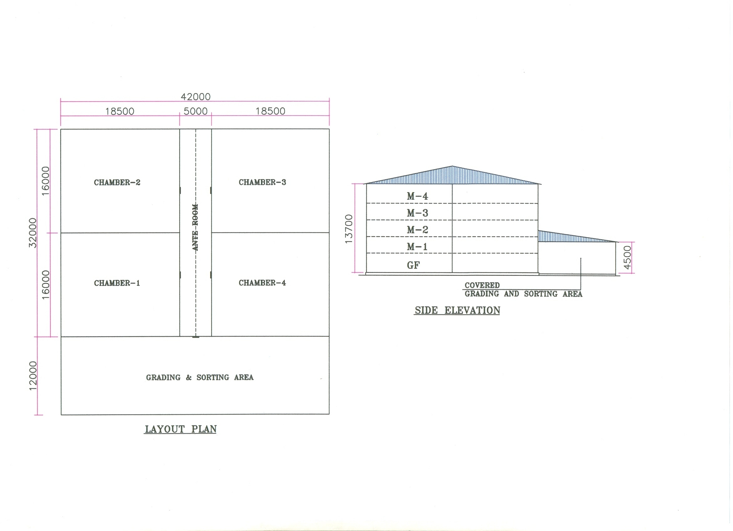

4

TYPE LAYOUT- OPTION-B
FOUR CHAMBER POTATO BASED COLD STORE
(With provision for staircase outside chambers, doors for each chamber at each floor, elevator and fire escape route etc)
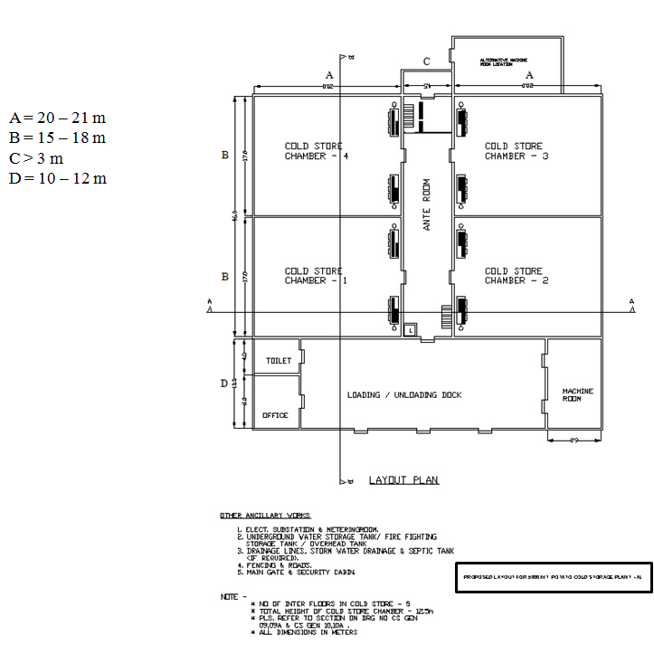
5
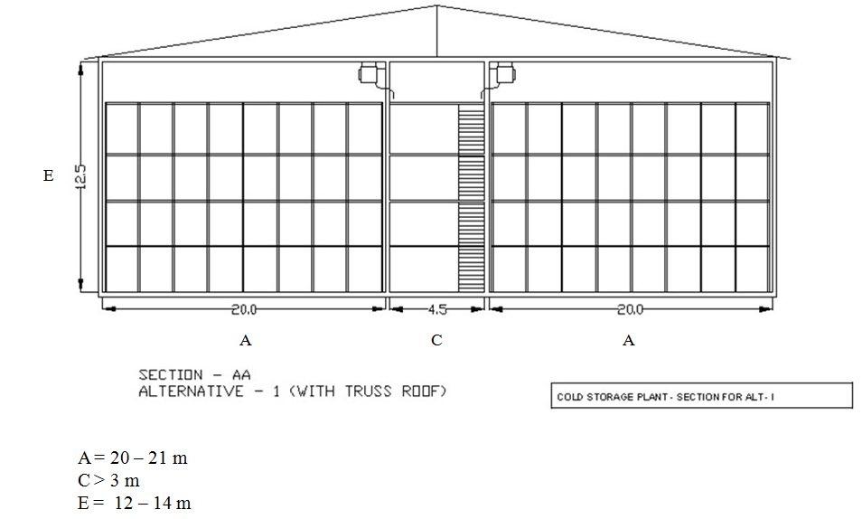

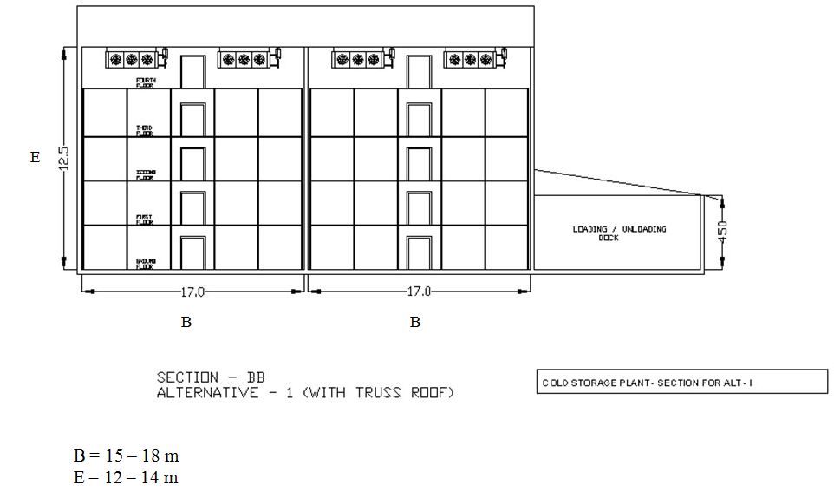
6
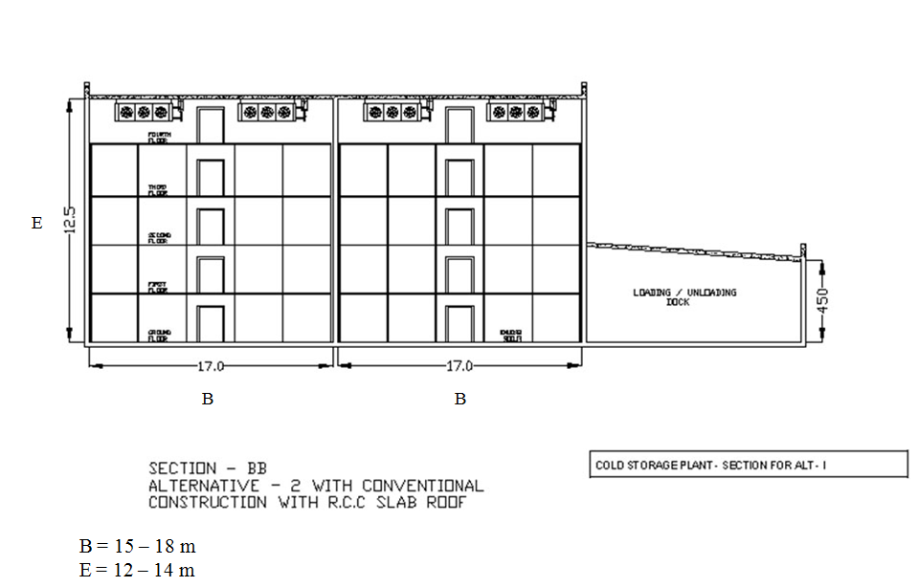
Construction Features- The general convention of conventional construction is as follows:
Foundation: Superstructure and Foundation (which may be conventional Footing Type, Pile Foundation, Raft Foundation etc) to be designed by qualified & licensed structural / civil engineer. The design shall meet the BIS standards and relevant seismic zone norms for earthquake proof designs.
Cold Chamber:
Walls Minimum 230 mm Brick walls / solid concrete blocks with sand-cement plaster. However, in RCC structure or pre-fabricated structure insulated panel boards may also be provided in place of masonry walls.
Roof RCC slabs or Truss Roof with G.S / Pre-coated G.S.Sheet cover. RCC slab to have proper water proofing with reflective colour paint / China mosaic finish. Slab to have proper slope for rain water drainage.
In case of truss roof, provision to be made for fixing insulated panels on the ceiling & supporting of cooling units from the trusses (alternatively cooling units can be supported on floor mounted frame structure on top floor).
7
Provision for FRP sheets for natural lighting to be made in roof sheeting at certain locations. For ventilation of attic, provision of ridge monitor or turbo ventilators (which require no electric power) can be made. Alternatively roof can also be designed by installing insulated roof panels with proper slope & sealing of longitudinal & lateral joints. The work to be handled by experienced agencies to ensure a trouble free roof structure. The roof may be kept walkable for maintenance.
Floor The floor comprises of base concrete, in cold stores with suitably lower levels in cold chambers. The level difference between cold chambers and ante room to be equal to the thickness of floor insulation plus the layer of PCC or tremix finish,
Inter-floors The basic structure can be RCC columns & beams or steel columns & steel beams
Grating Wooden batten grating or steel grating using flats / square tubes etc. The inter-floors have to be designed for a product loading of 900 kg/m² min. Where AC units are located on top floor, the structure has to be suitable for the unit static & dynamic loads.
Ante Room This should preferably be designed to accommodate staircase, electrical hoist cage and have wider doors. Provision for fire escape stair & exits to be made as per local norms. The inter-floors in ante room to have doors to each cold room on each floor.
Strip curtains for cold rooms and Air Curtains for external outlets/ inlets- Strip curtains are quite common for reducing infiltration of air during loading/ unloading. Air curtains need power for operation but are more effective if properly installed.
Rodent proof civil structure and proper drainage of water to be ensured.
Rooms for machines, Electricals etc.
Dock Loading & unloading dock shall be designed with RCC slab roof or sheet roofing. However the machine roof can have RCC slab-roof to accommodate the evaporative condensers, pump sets, water tank, water softener etc. The dock area to accommodate suitably sized office & toilet for staff & labour.
Ancillaries Underground fresh water storage, storage for fire fighting, water supply & sanitary arrangements, compound wall / fencing, main gate, security, small canteen / electrical sub-station & D.G. set platform, roads & parking place for vehicles etc. Green landscaping with benches for labourers is desirable.
8

- Thermal Insulation:
It is recommended that appropriate BIS standards are adopted for selection of design parameters (IS 661:2000) and method of application of thermal insulation (IS 661 & 13205).Though fresh F & V are stored at + 0º C, it is recommended to design thermal insulation for (- 4º C to + 2º C) temperature condition to have lower heat load.

Materials of thermal insulation and its application-
Cold chambers have to be insulated on walls, ceilings / roofs & floors with proper insulating material of adequate thickness, with provision for vapour barrier on outer side & proper cladding/ cover on inner side. The commonly used insulation materials are:
- Expanded polystyrene
- Rigid Polyurethane foam
- Rigid phenolic foam
- Mineral wool / glass wool
- Extruded polystyrene

The ancillary materials to be used include:
- Vapour barrier e.g. aluminium foil, polyurethane sheet, with bitumen / cold mastic adhesives
- Teakwood batten pegs, Tees etc.
- G.S. sheet runners (avoid wooden batten runners)
- Cladding of profiled / pre-coated G.S.sheets 0.5 / 0.6 mm thick / Fibre-glass sheets of suitable thickness

For Conventional Insulation
Walls & Ceiling
  - Primer Coat followed by two layers of bitumen
  - Fixing aluminium foil min. 50 microns
  - Fixing wooden pegs at suitable intervals
  - Fixing two layers of insulation with staggered joints
  - Fixing G.S sheet runners over the pegs in longitudinal & lateral directions
  - Fixing profiled & pre-coated g.s. sheets, 0.5 / 0.6 mm thick over the runners with proper finishing of joints. Alternatively FRP sheets can be used.
9
Floor
- Laying of polythene sheet, min. 250 microns, as vapour barrier
- Fixing insulation slabs in two layers with bitumen as adhesive for the first layer
- Covering with tar felt
- Laying PCC / tremix of 75 mm / 100 mm thickness

For Insulated Panel Structure
Walls & Ceiling
- Perimeter of the plinth to be in level for panel installation
- Panels to have cam lock or tongue / grove joints
- Sheet metal flashing to be provided on all concrete / wall ceiling joints internally & externally. PVC coving or concrete curbing to be provided on wall - floor joints.
- Horizontal Tie bracings to be provided between vertical wall panels & external columns, to take care of wind loads
- Adequate numbers of Pressure relief ports to be provided on all chambers with electrical connection
- Insulated doors shall be suitable for panel mounting

10
MINIMUM INSULATION THICKNESS FOR VARIOUS INSULATION MATERIALS BASED ON RECOMMENDED U VALUES FOR -4 TO +2 ° COLD STORAGE
Type of insulation | Material |  | Wall |  | Ceiling/ roof  U value = 0.24 W/m²K | Floor  U value = 0.29W/m²K
Type of insulation |  |  | External  U value = 0.27W/m²K | Partition  U value = 0.58W/m²K | Ceiling/ roof  U value = 0.24 W/m²K | Floor  U value = 0.29W/m²K
Type of insulation | ρ Density  Kg/m³ | K (at 10 ⁰C)  W/mK | Thickness  mm | Thickness  mm | Thickness  mm | Thickness  mm
EPS | 15 | 0.036 | 150 | 75 | 150 | 125
PUF | 32 | 0.023 | 100 | 50 | 100 | 100
XPS## | 30-35 | 0.025 | 100 | 50 | 100 | 100
Phenolic foam *** | 50 | 0.026 | 100 | 50 | 125 | 100
Mineral wool *** | 48 | 0.033 | 125 | 50 | 125 | 100
Bonded fibre glass/ glass wool*** | 32 | 0.033 | 125 | 50 | 125 | 100
*** Recommended only with vapour barrier and metal or FRP cladding min 0.5 mm TCT
## Recommended in conformance to ISO/FDIS 4898:2008(E) for properties of XPS used for thermal insulation of buildings, Categories II, III & IV only.
Notes-
- K values from IS661:2000.
- U values are the recommended heat transmission coefficients for cold storage temperature range -4 to 2°C by IS661:2000
- All values rounded off in multiples of inch (25 mm).
- Radiant barrier. This could be an option which the promoters can use for energy saving. However, the minimum thickness of insulation and the method of fixing will remain as specified in the standards.

- Total Refrigeration Load - Heat Load Calculation

- Procedure for load calculation
Procedures laid out by ASHRAE Fundamentals and Refrigeration handbooks may be followed. The current method prescribed by ASHRAE Fundamentals is RTS (radiant time series) method in which room by room analysis for each hour is carried out. However, the assumptions used for the building envelope and the loads are very crucial. ASHRAE refrigeration handbook elaborates a more traditional approach. Thus, based on the overall impact/ sensitivity of important parameters, some estimates can be made. Designers also tend to take a safety factor of 5-10% on the estimated loads.
11
  - Ambient conditions
0.4% annual design conditions of that location as per ASHRAE/ ISHRAE data may be used for holding period. For the loading and pull down periods, 0.4% design conditions for those months may be taken.
  - Product incoming temperature
It varies with location and harvesting time. However, average value may be taken as shown in Typical Designs enclosed.
- Capacity during loading, pull down, holding and lean periods
Refrigeration capacities should be calculated at various operating conditions and necessary arrangements for capacity control be included in the equipments to be provided.

- Refrigeration System & Equipment Selection
Vapour Compression systems are commonly used. However, absorption systems can also be used for cold storages, where heat is readily available instead of electricity e.g. solar, geothermal, waste heat etc. A 7.5TR ammonia-water absorption system was installed at Manikaran by IIT Delhi in 1980’s. It worked on Geo-thermal energy.
Refrigerant issues – eco-friendly, safety, energy efficiency.
Ammonia seems to be the best refrigerant in terms of environment (being natural) and energy efficiency for this application. However, it is toxic and precautions should be taken in its handling. In case there is a restriction of using ammonia at certain locations, the refrigeration system can be designed to work on R134a, R404A etc.
- Type of system – direct expansion (in case of HFC and others) , liquid overfeed and gravity with a surge drum in case of ammonia:-
Liquid overfeed systems force excess liquid through the evaporator to improve the system efficiency and reduce the operating costs. It becomes more favourable as the number of evaporators goes up. Details of a gravity feed system are included in details on subsequent pages with list of additional equipment for a liquid overfeed system.
12

- Compressor – reciprocating/ screw with capacity control

Multiple multi-cylinder reciprocating compressors or screw compressors with appropriate capacity control may be used. Typically the holding capacity may just be 50% of the peak capacity during loading. So, it may be suitable to go for two same sized compressors each suitable for holding capacity at peak loads. A third compressor as standby compressor is recommended. Compressors should be able to deliver the desired capacity at worst conditions not at rated conditions. VFD’s can also be used for closer control in some cases. Capacity of compressor shall be confirmed by data- sheet of manufacturer.
- Condenser – atmospheric, evaporative, water cooled
Condensers can be air cooled with water spray or with provision of pre-cooling of condenser air in case of HFC / HCFC or water cooled with S&T condenser and Plate Heat Exchanger ( PHE ) with cooling tower arrangement in case of HFC / HCFC / Ammonia plant or of evaporative / atmospheric type in case of ammonia plant. Capacity of condenser shall be confirmed by data-sheet of manufacturer.
- Air Cooling Unit – ceiling / wall mounted- for cold stores
Delta T (difference between evaporating and air inlet temperatures) should be kept low for higher humidity in the chamber. Typical values shall be 4.4 or less during holding period and can go up to 6 during peak loading period. This shall be confirmed by data sheet of manufacturer. This increases the coil surface substantially. The coils selected are kept on the higher side to keep higher humidity levels even during loading/ pull down periods. Ammonia coils are typically MS hot dip galvanised or SS/ aluminium tubes with Aluminium fins. The cooling units for other refrigerants have coils with copper tubes and aluminium fins. Coils with Aluminium tubes and Aluminium fins can also be used.
- Capacity control of fans
Fans' operation can be cycled to save power during part load operation. VFD’s may also be used on the fans to get good savings.
- Testing and Charging the system
Installation, Testing & Commissioning should be carried out as per BIS (for standards available). ASHRAE standards may be referred to as guidelines but not mandatory.
- Air purger (manual or automatic)
It is desirable to remove air and other non condensable gases from the refrigeration circuit to keep the compressor head pressures lower and also improve heat transfer coefficients.
13
- Defrosting method – water/ hot gas etc.
Water defrosting is a simple method and can be done manually or through a timer.
- Humidification system
Although higher humidity levels of 85-90% can be achieved by keeping low delta T in the cooling coil. But during loading periods and for RH>90%, humidification system is a must. Several techniques are available, but it should preferably be done using water mist with 2- 10 micron and uniformly distributed all over the chamber ensuring that the product does not get wet.
- Equipment derating at higher ambient
A designer should match the loads with the de-rated equipment capacity at higher ambient conditions.

- GENERAL SPECIFICATIONS FOR REFRIGERATION SYSTEM
(May refer to the Type Designs given in Section 4)

Brief Specifications for Equipment / Materials / Services
    - Refrigeration Compressors & Motors
Quantity | 3 No. each of 50% capacity (one preferred as standby) can be provided in case of ammonia. In case of HFC / HCFC, individual condensing units or rack system can be provided.
Type | For ammonia as refrigerant, reciprocating, multi cylinder complete with water-cooled head / jackets, with accessories like oil separators, capacity control & unloaded start. Alternatively screw compressor, open type with accessories can be provided. For HCFC / HFC, reciprocating. / scroll / screw can be provided.
Capacity at critical operating conditions | To be configured in kW
Estimated Motor rating | To be configured in kW, RPM, type of insulation, Input AC power supply

14
ii. Evaporative Condenser for Ammonia:-
Coil section | Hot dip galvanised M.S. pipes CDW Boiler quality tubes  or S.S.304 tubes
Fan section | With 2 / 3 Axial Flow Fans with Cast Aluminium OR S.S impellers, complete with TEFC Sq. cage motors, Class F insulation & IP-55 protection
Water sump tank | S.S.304 or M.S. Epoxy coated with necessary connections
Other provisions | Water spray arrangement, air inlet grilles, eliminators of suitable design
Unit casing | with removable G.S sheet panels & inspection windows etc.
Estimated Heat rejection capacity  at 38 deg C condensing & and applicable WB temp | To be configured in KW
Suggested Standard | ARI Std 490

Air-cooled / water-cooled condenser for HFC / HCFC.
Capacity | To be configured in KW
Size | To be furnished

iii. H.P. Receiver for Ammonia:-
Horizontal Ammonia receiver complete | With necessary connections, reflex type level gauge etc.
Capacity | To be configured
Material of Construction | Boiler quality steel plates
Quantity | 2 Nos. (Two no’s are suggested in case some States’ regulations call for Pressure testing of high pressure vessels on a periodic basis)  15
Suggested Standard | ANSI / ARI 495 / BIS Code IS 2825

iv. Air Cooling Units
a) Finned cooling coil | Coil design to be suitable for gravity feed / pump re- circulation/overfeed system for ammonia & DX operation for HCFC / HFC as per design
M.O.C | Hot dip galvanised coil with M.S. pipes CDW Boiler quality tubes – ASTM A 214 with MS fins  OR, S.S.304 tubes &Aluminium fins OR, Aluminium Tubes & Aluminium fins with proper bonding system with bullet drawn expansion/ equivalent expansion for Ammonia; For HFC / HCFC coils with copper tubes & aluminium fins or aluminium tubes with aluminium fins with bullet drawn expansion may be used.
Fin spacing | 6.25 to 8.5 mm (3 to 4 FPI)
b) Axial Flow fans | With cast aluminium / S.S. / FRP impellers, with variable pitch, TEFC Squirrel cage motors with class F insulation, IP-55 protection
c) Accumulator | Vertical / horizontal with necessary connections (in case of gravity feed units) for Ammonia
d) Unit casing | G.S. sheet duly painted, drain pan of G.S / M.S with epoxy paint
d) Defrosting arrangement | Water
Unit capacities
Number per chamber | To be configured
Estimated capacity each at critical operating conditions | To be configured
Estimated coil surface area | To be configured
Estimated air flow capacity each | To be configured

16
For Fruits & Vegetables requiring higher humidity, lower delta T, higher flow rates of air and higher coil surface areas need to be used.
For F & V cold store | One or more nos. per chamber depending on chamber size and capacity; generally 3 to 4 nos. to ensure uniform air distribution, as per configuration
Estimated capacity each at critical operating condition | To be configured
Estimated coil surface area | To be configured
Estimated air flow capacity each | To be configured
Suggested Standard | ARI Std. 420
Notes:
- Number of ACUs may vary from 2 to 4 per chamber, in which case the capacity parameters shall be increased or decreased proportionally
- The ranges in capacities have been mentioned considering the possibility of higher cooling capacity requirement if incoming product temperatures are around 30 deg C, mostly in western & southern zones

v. Refrigerant Piping, Fittings & Valves
Piping  Interconnecting piping between compressor, condenser, receiver and cooling units | M.S. black piping conforming to IS-1239/ ASTM A Gr.106B for 40 NB & smaller sizes / ASTM A Gr.53B for 50 NB & larger sizes in case of ammonia plants. For HFC / HCFC, hard Copper piping type L  Piping as per. ANSI guidelines and pressure vessels as per BIS Code IS 2825). Reference to ASHRAE B-31.5 recommended.

vi. Water Piping, Fittings & Valves
Piping shall be used for  a. Condenser water circulation  b. Compressor cooling  c. Defrosting  d. Drain lines | Piping to be G.I class B or sizes up to 65 NB & M.S. black pipe conforming to IS-1239.  Valves up to 40 NB to be Gate / Globe type.  Valves 50 NB / larger to be butterfly type.  17

vii. Water Pump sets
Water flow capacity to take care of condenser water flow & compressor head / jacket cooling | At least 2 nos. operational during peak load and 1 no standby
Capacity | To be configured

viii. Thermal insulation for refrigerant piping etc.
Material for insulation for refrigerant suction line, accumulators etc. | - EPS pipe section  - PUF pipe section  With 0.6 mm Aluminium or 0.5 mm G.S. pre-coated sheet cladding  - Nitrile Rubber / EPDM / chemically cross linked polyethylene pipe section / other acceptable materials with woven glass cloth with UV treated pigmented epoxy Coating
ix. Duct Mouthpieces
To be provided on each fan outlet for uniform distribution of air at the topmost level | G.S. sheet ducting as per IS 655

x. Ventilation for cold chambers
System to be designed for providing adequate air changes / day | Axial flow / Inline duct fans with cleanable inlet filters, G.S sheets / Aluminium / PVC ducting up to cold chambers and ducting for exhaust from cold chambers to outside  Heat exchanger with energy recovery wheel or heat pipe can be used for cooling the incoming air from the exhaust air. Typical efficiencies of heat exchangers are 70% or higher for achieving desired CoP.  18

xi. Humidification
External humidification for 90 to 95 % RH | Fogger type external humidification system with 2 to 10 micron particles with automatic regulation

xii. Controls. One sensor per 100 ton of storage is suggested as good (Univ. of Idaho study).
Temperature control | Temp Indicators cum controllers for individual chambers. Temperature scanners and a centralized temperature indication in machine room
RH control | RH indicator & controller
CO₂ control | CO₂ sensors for regulation of ventilation system
Refrigerant flow controls | Liquid level controls, solenoid valves etc.
PLC control systems | For overall control of various parameters

Note. Location for installing the sensors will depend on site conditions and stacking pattern etc. However, facility for recording temperatures and RH at various locations on hourly basis and displayed in the plant room is desirable. Therefore Programmable Logic Controllers (PLC) is recommended for large cold stores (3,000 MT and above) with the display point in the manager’s cabin.

xiii. Installation, Testing & Commissioning
Installation | The plant shall be installed, tested & commissioned as per IS 660 / ASHRAE. Std 15.

19

General Notes:
- The above design recommendations are based on Ammonia as refrigerant & the system designed for gravity feed for air-cooling units. It is also possible to use pump circulation system (overfeed system) requiring following components:
- Centralised ammonia L.P receiver
- Ammonia pumps – 2 nos
- Refrigerant flow & safety controls
- Interconnecting piping – both supply & return lines shall be insulated. In this case the individual accumulators for AC units & level controls etc. are not required.
- In case of palletized cold store, it is recommended that in order to prevent damages to the walls from the pallet movement etc., strong GI Pipe/tubing should be laid out to create a barrier.
- The docks should ensure that dimensions of the dock should commensurate with the dimensions of the containers to avoid hot air entering the inside of the bay. Further, dock cushioning and shock absorber should be installed to avoid damage by the impact of container adjustment on the docking bay.
- All cold store doors should be constructed to be airtight and weather-proof, to suitable to the cold store specific applications.
20

- ELECTRICAL INSTALLATIONS
- Power Factor – not less than 0.95
- Transformer of minimum required capacity

ELECTRICAL INSTALLATION
    - Substation
Substation with a rating of about 200kW | a. Step down transformer suitable for incoming H.T. voltage / 433 V as per IS-2026 / other applicable standards  b. Two pole / four pole structure as per local requirements  c. Outdoor type metering cubicle with approved meter, CTs / PTs etc.  d. Earthling station as per requirement  e. Switchyard fencing with gates as per Electrical Board requirements

    - D.G. Set for standby power

D.G. set complete with accessories and with weather-proof and noise-proof canopy as per local pollution control norms | Estimated Rating: as per design. One big for pull down period and one small for holding period may be used. The use of Diesel engines on compressors is left to the promoter to assess but keeping in view overall CoP of the plant.

    - Main power distribution panel

Main power distribution panel with changeover facility for normal electric supply & D.G. set supply. With ongoing feeders for various electrical panels.

    - Electric panels

Electric panels for | a. Refrigeration  b. Lighting, Electric hoist, Fans  c. APFC (automatic power factor correction) panel  d. Water supply, fire fighting etc.  21

    - Power & Control cabling etc
Power and Control cabling, earthing etc  for various electrical circuits | Aluminium armoured conductors for main power lines & equipment lines & copper conductors for lighting, control wiring etc.

    - Lighting
Lighting in  a. Cold stores, ante room  b. Other areas  c. Outside areas | The light fittings (with non glass covering) should be energy efficient eg. CFL (with vapour proof casing) fittings for cold chambers. A central switch should be provided outside each chamber. Typical installations for lights may be 2 to 3 W / m² of floor area. (IS 15111)

vii. Electrical hoist
Electric hoist | With wire ropes, steel fabricated cage with guides & openable doors for material movement, product lifting
Capacity | 2 MT of product

- Safety.
SAFEETY MEASURES
Provision for handling accidental leakage of ammonia | Ammonia sensors in cold chambers near ACUs & machine room  Emergency ventilation for machine room  Safety release of refrigerant to water sump  Ammonia masks  First aid kit  Instructions for handling emergencies
Fire protection | Fire sensors in cold chambers & machine room.  Dry & water based fire fighting systems as per specs below.  Sprinklers for high pressure receivers  22
Emergency lighting system | May be solar PV cells with batteries & controller
Emergency alarm system | To be provided with switches near all cold store doors and alarms located in common public areas
Lightning arrestors for the building as per local regulations

- Fire Fighting
- Dry Type

Fire fighting equipment necessary for  extinguishing liquid, solid and electrical fire : | i) Dry chemical powder type 5.0 Kg Cap with ISI Mark Fire Extinguisher complete with wall mounting bracket.  ii) Carbon Di-Oxide (CO₂) type 4.5 Kg. capacity Fire Extinguisher complete with wall mounting bracket.  iii') G.I. Fire Buckets  iv) M.S. Stand for Fire Buckets

- Water based (mandatory if local code so prescribes)

System shall comprise of | i) 2 sets of Water supply pumps.  ii) 2 sets Fire fighting pumps  iii) G.I. piping, class C with necessary fittings & valves  iv) Rubber Hose reel  v) Canvas Hose pipe  vi) M.S. Fabricated hose box with key

- Provision of lifts/ material handling equipments – no. of doors (one on GF or on each floor)
Improper handling may cause injury to the potatoes. As labour is cheap in India and power is not reliable, lifts/mechanized handling is not common but may be useful in some cases. Palletization; wherever feasible and economical would maintain the quality of potato.
23

- Coefficient of Performance (CoP) - Optimum energy efficiency should be determining criteria for CoP. However, for the instant type of cold storage CoP of minimum 3.6 at peak load condition, 3.3 for holding period and about 2.5 during lean period is recommended.
- Operation & Maintenance- Cold storage design must be accompanied by Operation & Maintenance Manual for cold storage operator which should cover following points in English as well as Hindi languages-
- No. of operating hours
- Training of operators
- Monitoring & control – temperature, humidity, CO₂
- Door seals – checking methods
- Maintenance of equipment / cold store
- Hygiene issues

- Variation / amendment Clause-

The standards prescribed above are not intended to prevent or discourage variations arising out of new concepts, innovations and R & D in building design & construction, thermal insulation and cooling & refrigeration technology etc. However, any variations or deviations from the above prescribed standards must be supported by scientific / technical details for prior approval of the competent authority, on the basis of merit who may decide the proposal in view of relevant technical details including critical storage requirements, energy efficiency (coefficient of performance), availability of Standards, environmental concerns, safety etc. Similarly, periodic amendment of standards for general application may also be undertaken by the National Horticulture Board; in consultation with a committee of subject matter experts duly constituted for this purpose.

24

SECTION 2

Basic Data Sheet
Section-2
Basic Data Sheet

A. Identification

Name of Cold Storage
Location of Cold Storage | Area / Village |  | Town
Location of Cold Storage | District |  | State
Name of Promoter Company / Owner
Type of company
(Proprietorship / Partnership / Pvt. Ltd / Ltd)
Postal address of Promoter
Postal address of Promoter | Tel / Fax | Mob. No |  |  | E-mail
Present activity in brief

Name of CEO / MD
Name of Manager / Contact Person |  |  |  | Phone / Mobile No
25

B. Basic Cold Store Design Considerations

i) Commodity Storage Requirements

Type of Commodities/Produce
Ideal / Recommended Storage Conditions
– Temperature (DB in ^{O}C)
– Humidity RH (%) Range
– Air Circulation (CMH/MT of Produce)
– Ventilation (Air Changes/Day)
– CO₂ Range (PPM)
- Produce Cooling Rate ( ^{O}C/day)
- Freezing Point ^{O}C
– Others
Cold Chamber Dry bulb (DB in ^{O}C)
Cold Chamber RH (%)
Max Storage period (months)
Max product temp (^{O}C)
– at the time of loading
Daily loading rate (MT/day)
– in each cold chamber
Loading Period (months)
Pull down rate (^{O}C / day)

Unloading Period (months) |  | 26
Daily unloading rate (MT/day)
– from each cold chamber
Ante Room Conditions (T ^{O}C & RH %)
Sorting & Grading Area (T ^{O}C & RH %)
Special Provisions
- CIPC treatment for Process Potatoes
Special Provisions – MA / Ethylene Control / Fumigation/ Fresh Air etc

ii) Fresh Air / Ventilation System
Brief Description of CO₂ Extraction / Ventilation System
CO₂ Concentration Control Range (PPM)
Monitoring & Control Instrument
– Type
– Accuracy
Ventilation Capacity (Max Air Changes/Day)
Design Considerations for Energy Recovery and Preventing Wetting of Produce
27
iii) Cold Store Chamber Sizing and Capacity
  - No. of chambers:
  - Type : Mezzanine/ Palletized
  - Max Height of Building

Details | CSC 1 | CSC 2 | CSC 3 | CSC 4
Total Capacity of Each Cold Store Chamber ( MT)

Internal Chamber Dimensions
L x B x H (m)
No. of mezzanine floors
X Height (m) per floor
Size &Weight of Bags or Boxes being stored
Total number of Bags/Boxes stored in each Cold Store Chamber

iv) Ante Room & Process Areas

Details | Length (m) | Width (m) | Height (m)
Ante Room
Sorting & Grading Area
Loading / Unloading dock

v) Machine Room & Utility Areas

Details | Length (m) | Width (m) | Height (m)
Machine Room
Office Area |  |  | 28
Toilets & Changing rooms
Any other

vi) Building & Construction Details

- Type of construction : Civil/ Pre-engineered Building

Type of External walls of cold chambers
Type of Internal / Partition walls
Type of Roof / Ceiling
Type of Internal structure / Racks
Type of mezzanine grating
Types of Lighting fixtures in cold Chambers
Types of Lighting fixtures in Process & Other Areas

vii) Insulation and Vapor Barrier

- Type of Insulation : Insulating Sheets / Metal Skin Composite panels

Type of Insulation | Wall |  | Ceiling / Roof | Floor
Type of Insulation | External | Internal | Ceiling / Roof | Floor
Type of material
EPS / Metal Skin PUF Composite Panels / XPS/ PUR, Others
Relevant IS Code |  |  |  | 29
Density (kg/m³)
Thermal Conductivity at +10°C
k value ( W/m.K)
Thermal diffusivity m2/h
Water vapour transmission rate, ng/Pa.sm, Max.
Water absorption after 24h immersion, percentage by mass.
Relevant IS Code of Practice for Thermal Insulation of Cold Store
Total Insulation Thickness (mm)
No. of layers &
Thickness / layer (mm)
Type of vapor barrier & thickness (microns)
Type of Bituminous/Sticking Compound
Type of Cladding / Covering/External Finish
Locking/Fixing & Sealing System in case of Metal Skin Composite Panels
Any other info

30
viii) Cold Store Doors & Air Curtains

Type of Insulation | Details
No. of Insulated doors
Type hinged / sliding
Insulation Material
EPS / PUF / Others
Thickness of Insulation (mm)
Type of cladding
Size of door opening
Provision of Strip curtains – nos. & overlap %
Air curtains, if any
Others

ix) Material Handling
- Proposed Practice : Manual / Semi Automated /Automated

Procedure | Brief Description
Material Handling Procedures
& Equipments
Cap of Electric Elevator
Rating of motor (kW)
Any other device | 31

x) Grading, Sorting Washing & Packing Line (optional)
- Proposed Practice : Manual / Semi Automated /Automated

Procedure | Brief Description
Process Line
Total Connected Load (kW)

Please attach a Plan & Layout of the proposed Cold Store unit in accordance to the Statutory Building By-Laws and BIS Building Codes & Standards duly approved by a Registered Architect and Structural Engineer. The drawings should detail out insulation type, thickness, and fixing methodology in sectional details.

C. Heat Load Calculation of Cooling System – Summary

Ambient Conditions | Summer | Monsoon | Winter
Dry Bulb Temperature (°C)
Wet Bulb Temperature (°C)

Refrigeration Load |  | During Loading (kW) | During Pull Down (kW) | During Holding (kW)
Transmission Load
Product Load
Internal Load | Lighting load
Internal Load | Occupancy load
Infiltration Load |  |  |  | 32
Ventilation/ Fresh Air Load
Equipment Load - Fan motors etc.
Total Load (kW/24 hrs)

Compressor Operation  Hours/Day | Loading Period
Compressor Operation  Hours/Day | Pull Down Period
Compressor Operation  Hours/Day | Holding period

Multipliers | Safety Factor
Multipliers | Defrost Period

Total Refrigeration Load | Peak Period | Holding Period | Lean Period
Total Load (KW)

Please attach detailed heat load calculation sheets of the proposed cold store unit in accordance to the prescribed Technical Standards and Guidelines duly approved by a Qualified Engineer.

- Cooling System Design & Equipment Selection

  - Cooling System Configuration

Type of Refrigerant | Ammonia /Freon /Others
Type of System | Direct Exp / Gravity Feed / Overfeed
Type of compressor | Reciprocating / Screw / Scroll / Others
Type of capacity control | Automatic In steps / Step less  33
Type of condenser | Atmospheric / Evaporative / Shell & Tube / Plate Heat Exchanger / Other
Cooling Towers ( if applicable) | FRP Induced Draft / Others
Type of cooling coil | Ceiling suspended / Floor Mounted / Others
Type of defrosting | Air / Water / Electric / Hot gas
Humidification System & Control
( Brief Description)

  - Compressor Detail

Compressor Make & Model | Nos. | Comp. RPM | Operating Parameters Evap. SST. / Cond. Temp (^{O}C) | Refrigeration Capacity  (KW) | Motor Rating.  (KW) | Total Electric Power.  (BkW) | Remarks Working /Standby

  - Condenser Details

Condenser Make & Model | Nos. | Operating Parameters Cond.Temp.(SDT)/ in/out water temp(^{O}C) &flow (lps) | Condenser Capacity  (kW) | Electric Fan /Pump Motor Rating  (kW) | Total Electric Power (BkW) | Remarks Working /Standby

34

  - Cooling Tower Details ( if applicable)

Cooling Tower Make & Model | Nos. | Operating Parameters DB & WB Temp, in/out water temp(^{O}C) | Cooling Tower Capacity(KW) | Fan & Pump Capacity (CMH/LPS) & Motor (kW) | Total Electric Power (BkW) | Remarks Working /Standby

  - Air Cooling Units (ACU)

ACU Make & Model | Nos. | Operating Parameters Evap. (SST)  & TD* (^{O}C) | Cooling Capacity  (kW) | Air Flow  (CMH) &  Face Velocity (M/S) | Material of Coil Tubes  & Fins | Fin pitch  (mm) | Total Fan  Electric Power (BKW)

(*) TD – Temperature difference between Evap. (SST) ^{O}C & Return Air (at coil inlet).
Please attach Detailed Technical Data Sheets of each equipment namely Compressors, Condensers, Cooling Towers, Air Cooling Units giving General Layout, Dimensions, Material of Construction, Rated Capacity, Operating Parameters and COP (please note that the Air Cooling Unit data sheet should include heat transfer area, fin spacing, no. of rows, air flow, face velocity, fan static, air throw, Fan Motor BKW/KW, fin spacing, etc ) duly Certified by the respective equipment manufacturers with reference to the Relevant Codes & Standards.

35

- Electrical Instillation

Total Connected load (kW)
Estimated power requirement at Peak Load Period (BkW)

Estimated power requirement at Holding Load Period (BkW)

Estimated power requirement at Lean Load Period (BkW)

Capacity of Transformer (KVA)
(proposed)
Size of Capacitor for power factor
correction & their operation

Make & Capacity of standby
D.G.Set (KVA)

- Safety Provisions

Details of Fire Fighting equipment | Dry
Details of Fire Fighting equipment | Water based
Handling Refrigerants & Leaks | Leak Detection
Handling Refrigerants & Leaks | Handling measures | 36
Safety devices – LP/HP cutouts, safety valves, shut off valves etc.
Details of Emergency alarm system
& push button system in cold chambers
Emergency lighting in Cold chambers & other areas
Lightening arrestors
Any other safety provisions

- Codes & Standards Followed

Building Design & Structure
Construction Materials
Thermal Insulation & Application
Refrigeration Equipment & Systems
Electrical & Mechanical Systems
Food Safety
Others

- Energy Saving Equipment & Measures

Details of Energy Saving devices | Brief Description and Savings
Light Fixtures CFL/LED
Natural Lighting for general areas | 37
VFD for fans / compressors
Refrigerant Controls and Automation
Air Purger
Power Factor Controller

Energy recovery heat-exchanger for Ventilation System
Renewable/ Solar Energy e.g.
PV lighting
PLC Control, & Data Acquisition
Any other features e.g. water recycling, rain water harvesting …

- Operation & Maintenance

Description | Nos. / Details
Proposed staff for Operation & Maintenance
Proposed Annual Maintenance Contracts (if any)
Training & Preventive Maintenance procedures
Sanitation & Hygiene practice
Pollution Control

38

- Estimated Performance Parameters of Proposed Cold Store

Parameters | Peak Period | Holding Period | Lean Period
Coefficient Of Performance (COP)
Of the Cold Store Unit

Power Consumption (KWH/Day)
Total Electricity Cost (Rs/Day)
Electricity Cost towards Storage (Rs/ MT /Day)

- Other Information

Place Signature and
Date Name of Applicant with seal

39

SECTION 3

Protocol for Implementation
of
Technical Standards
Section-3

Protocol for Implementation of Technical Standards

Subject to provisions of Variation Clause, only those cold storage projects that are in conformity with the prescribed technical standards will be eligible for Central Government Subsidy. In order to verify this, following mechanism needs to be put in place-

- System of Letter of Intent (LoI)- LoI to be obtained by the promoter prior to undertaking construction of cold storage needs to be introduced. An application for Letter of Intent must be accompanied by following documents, in addition to any other documents prescribed-

- A copy of the detailed project report
- Information in prescribed Basic Data Sheet accompanied by requisite documents

Technical scrutiny of the above documents will be undertaken to ensure that the project is in conformity with the prescribed technical standards or any variation is fully justified keeping in view the product to be stored, prescribed storage conditions, energy efficiency and environmental and safety concerns.

- Civil Structure- Following documents must be submitted by the promoter in respect of civil construction

- Certificate of approval of the building plan by local planning authority,
- Certificate issued by registered civil design engineer about conformity with relevant BIS Standards and prescribed standards and safety concerns,
- Certificate by site engineer / architect to the effect of construction of the civil structure as per approved building plan and design and completion of the civil components accordingly in all respects as per prescribed plan and standards,

C. Thermal Insulation & Refrigeration System, Control and Safety Devises

- The components of insulation and refrigeration system should be certified in form of a technical data sheet by the manufacturer confirming the rating and performance as per prescribed standards.
- Further, site inspection at appropriate stages of construction / erection and commissioning may be undertaken by an inspection team constituted by competent authority for this purpose.
- Finally, the manufacturer/refrigeration contracting agency will issue a certificate of satisfactory commissioning of the cooling system in conformance to the performance indicators as per prescribed standards.
- The manufacturer/refrigeration contracting agency will also provide “as built drawings”, including cold store layout, P&I and electrical drawing and an operation & maintenance manual along with a list of essential spare parts.
- A set of above documents along-with the refrigeration system performance certificate issued by the refrigeration company / contracting agency, duly signed by an authorized graduate engineer of the company/agency, must be submitted to competent authority for record and a copy of the same must be issued to the promoter / owner of the project.
40

SECTION 4

Type Designs

Section-4
Typical Design for Layout Option- A
(For 5000 MT Potato Storage)

- Basic Design Data-
- Plant location: Uttar Pradesh / Major Potato production belt of India
- Outside dry-bulb temp: +45°C (max.)
- Outside wet-bulb temp: +30°C (max.)
- Power supply: 415 V, 3 phases, 50 Hz
- Control Power Supply: 220 V, 1 phases, 50 Hz
- Product Receiving system : Open trucks
- Product Temperature at the time of loading: 20 °C to 25 °C
- Storage system : 50kg Bags
- Total Storage Capacity: 5000 Mt
- No of Chambers & Capacity: 4 X 1250 Mt.
- Chamber Size: 21.00 m x 16.00 m x 13.70 m (L xWx H)
- Loading Rate: 4% to 5% of the total storage capacity / day (equally split into four chambers)
- Pull-down time : 24 hours
- Compressors running hours : During Pull Down - 20 hours/day and During Holding – 18 hours/day
- Total Storage Capacity: 5000 MT
- No of Chambers & Capacity: 4 X 1250 Mt.
- Chamber Size: 21.00 m x 16.00 m x 13.70 m (L x W x H)
- Duel Commodity Cold Store with mezzanine floors

41

- Layout- Option A
- Thermal Insulation: Expanded Poly Styrene (EPS)– on Civil Building applied as per IS 661:2000 for cold storage temperature range of -4°C to +2°C (Duel Commodity Storage)

Application Area U Values (W/ m2. K) R Value (m2. K/W) Thickness (mm)

Exposed Walls 0.27 3.70 150
Intermediate Walls 0.58 1.72 60
Roofs 0.24 4.17 150
Floors 0.29 3.6 125

Thermal conductivity “k” is 0.036 W/ (m.K.) at 18 kg / m3 (IS 4671-1984)

4. Other Considerations:
  - A factor of safety of 10% on account of miscellaneous source of heat and possible discrepancies between design criteria and actual operation is considered.
  - The total heat load is estimated through “hour by hour calculations” and spreading it across 24 Hrs operations per day
  - Air Circulation is based on minimum 50 CFM/MT of Potato (85 CMH/ MT of Potato) during the loading and pull-down period. However, during the holding period fan power is optimized by fan speed reduced to almost 70% by VFD control (which will reduce fan motor power consumption to 34%) and thereafter automatic control will maintain temperature variation within each chamber at less than +/- 1 °C throughout the storage period.
42
  - The ventilation air load is estimated based on 70% energy recovery using heat exchanger between the exhaust and supply air. The ventilation requirements range between 2 to 6 air changes per day to maintain CO2 less than 4000 ppm.
  - Deal with adverse harvest conditions when the produce is wet, rotting, too cold or too warm
  - Provide adequate and controlled cooling to maintain desired temperature and high humidity conditions during the storage phases.

- Total Refrigeration Load Summary- Method of calculation as per ASHARE

A. During loading and Pull Down to 15°C (loading @ 1000 Bags/day Per Chamber)*
S. No. | Description | KW / 24 Hrs. | Percentage
1. | Transmission Load | 12.12 | 14.20%
2. | Product Load (including respiration) | 43.16 | 50.58%
3. | Internal Load | 5.25 | 6.16 %
4. | Infiltration & Ventilation Air Load  ( with 70% recovery ) | 16.14 | 18.93%
5. | Equipment Load | 8.65 | 10.13%
 | Total | 85.32 (24.37 TR) | 100 %

(*) Variable on Loading Rate & Product Temperature

B. During Pull Down to 3°C @ 0.5°C per day - fully loaded (Per Chamber)*
S. No. | Description | KW / 24 Hrs. | Percentage
1. | Transmission Load | 12.12 | 14.35%
2. | Product Load (including respiration) | 54.56 | 64.60%  43
3. | Internal Load | 0.0 | 0.00%
4. | Ventilation Air Load (70% recovery) | 9.11 | 10.79%
5. | Equipment Load | 8.66 | 10.26%
 | Total | 84.45 (24.13 TR) | 100 %
(*) Fixed Load
C. During Holding Period at 3°C – fully loaded (Per Chamber)*
S. No. | Description | KW / 24 Hrs. | Percentage
1. | Transmission Load | 12.12 | 36.80 %
2. | Product Load (including respiration) | 14.80 | 44.94 %
3. | Internal Load | 0.0 | 0.00 %
4. | Ventilation Air Load (with 70%recovery) | 3.03 | 9.20 %
5. | Equipment Load ( with VFD ) | 2.97 | 9.06 %
 | Total | 32.93 (9.41 TR) | 100 %
(*) Fixed Load
D. Total Refrigeration Load Summary with 10% safety factor
Total Refrigeration Load | Peak Period | Holding Period | Lean Period  with 2 chambers
Total Load (KW/24 Hrs.) | 371.58 (106.17 TR) | 144.90 (41.40 TR) | 72.45 (20.70 TR)

- A Typical Configuration of Cooling System & Equipment Selection

Type of Refrigerant | Ammonia
Type of System | Overfeed  44
Type of compressor | Multi Cylinder - Reciprocating
Type of capacity control | Automatic In steps
Type of condenser | Atmospheric
Type of cooling coil | Ceiling/Wall Suspended - High Efficiency Finned Coil with carbon steel tubes and fins, hot dip galvanized, 6 rows deep, 8mm fin Pitch
Type of defrosting | Air / Water
Humidification System & Control | Micro Mist Generator of Capacity 20 lit/hrs/chamber with controller, operational during pull down period ( 30 days only)

    - Compressor Operating Parameter

Compressor Make & Model | Nos. | Comp. RPM | Operating Parameters Evap. SST. / Cond. Temp (^{O}C) | Refrigeration Capacity  (KW) | Motor Rating.  (KW) | Total Electric Power.  (BKW) | Remarks Working /Standby
Investor’s Selection | 1 | 880 | +2 ^{O}C / 38 ^{O}C  52 psig/197.5 psig | 234.85 KW | 55KW | 45.5 BKW | Pull-down
Investor’s Selection | 1 | 880 | - 2 ^{O}C / 38 ^{O}C  43psig/197.5 psig | 200.90 KW | 55KW | 45.3 BKW | Holding

    - Atmospheric Condenser Operating Parameter

Condenser Make & Model | Nos.  of  stands | Operating Parameters &  flow (lps)  (max) | Condenser Capacity  (kW) | Pump Motor Rating  (kW) | Total Electric Power (BkW) | Remarks Working /Standby
Atmospheric  2” Dia. Pipe | 24 | 38 ^{O}C/197.5 psig/38.4 lps | 560 KW  ( 2 Comp) | 3.7 KW x 2 | 6.29 BKW | 50% During Holding

45

    - Air Cooling Units (ACU) Operating Parameters

ACU Make & Model | Nos. | Operating Parameters Evap. (SST)  & TD* (^{O}C) | Cooling Capacity  (KW) per coil | Air Flow  (CMH)/Coil | Material of Coil Tubes  & Fins | Fin pitch  (mm) | Total Fan  Electric Power (BKW)
Investor’s Selection | 12 | - 2 ^{O}C SST &  + 3 ^{O}C Return  During holding | 28 KW | 35700 CMH | Hot Dip Galvanized | 8mm | 1.78
Investor’s Selection | 12 | + 2 ^{O}C SST &  + 9 ^{O}C Return  During Pull Down | 38 KW | 35700 CMH | Hot Dip Galvanized | 8mm | 1.78

(*) TD Refrigerant Temperature and Delta T (TD) across the Coil (i.e., difference between return air and saturated suction temperature of refrigerant) is a critical factor determining the size and heat transfer capacity of the cooling coil.
- For low humidity Delta T can be selected between 11°C to 17°C.
- For High humidity Delta T can be selected between 2.2°C to 4.4°C.
(Ref..Stoecker, W.F. 1998)

- Summary of Estimated Electrical Operating Load

Equipment | Peak Period  BKW | Holding Period  BKW | Lean Period  BKW
Compressors | 91 | 45.3 | 27.18
Condenser Pumps | 6.29 | 3.145 | 3.145
Air Cooling Units | 21.36 | 7.32 | 3.66
Over Feed System | 4.7 | 4.7 | 4.7  46
Internal Lighting/Misc. | 2 | 0 | 0
Total Operating Load (BKW) | 125.35 | 60.47 | 38.68

- Estimated Performance Parameters of the Proposed 5000MT Cold Store

Parameters | Peak Period*  Two Compressors Operating & Two Condenser Pumps | Holding Period*  One Compressor Operating , One Condenser Pump &VFD Control | Lean Period*  One Compressor Operating at 50%  One Condenser Pump &VFD Control
Coefficient Of Performance  (COP=KW Cooling/BKW Power) of the Proposed MT Cold Store Unit | 469.70 /125.35  =3.747 | 200.90/60.47  =3.322 | 100.45/38.68  =2.596
Power Consumption (KWH/Day)  considering diversity factor of 0.8 | 125.35 x 0.8x 20 hrs  =2005.6 | 60.47 x 0.8x18 hrs  =870.78 | 38.68x 0.8x 18 hrs  =557.11

(*) Peak Period: 15th Feb. to 15th March and Subsequent Holding Period: till end October

47
TYPICAL DESIGN-FOR LAYOUT OPTION- B
For a 5000 MT Potato Cold Store
- COMMODITY STORAGE CONDITIONS
- Design conditions for Irish Potatoes

Fresh Potato | Temperature | Storage Period | Relative Humidity
Early Crop | 4 – 10°C | 0 – 3 months * | 95%
Seed Potato | 3°C | 5 – 10 months | 90 – 95%
Table Potato | 4°C | 5 – 10 months | 90 – 95%
For French Frying | 7.2 - 10°C | 1 – 10 months ** | 90 – 95%
For Chipping | 7.2-10°C# | 1 – 8 months ** | 90 – 95%

(*) If cured / wounds healed before storage
(**) Sprout suppressors must be used for long term storage.
(#) Generally stored between 9 - 13°C as per WFLO manual
Ref. : Commodity Storage Manual – WFLO for Irish Potatoes

- To control shrinkage in potatoes, desired RH > 95%.
- Ethylene sensitivity is moderate for potatoes.
- Processing and see potatoes should be stored in dark while fresh potatoes can be stored in diffuse light.
- Ventilation air to be provided such that the carbon dioxide levels may be maintained below the desired level (generally considered to be 4000ppm). For processing potatoes the values are more critical.
- Loading period : 20 -30 days
- Pull down rate : 2-3⁰C/ week
- Intake product temperature : 20⁰C (Northern India) - 30 ⁰C (Southern & Western India)
48

- COLD STORE CAPACITY & TYPICAL LAYOUT OF A FOUR CHAMBER DESIGN

- Each chamber of 20 x 17 x 12.5
- Capacity of each chamber - 1250 MT based on 3.4 m³/ MT
- Each bag of 50kg
- Ante room and other areas as marked on the layout

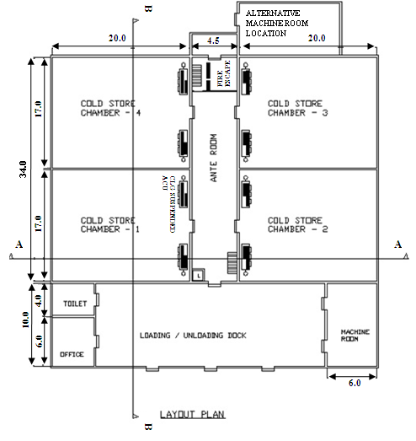

All dimensions in meters.
49

Other ancillary works

- Electrical substation & metering room.
- Underground water storage tank / fire fighting storage tank / overhead tank.
- Drainage lines, storm water drainage & septic tank (if required).
- Fencing & roads.
- Main gate & security cabin.
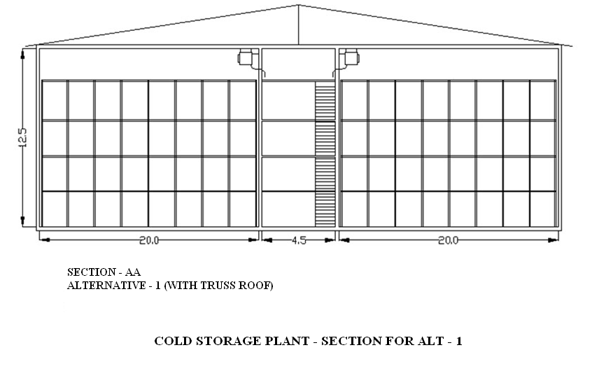

50
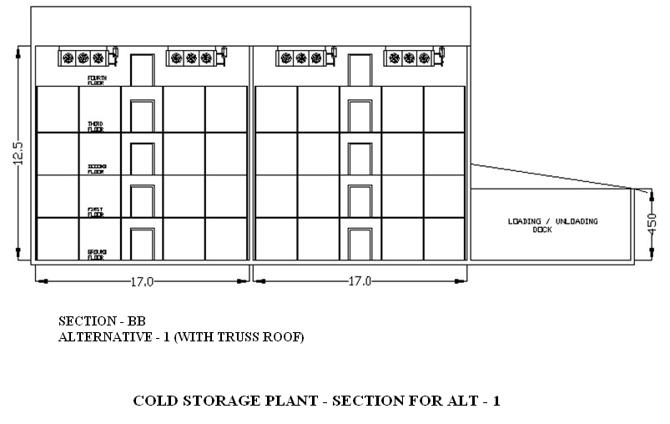

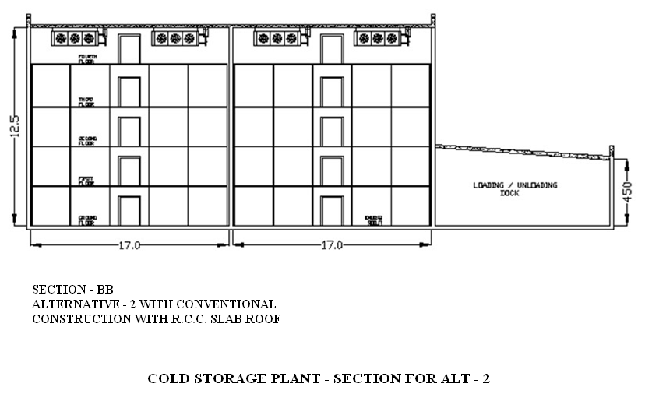
51

- CONSTRUCTION FEATURES

The general norms for conventional construction are as follows:
Foundation: Conventional Foundation / Pile Foundation / Raft Foundation – to be designed by qualified & licensed structural / civil engineer. The design shall meet the relevant seismic zone norms for earthquake proof designs.
Cold Chamber:

Walls 230 mm Brick walls / solid concrete blocks with sand- cement plaster

Roof RCC slabs or Truss Roof with GI / Pre-coated GI Sheet cover. RCC slab to have proper water proofing with reflective colour paint / China mosaic finish. Slab to have proper slope for rain water drainage.
In case of truss roof, provision to be made for fixing insulated panels on the ceiling & supporting of cooling units from the trusses (alternatively cooling units can be supported on floor mounted frame structure on top floor).
Provision for FRP sheets for natural lighting to be made in roof sheeting at certain locations. For ventilation of attic, provision of ridge monitor or turbo ventilators (which require no electric power) can be made. Alternatively roof can also be designed by installing insulated roof panels with proper slope & sealing of longitudinal & lateral joints. The work to be handled by experienced agencies to ensure a trouble free roof structure. The roof may be kept walkable for maintenance.

Floor The floor comprises of base concrete, in cold stores with suitably lower levels in cold chambers. The level difference between cold chambers and ante room to be equal to the thickness of floor insulation plus the layer of PCC or tremix finish.
Inter-floors The basic structure can be RCC columns & beams or steel columns & steel beams
Grating Wooden batten grating or steel grating using flats / square tubes etc. The interfloors have to be designed for a product loading of 900 kg/m² min. Where AC units are located on top floor, the structure has to be suitable for the unit static & dynamic loads.
52

Ante Room This shall be designed to accommodate staircase, electrical hoist cage and have wider doors. Provision for fire escape stair & exits to be made as per local norms. The interfloors in ante room to have doors to each cold room on each floor.
Rooms for machines, Electricals etc.
Dock Loading & unloading dock shall be designed with RCC slab roof or sheet roofing. However the machine roof can have RCC slab-roof to accommodate the evaporative condensers, pump sets, water tank, water softener etc. The dock area to accommodate suitably sized office & toilet for staff & labour.
Strip Curtains To be provided to reduce infiltration during loading/ unloading. Air curtains can also be used although they consume energy.
Ancillaries Underground fresh water storage, storage for fire fighting, water supply & sanitary arrangements, compound wall / fencing, main gate, security, small canteen / electrical sub-station & D.G.set platform, roads & parking place for vehicles etc. Green land scaping with benches for labourers.

- THERMAL INSULATION

Cold chambers have to be insulated on walls, ceilings / roofs & floors with proper insulating material of adequate thickness, with provision for vapour barrier on outer side & proper cladding/ cover on inner side. The commonly insulation materials are:
- Expanded polystyrene
- Rigid Polyurethane foam
- Rigid phenolic foam
- Mineral wool / glass wool
- Extruded polystrene

The ancillary materials to be used include:
- Vapour barrier eg. aluminium foil, polyurethane sheet, with bitumen / cold mastic adhesives
- Teakwood batten pegs, Tees etc.
- G.S. sheet runners (avoid wooden batten runners)
53
- Cladding of profiled / pre-coated G.S. sheets 0.5 / 0.6 mm thick / Fiberglass sheets of suitable thickness

For Conventional Insulation

Walls & Ceiling
  - Primer Coat followed by two layers of bitumen
  - Fixing aluminums foil min. 50 microns
  - Fixing wooden pegs at suitable intervals
  - Fixing two layers of insulation with staggered joints
  - Fixing G.S sheet runners over the pegs in longitudinal & lateral directions
  - Fixing profiled & precoated g.s.sheets, 0.5 / 0.6 mm thick over the runners with proper finishing of joints. Alternatively FRP sheets can be used.

Floor
- Laying of polythene sheet, min. 250 microns, as vapour barrier
- Fixing insulation slabs in two layers with bitumen as adhesive for the first layer
- Covering with tarfelt
- Laying PCC / tremix of 75 mm / 100 mm thickness

For Insulated Panel Structure

Walls & Ceiling
- Perimeter of the plinth to be in level for panel installation
- Panels to have camlock or tongue / grove joints
- Sheetmetal flashing to be provided on all concrete / wall ceiling joints internally & externally. PVC coving or concrete curbing to be provided on wall - floor joints.
- Horizontal Tie bracings to be provided between vertical wall panels & external columns, to take care of wind loads
- Adequate numbers of Pressure relief ports to be provided on all chambers with electrical connection
- Insulated doors shall be suitable for panel mounting

54
Minimum insulation thickness for various insulation materials

Type of insulation | Material |  | Wall |  | Ceiling/ roof  U value = 0.24 W/m²K | Floor  U value = 0.29W/m²K
Type of insulation |  |  | External  U value = 0.27W/m²K | Partition  U value = 0.58W/m²K | Ceiling/ roof  U value = 0.24 W/m²K | Floor  U value = 0.29W/m²K
Type of insulation | ρ Density  Kg/m³ | K (at 10 ⁰C)  W/mK | Thickness  mm | Thickness  mm | Thickness  mm | Thickness  mm
EPS | 15 | 0.036 | 150 | 75 | 150 | 125
PUF | 32 | 0.023 | 100 | 50 | 100 | 100
XPS# | 30-35 | 0.025# | 100 | 50 | 100 | 100
Phenolic foam *** | 50 | 0.026 | 100 | 50 | 125 | 100
Mineral wool *** | 48 | 0.033 | 125 | 50 | 125 | 100
Bonded fibre glass/ glass wool*** | 32 | 0.033 | 125 | 50 | 125 | 100
*** Recommended only with vapour barrier and metal or FRP cladding min 0.5 mm TCT
# Recommended in conformance to ISO/FDIS 4898:2008(E) for properties of XPS used for thermal insulation of buildings, Categories II, III & IV only.
Notes-
- K values from IS661:2000 at 10 °C for all insulation materials except XPS
- K value# in case of XPS is as per ISO/FDIS 4898:2008(E) at 10°C mean/28days minimum
- U values are the recommended heat transmission coefficients for cold storage temperature range -4 to 2°C by IS661:2000
- All values rounded off in multiples of inch (25 mm)

55

- COOLING LOAD CALCULATIONS

Chamber size: 20*17*12.5

Basic Assumptions:

Ambient Conditions : 0.4% annual for Delhi – 42⁰C/ 22.1⁰C
(ASHRAE data) : 0.4% for March in Delhi (for loading period only) – 34.9⁰C/19.9⁰C
Loading period : 20 days
Specific heat of the potato : 3.433kJ/kg
Ventilation air : 4 air changes/ day
Heat of respiration at 3° : 0.018W/kg (Ref. - Ashrae Refrigeration handbook 2006)
(California potato) at 15° : 0.027W/kg.
Occupancy : 4 people working for 12 hours during loading
Lighting load : 1.85 kW for 12 hours during loading period for 4 chambers
Enthalpy wheel for ventilation: 70% energy recovery
Fan load : Estimated based on refrigeration capacity of each
chamber, (Ref. : W.F . Stoecker, Industrial
refrigeration handbook) Front face(40*12.5) orientation of the building assumed to be 60 degree west of south

Insulation U values as per IS 661:2000
Transmission load calculated on the basis of ASHRAE RTS method.
Pull down period : 24 hrs
56

As the loads shown in the tables below are the estimated peak loads based on the above assumptions suitable diversity and safety factors can be used which may change the load values by few kW.

Loading and pull down to 15º C (per chamber)

Load type | Value | Units
 | Maximum load value
Transmission | 8.49 | kW
Ventilation | 1.76 | kW
Product cooling load | 37.25 | kW
Respiration | 33.75 | kW
Occupational load | 0.13 | kW
Lighting | 0.22 | kW
Fan motor | 9.00 | kW
Total | 90.59 | kW
57

Pull down to 3º C (0.5º C per day) (per chamber)

Load type | Max load value | Units
Transmission | 12.35 | kW
Ventilation | 3.58 | kW
Product cooling load | 24.84 | kW
Respiration | 33.75 | kW
Occupational load | 0.00 | kW
Lighting | 0.00 | kW
Fan motor | 9.00 | kW
Total | 83.51 | kW

Hold on at 3° C (per chamber load)

Load type | Load value | Units
Transmission | 12.35 | kW
Ventillation | 3.58 | kW
Product cooling load | 0.00 | kW
Respiration | 22.50 | kW
Occupational load | 0.00 | kW
Lighting | 0.00 | kW
Fan motor | 3.38 | kW
Total | 41.80 | kW
58

Loading and pull down to 15º C
(Assuming March conditions instead of annual design conditions)

Load type | Value | Units
 | Maximum load value
Transmission | 6.30 | kW
Ventilation | 1.22 | kW
Product cooling load | 37.25 | kW
Respiration | 33.75 | kW
Occupational load | 0.13 | kW
Lighting | 0.22 | kW
Fan motor | 9.00 | kW
Total | 87.86 | kW

- TYPICAL SPECIFICATIONS OF REFRIGERATION SYSTEM

- Products that can be stored: Potatoes, Apples, pears for storage above 1⁰C.
- Estimated refrigeration capacity : 340 -370 kW
- Refrigerant : Anhydrous Ammonia
- Gravity feed system

Refrigeration Compressors & Motors
Quantity | 3 Nos each of 50% capacity  (One standby)
Type | Reciprocating, multi cylinder complete with water cooled head / jackets, with accessories like oil separators, capacity control & unloaded start.  Alternatively screw compressor, open type with accessories  59
Capacity at (-) 3 deg C Evaporating & 38 deg C Condensing | 185 to 190 kW
Estimated Motor rating | 55 kW x 1450 RPM, TEFC Sq.cage, class F insulation, suitable for 415 V, 3 ph, 50 c/s. AC supply

Evaporative Condenser
Coil section | Hot dip galvanized M.S. pipes CDW Boiler quality tubes or S.S.304 tubes
Fan section | With 2 / 3 Axial Flow Fans with Cast Aluminium OR S.S impellers, complete with TEFC Sq.cage motors, Class F insulation & IP-55 protection
Water sump tank | S.S.304 or M.S. Epoxy coated with necessary connections
Other provisions | Water spray arrangement, air inlet grilles, eliminators of suitable design
Unit casing | with removable G.S sheet panels & inspection windows etc.
Estimated Heat rejection capacity  at 38 deg C condensing & and applicable WB temp | 480 to 500 kW

H.P. Receiver
Horizontal Ammonia receiver complete | With necessary connections, reflex type level gauge etc.
Capacity | 1500 liters (min)
Material of Construction | Boiler quality steel plates
Quantity | 2 Nos. (Two nos are suggested since some states regulations call for Pressure testing of high pressure vessels on a periodic basis)

Air Cooling Units
60
a) Finned cooling coil | Coil design to be suitable for gravity feed / pump circulation as per design
M.O.C | Hot dip galvanised M.S. pipes CDW Boiler quality tubes or S.S.304 tubes & Aluminium fins with proper bonding system
Fin spacing | 6.25 to 8.5 mm (3-4 FPI)
b) Axial Flow fans | With cast aluminum / S.S. / FRP impellers, with variable pitch, TEFC Squirrel cage motors with class F insulation, IP-55 protection
c) Accumulator | Vertical / horizontal with necessary connections (in case of gravity feed units)
d) Unit casing | G.S. sheet duly painted, drain pan of G.S / M.S with epoxy paint
d) Defrosting arrangement | Water
Unit capacities | 3 nos per chamber
Estimated capacity each at (-) 3 deg C Evaporating & 5 deg C T.D (between evap temp & air entering temp) | 34.5 to 38.3 kW
Estimated coil surface area | 270 to 330m²
Estimated air flow capacity each | 9 to 10 m³ / s
For fruits & Vegetables requiring higher humidities, lower delta T, higher flow rates of air and higher coil surface areas need to be used.
For 1 no. F & V cold store | 3 nos
Estimated capacity each at (-) 2 deg C Evaporating & 4 deg C T.D | 38.3 kW
Estimated coil surface area | 300 to 380 m²
Estimated air flow capacity each | 10 to 12 m³ / s

Refrigerant Piping, Fittings & Valves
Piping  Interconnecting piping between compressor, condenser, receiver and cooling units | M.S. black piping conforming to IS-1239 and other relevant Indian standards  61

Water Piping, Fittings & Valves
Piping shall be used for  a. Condenser water circulation  b. Compressor cooling  c. Defrosting  d. Drain lines | Piping to be G.I class B for sizes up to 65 NB & M.S. black pipe conforming to IS-1239.  Valves up to 40 NB to be Gate / Globe type.  Valves 50 NB / larger to be butterfly type.

Water Pump sets
Water flow capacity to take care of condenser water flow & compressor head / jacket cooling | 2 nos. (one standby)
Capacity | 13 to14 lps

Thermal insulation for refrigerant piping etc.
Material for insulation for refrigerant suction line, accumulators etc. | - EPS pipe section  - PUF pipe section  With 0.6 mm Aluminum or 0.5 mm GI precoated sheet cladding  - Nitrile Rubber / EPDM / pipe section / other acceptable materials with woven glass cloth with UV treated pigmented epoxy Coating

Duct Mouth pieces
To be provided on each fan outlet for uniform distribution of air at the topmost level | GI sheet ducting as per IS 655

62

Ventilation for cold chambers
System to be designed for providing adequate air changes / day | Axial flow / Inline duct fans with cleanable inlet filters, GI sheets / Aluminium / PVC ducting upto cold chambers and ducting for exhaust from cold chambers to outside  Heat exchanger with energy recovery wheel or heat pipe can be used for cooling the incoming air from the exhaust air. Typical efficiencies of heat exchangers are 70% or higher.

Humidification
External humidification for 90 to 95 % RH | Fogger type external humidification system with 2 to 10 micron particles with automatic regulation

Controls
Temperature control | Temp Indicators cum controllers for individual chambers. Temperature scanners and a centralized temperature indication in machine room
RH control | RH indicator & controller
CO₂ control | CO₂ sensors for regulation of ventilation system
Refrigerant flow controls | Liquid level controls, solenoid valves  etc.
PLC control systems | For overall control of various parameters

Installation, Testing & Commissioning
Installation | The plant shall be installed, tested & commissioned as per IS 660.  63

Liquid Overfeed System:
- The above design recommendations are for gravity feed for air cooling units. It is also possible to use pump circulation system (overfeed system) requiring following components :
- Centralized ammonia L.P receiver
- Ammonia pumps – 2 nos
- Refrigerant flow & safety controls
- Interconnecting piping – both supply & return lines shall be insulated

In this case the individual accumulators for AC units & level controls etc. are not required. The coil surface area may be 5 – 10% lower.
- ELECTRICAL INSTALLATION

Substation

Substation with a rating of about 200kW | a. Step down transformer  suitable for incoming H.T. voltage / 433 V as per IS-2026 / other applicable standards  b. Two pole / four pole structure as per local requirements  c. Outdoor type metering cubicle with approved meter, CTs / PTs etc.  d. Earthing station as per requirement  e. Switchyard fencing with gates as per Electrical Board requirements  64

D.G.Set for standby power

D.G.set complete with accessories and with weather-proof and noise-proof canopy as per local pollution control norms | Estimated Rating : 160kW for single  One big and one small can also be used

Main power distribution panel

Main power distribution panel with changeover facility for normal electric supply & D.G.set supply. With ongoing feeders for various electrical panels

Electric panels
Electric panels for | a. Refrigeration  b. Lighting, Electric hoist, Fans  c. APFC (Automatic Power Factor Correction) panel  d. Water supply, fire fighting etc.

Power & Control cabling etc
Power and Control cabling, Earthing etc  for various electrical circuits | Aluminium armoured conductors for main power lines & equipment lines & copper conductors for lighting, control wiring etc.

Lighting
Lighting in  a. cold stores, ante room  b. other areas  c. outside areas | The light fittings should be energy efficient eg. CFL fittings for cold chambers. A central switch may be provided outside each chamber.  65

Electrical hoist
Electric hoist | With wire ropes, steel fabricated cage with guides & openable doors for material movement, product lifting
Capacity | 2 MT of product

- SAFEETY PROVISIONS

Provision for handling accidental leakage of ammonia | Ammonia sensors in cold chambers near ACUs & machine room  Emergency ventilation for machine room  Safety release of refrigerant to water sump  Ammonia masks  First aid kit  Instructions for handling emergencies
Fire protection | Fire sensors in cold chambers  & machine room.  Dry & water based fire fighting systems as per specs below.  Sprinklers for high pressure receivers
Emergency lighting system | May be solar PV cells with batteries & controller
Emergency alarm system | To be provided with switches near all cold store doors and alarms located in common public areas
Lightning arrestors for the building as per local regulations
66

Fire Fighting
- Dry Type

Fire fighting equipment necessary for  extinguishing liquid, solid and electrical fire : | i) Dry chemical powder type 5.0 Kg  Cap with ISI Mark Fire Extinguisher  complete with wall mounting  bracket.  ii) Carbon Di-Oxide (CO₂) type 4.5 Kg.  capacity Fire Extinguisher complete  with wall mounting bracket.  iii') G.I. Fire Buckets  iv) M.S. Stand for Fire Buckets

- Water based
System shall comprise of | i) 2 sets of Water supply pumps.  ii) 2 sets Fire fighting pumps  iii) G.I.piping, class C with necessary fittings & valves  iv) Rubber Hose reel  v) Canvas Hose pipe  vi) M.S.Fabricated hose box with key
67
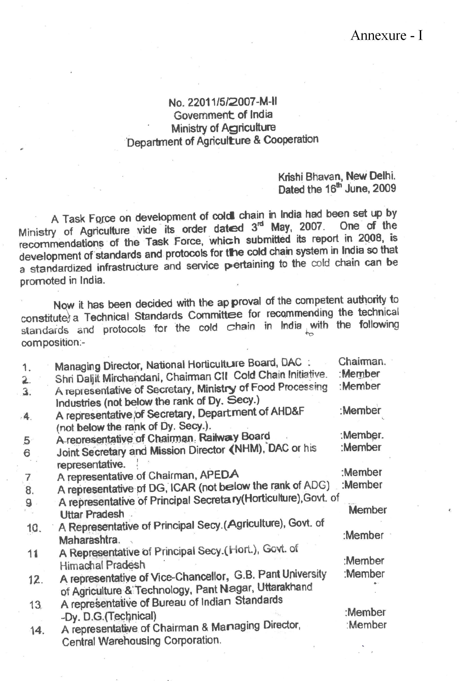
68
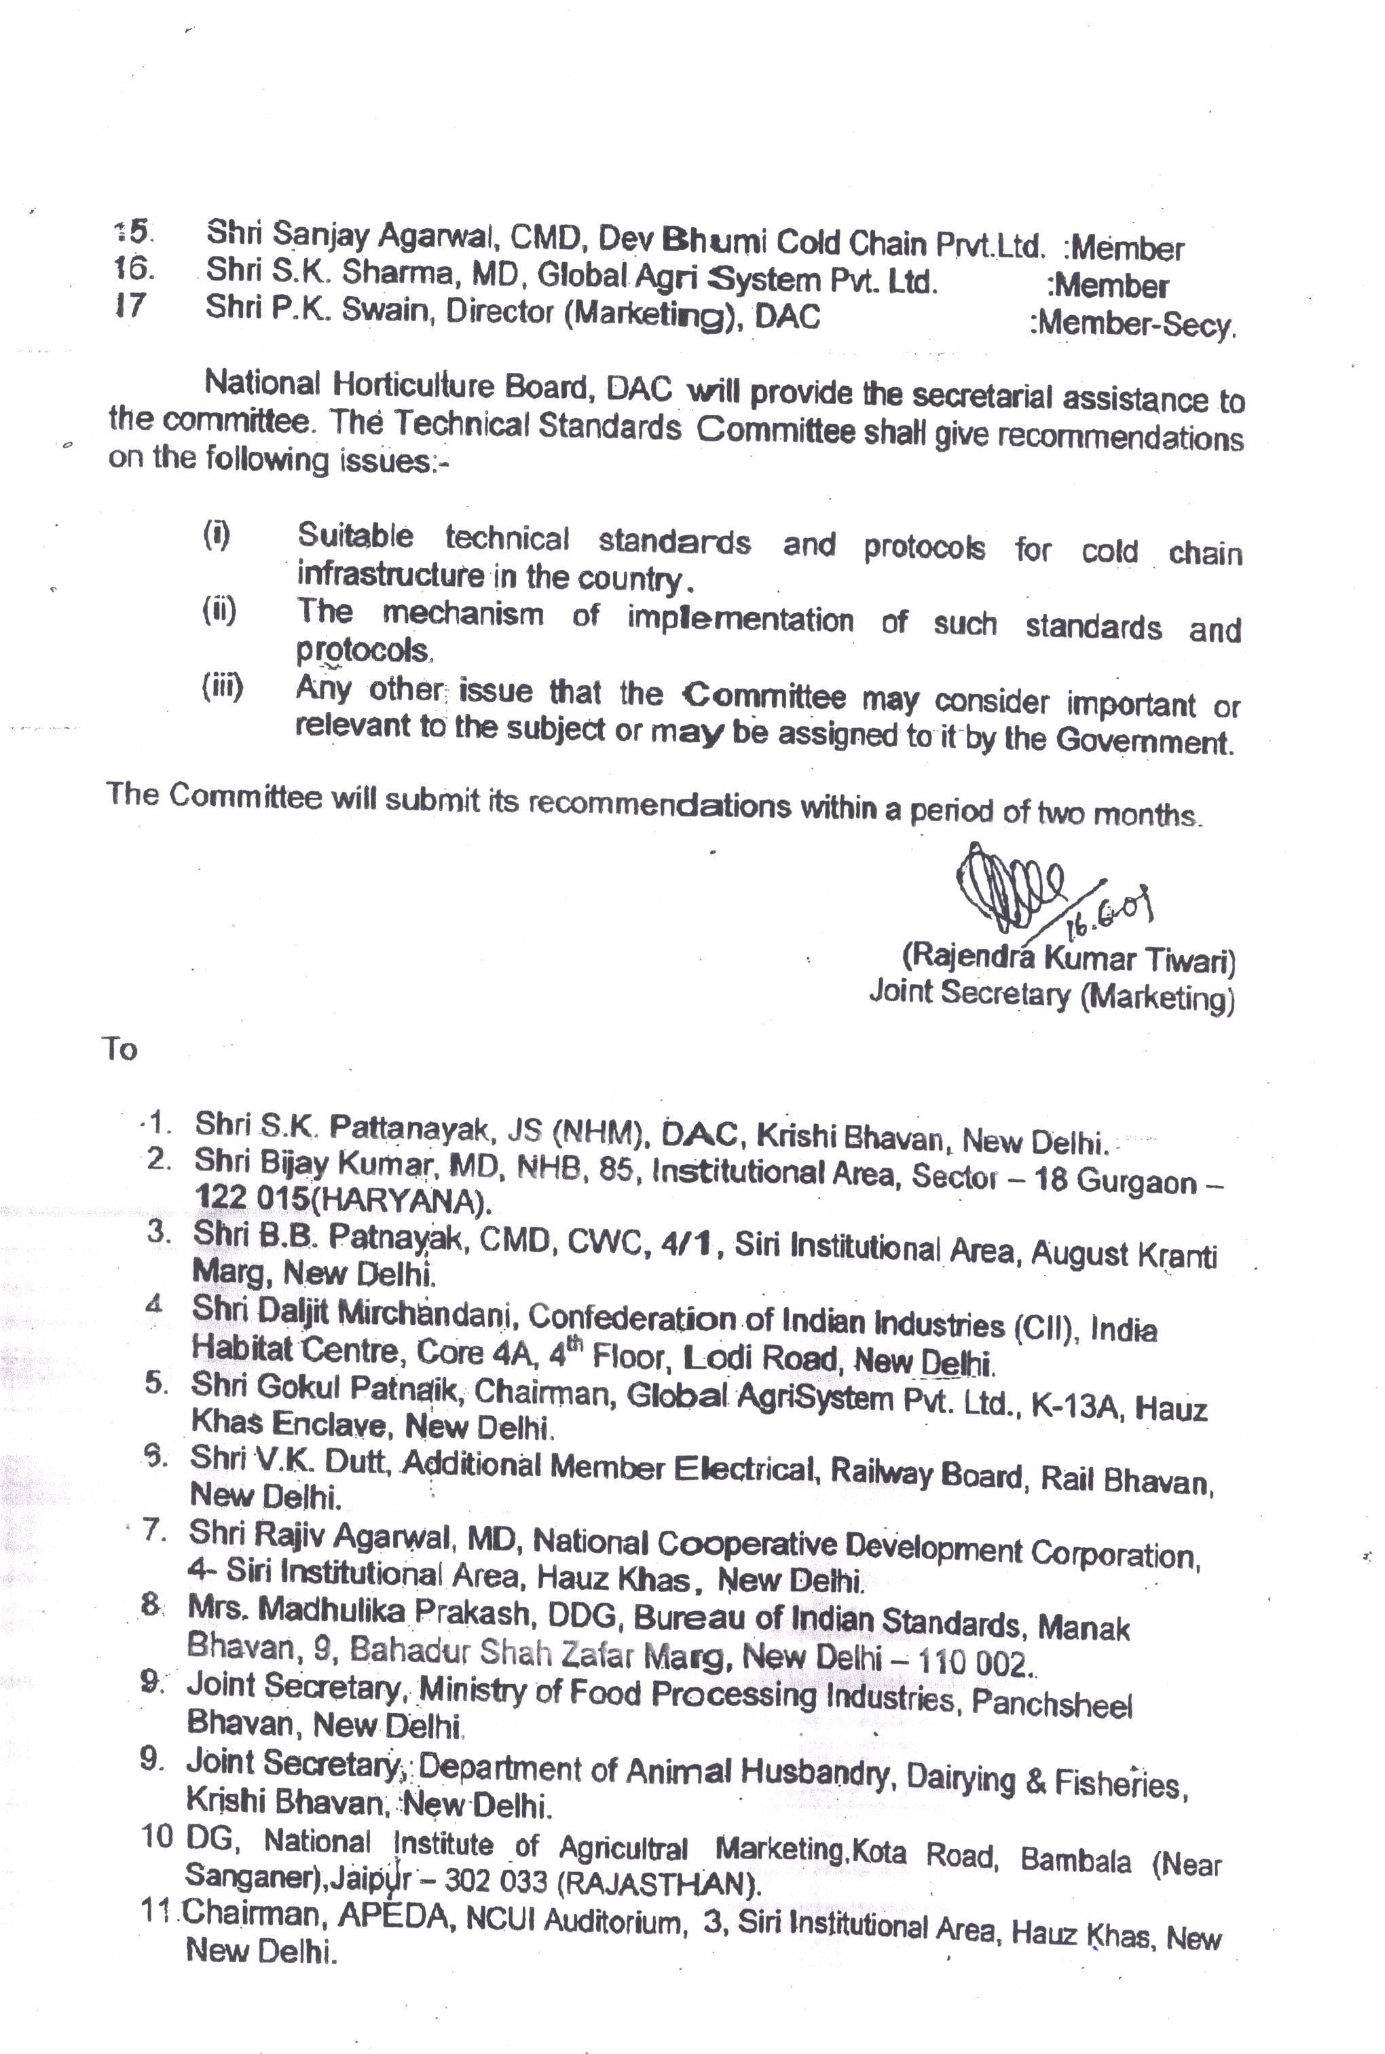
69
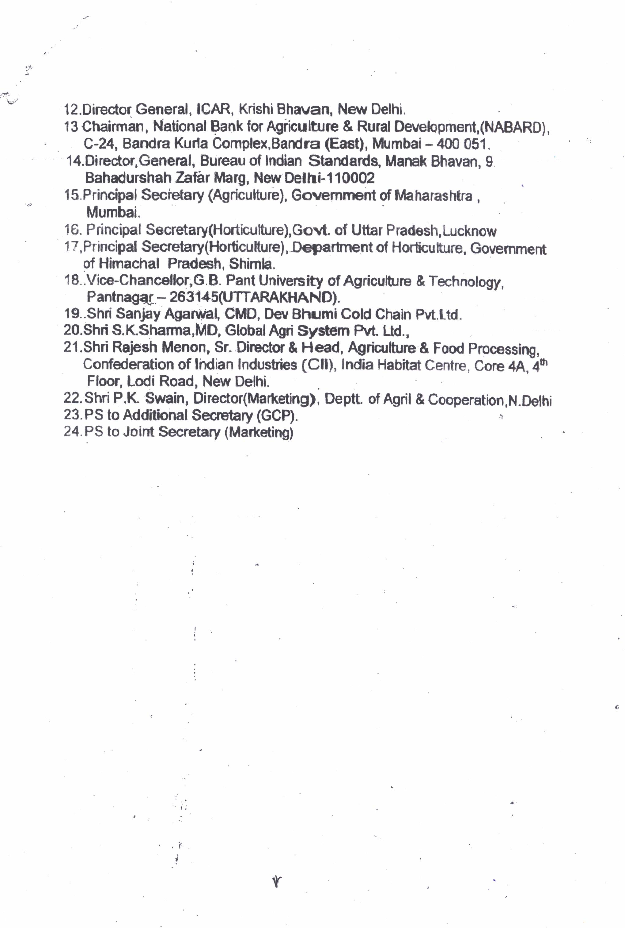
70
Annexure - II
Technical Standards Committee Experts

- Sh. Bijay Kumar, Managing Director, National Horticulture Board, Ministry of Agriculture, Govt. of India, Plot No. 85, Institutional Area, Sector-18, Gurgaon-122 015 (Haryana)
- Sh.D.L.Mirchandani, Chairman, Confederation of Indian Industry (CII)
India Habitat Centre, Core 4A, 4th Floor, Lodi Road, New Delhi - 110 003 (INDIA)
- Sh. R. Vaithiyanathan, Deputy Director, Confederation of Indian Industry (CII), India Habitat Centre, Core 4A, 4th Floor, Lodi Road, New Delhi - 110 003 (INDIA)
- Sh. Gurmit Singh, Managing Director, M/s Walco Engineering Ltd., 7/15, Kirti Nagar, Industrial Area, New Delhi-110 015 (and Chairman of CII, Technical Standards Committee).
- Sh. Zafar Ansari, Vice President Marketing & Sales, Dow Chemical International Pvt. Ltd. Corporate Park, Unit No. 1, V.N. Purav Marg, Chembur, Mumbai – 400 071
- Mr. J. M. Gupta, Managing Director, JBM engineering Pvt. Ltd., A-1/296, 3rd Floor, Janak Puri, New Delhi -110 058
- Sh. K.K. Mitra, Sr. General Manager Marketing & Technical, Lloyd Insulation Pvt. Ltd., Punj Star Premises, 2, Kalkaji, Industrial Area, Opposite Chandiwala Estate, New Delhi – 110 009
- Sh. S.K. Sharma, Global Agri Systems Pvt. Ltd. K-13A, Hauz Khas Enclave, New Delhi-110 016
- Sh. Arvind Surange, ACR-Project Consultant, H.O. Vijay Apts., 39/35 Erandavana, Pune-411 004 (Maharashtra)
- Sh. Kumar Aggarwal, Dev Bhumi Cold Chain Pvt. Ltd., 17 & 18, Azadpur, New Subzi Mandi Delhi-110 033
- Sh. Anil Dwivedi, Dev Bhumi Cold Chain Pvt. Ltd., 17 & 18, Azadpur, New Subzi Mandi, Delhi-110 033
- Mr.Rahul Sood, The Supreme Industries Limited, 26, Deepak Building, 13, Nehru Place, New Delhi-110019.
- Sh. B.K. Sikka, Dean, College Of Agribusiness Management, G. B. Pant University of Agriculture and Technology, Pantnagar – 263145, Uttaranchal (India)
- Sh. Samur Pandita, Assistant Energy Economist, Bureau of Energy Efficiency, New Delhi-110 066
- Sanjeev Jain, Prof., IIT, Houz Khas, New Delhi
- Sh. N.S. Ranawat, Deputy Director, National Institute of Agricultural Marketing, (Ministry of Agriculture, Government of India), Kota Road, Bambala, Sanganer, Jaipur – 303906
71
- Sh. Ajay Kumar Lal, Bureau of Indian Standards, Manak Bhavan, 9 Bahadur Shah Zafar Marg, New Delhi – 110002
- Sh. A.K. Saini, Head Civil Engg. Department, Bureau of Indian Standards Manak Bhavan, 9 Bahadur Shah Zafar Marg, New Delhi – 110002
- Sh. C.K. Veda, Bureau of Indian Standards Manak Bhavan, 9 Bahadur Shah Zafar Marg, New Delhi – 110002
- Sh. E. Devendar, Bureau of Indian Standards, Manak Bhavan, 9 Bahadur Shah Zafar Marg, New Delhi – 110002
- Sh. K.K. Paul, Sc. E.(Chemicals), Bureau of Indian Standards, Manak Bhavan, 9 Bahadur Shah Zafar Marg, New Delhi – 110002
- Sh. Har Pal Singh, Deputy General Manager, Agricultural and Processed Food Products Export Development Authority (APEDA), 3rd Floor, NCUI Building, 3 Siri Institutional Area, August Kranti Marg, New Delhi-110016.
- Sh. R.K. Boyal, General Manager, Agricultural and Processed Food Products Export Development Authority (APEDA), 3rd Floor, NCUI Building, 3 Siri Institutional Area, August Kranti Marg, New Delhi-110016.
- Sh. R.V. Dave, Assistant General Manager, (Investment Credit Department) ,National Bank for Agriculture and Rural Development, (NABARD), 3rd floor, A & B Wing, C-24, “G” Block, Bandra Kurla Complex, Bandra (East), Mumbai-400051.
- Sh. P. Saxena, Executive Director, National Cooperative Development Corporation (NCDC), 4 Siri Institutional Area, Hauz Khas, New Delhi-110016.
- Sh. H.P.Verma, National Cooperative Development Corporation (NCDC), 4 Siri Institutional Area, Hauz Khas, New Delhi-110016.
- Dr. R.K. Sharma, Sr. Deputy Director, National Horticulture Board, Ministry of Agriculture, Govt. of India, Plot No. 85, Institutional Area, Sector-18, Gurgaon-122 015 (Haryana)
- Sh. P. K. Swain, Director (Marketing), Department of Agriculture, Ministry of Agriculture, Govt. of India, Krishi Bhawan, New Delhi
72
Annexure – III
List of Relevant BIS and Other Standards

The Codes and Standards listed in this annexure represent practices and methods published by Bureau of Indian Standards (BIS) and other International Organizations applying to design and construction of Cold Stores, Pack House, Ripening Chambers, and Food Processing Facilities etc. They are valuable guides for the practicing engineer in determining test methods, rating, performance requirement and limits applying to design construction and equipments used.
The codes and standards listed are intended to serve as minimum requirement, and are not to be construed as limiting good practice. Wherever IS-Code is not available, relevant standard codes of ASME / ASHRAE / IIAR or other International Codes are to be followed. Latest revisions will be followed in all cases.
The responsibility for deciding whether other requirements additional to the ones listed in this document are necessary to ensure system integrity, efficiency and overall safety, including operation, maintenance and servicing and/or the necessity to adopt additional requirements in the system design and construction to guarantee the overall performance, still rests with the supplier / manufacturer. The suppliers / manufacturers shall furnish to the owner copies of instruction manual which shall include operation & maintenance instruction, as built drawings, wiring diagrams, recommended spare parts and replacement part list.
The suppliers / manufacturers shall provide training for the plant and machinery installed including safety and emergency procedures. The supplier /manufacturer will follow all practices set forth by “good manufacturing practices” by various applicable Codes and Standards listed in this document and shall fully certify the equipment, plant and machinery supplied / installed in compliance to the relevant codes and standards.
Where there is a requirement for deviation, the difference(s) must be brought to the intention of the regularity body and the customer in writing.
All “exceptions/deviations” to the codes and standards for the plant and machinery including civil works and design shall be identified and detailed in the proposal / bid documents to the customers /owner and his specific approval in writing will be taken before commencement of supply/work.
The supplier / manufacturer/contractor should be fully aware of all details in his scope etc, and it is imperative that all work performed shall be done by personnel trained and skilled in the installation of plant and machinery.
73

CODES AND STANDARDS

- Electrical
Bureau of Indian Standards (BIS)

S. No. | Title | Reference
1. | PVC Insulated cables (light duty) for working voltage up to 1100 volts | IS 694-1977  Part I & II
2. | PVC Insulated cables (heavy duty) for working voltage up to 1100 volts | IS 1554-1976  Part-I
3. | PVC Insulated cables for voltage 3.3 KV to 11 KV | IS 1554-1976  Part-II
4. | Specification of Polyurethane insulated PVC sheeted heavy duty electrical cables, voltage not exceeding 1100 V | IS 5959-1970  Part-I
5. | Specification of Polyurethane insulated PVC sheeted heavy duty electrical cables, voltage 3.3 KV to 11 KV | IS 5959-1970  Part-II
6. | Guide for making of insulated conductors | IS 5578-1970
7. | Code of practice for installation and maintenance of paper insulated power cables | IS 1255-1967
8. | Code of practice for earthling | IS 3043-1966
9. | Guide of practice for installation and maintenance of induction motors | IS 5216-1969
10. | Code of practice for installation and maintenance of AC induction motor starters | IS 5214-1969  74
11. | Code of practice for installation and maintenance of AC induction motors | IS 900-1965
12. | Code of practice for installation and maintenance of switchgears | IS 372-1975
13. | Code of practice for installation and maintenance of transformers | IS 1886-1967
14. | Code of practice for electrical wiring installation, voltage not exceeding 650 V | IS 732-1963
15. | Code of practice for electrical wiring installation (system voltage exceeding 650 V) | IS 2274-1963
16. | Guide for testing three-phase induction Motor | IS 4029-1967
17. | Three Phase induction Motors | IS 325
18. | Electrical measuring instruments and there accessories | IS 248
19. | Current transformers | IS 2705
20 | Dimensions of slide rails of electric motors | IS 2968
21. | Flexible Steel conduits for electric wiring | IS 3480
22. | Air-Break Switches | IS 4064
23. | Motor Starters for voltage not exceeding 1000 Volts | IS 8544
24. | Conduits for electrical installation | IS 9537
25. | Selection, installation & maintenance of  Transformers | IS 10028
26. | Selection, installation & maintenance of switch gear and control gear | IS 10118
27. | National Electrical Codes | SP: 30
28. | Self blasted lamps for general lighting service | IS 15111 Part 1 and 2

75

- Mechanical
Bureau of Indian Standards (BIS)

S. No. | Title | Reference
1. | Safety cods for Mechanical Refrigeration | IS 660
2. | Code of practice for thermal insulation of cold storages | IS 661
3. | Code of practice for application of polyurethane insulation by in-situ pouring method | IS 13205
4. | Rigid phenolic foams for thermal insulation | IS 13204
5. | Application for spray applied insulation code of practice – Polyurethane / Poly-isocyanurate | IS 12432  Part-III
6. | Specifications for preformed rigid polyurethane (Pur) and poly isocyanurate (Pir) foams for thermal insulation | IS 12436
7. | Expanded polystyrene for thermal insulation | IS 4671
8. | Code for practice for fire safety of industrial buildings: General Storage and warehousing including cold storage | IS 3594
9. | Anhydrous ammonia | IS 662
10. | Industrial Bitumen | IS 702
11. | Gunmetal gate, globe and check valve for general purpose | IS 778
12. | Ball Valves including floats for water supply purposes | IS 1703
13. | Mild Steel Tubes, tubular and other wrought steel pipes fittings | IS 1239
14. | Steel Plates for pressure vessels used at moderate and low temperature | IS 2041  76
15. | Color code for identification of pipe lines | IS 2379
16. | V-belts for industrial purposes | IS 2494
17. | Hot dip galvanizing of iron and steel | IS 2629
18. | Code for unfired pressure vessels | IS 2825
19. | Glossary of terms for safety and relief valves | IS 3233
20 | Steel for pressure vessels and welded structures | IS 3503
21. | Steel tubes for mechanical and general engineering purposes | IS 3601
22. | Steel for general structural purposes | IS 2062
23. | Steel tubes for structural purposes | IS 1161
24. | Specifications for steel doors, windows and ventilators | IS 1038
25. | Code of practice for design loads (other than earthquake) for building and structures | IS 875  Part I to V
26. | Criteria for earthquake resistant design of Structures | IS 1893
27. | Specifications for cold formed light gauge structural steel sections | IS 811
28. | Code of practice for use of Steel Tubes in general building construction | IS 806
29. | Code of practice for use of cold form light gauge steel structural members in general building construction | IS 801
30. | Code of practice for general construction in steel | IS 800
31. | Glossary of terms used in refrigeration and air-conditioning | IS 3615
32. | Pressure and vacuum gauges | IS 3624
33. | Safety Codes for scaffolds and ladders | IS 3696
34. | Formed ends for tanks and pressure vessels | IS 4049  77
35. | Shell an tube type heat exchangers | IS 4503
36. | Code of safety for ammonia | IS 4544
37. | Expanded polystyrene for thermal insulation purposes | IS 4671
38. | Hot-dip Zinc coating on steel tubes | IS 4736
39. | Units and symbol for refrigeration | IS 4831
40. | HDPE pipes for potable water supplies, sewage and industrial effluents | IS 4984
41. | Gauge glasses | IS 5428
42. | Specification for sprayed aluminum and zinc coating on iron and steel surfaces | IS 5905
43. | Steel Pipe flanges | IS 6392
44. | Injection molded HDPE fittings for portable water supplies | IS 8008
45. | Vertical steel ladders | IS 8172
46. | Treatment of water for industrial cooling systems | IS 8188
47. | Nominal sizes of valves | IS 9520
48. | Selection, use and maintenance of respiratory protective devices | IS 9623
49. | Polythene floats for ball valves | IS 9762
50. | General purpose ball valves | IS 9890
51. | SI units | IS 10005
52. | Recommendations for general pipeline welding | IS 10234
53. | Ammonia valves | IS 11132
54. | Finned type heat exchanger for room air conditioner | IS 11329
55. | Refrigeration oil separators | IS 11330
56. | MS tubes for vertical condenser | BS 3059  78
57. | Specification for metal air duct | IS 655
58. | Specification for galvanized steel sheet | IS 227
59. | Specifications for Performed Rigid Polyurethane | IS 12436 -1988
60. | Glossary of Terms used in Refrigeration& Air conditioning | IS 3615: 2007
61. | Code of Practice for Fire Safety of Ware housing including cold storages | As per Relevant IS specification
62. | Food Hygiene – General Principle – Code of Practice | IS 2491-1998

- Publication by International Societies and Associations
Pre Engineered Building
S. no. | Title | Reference
1. | Building Code | IBC 2006
2. | Design Code | AISC 2005
3. | Tolerance Code | MBMA 2002
4. | Purlin Code | AISI 2001
5. | Welding Code | ANS 2006
6. | Wind Load & Seismic Load | IS 875 & IS A893-2002& Relevant Codes

- European Organization for Technical Approvals (EOTA)

S. no. | Title | Reference
1. | External Thermal Insulation Composite Systems with Rendering | ETAG 004  79
2. | Cold Storage Premises Kits Part-1: Cold Storage Room Kits | ETAG 21
3. | Cold Storage Premises Kits Part-2: Cold Storage Building Envelope and building its | ETAG 021

American Society of Heating, Refrigeration and Air Condition Engineers, Inc -ASHRAE
Refer to REFRIGERATION - Systems and Applications, Handbook
Chapter – 51 Codes and Standards.
Other Standards and References
There is sufficient data available on design of energy efficient cold stores and commercial storage practices of fresh fruits and vegetables and other perishable commodities from various publications by organizations such as:
- International Association of Refrigerated Warehouses (IARW) and World Food Logistics Organizations,
- Commodity Storage Manual
- Crisis Management Manual
- Guide to Effective Ware House Operations
- Maintenance and Modernization Manual

- American Society of Heating, Refrigeration and Air Condition Engineers, Inc -ASHRAE Handbooks

- REFRIGERATION – Systems & Applications
- FUNDAMENTALS
- HVAC Systems and Equipment
- HVAC Applications

- The International Institute of Refrigeration (IIR),
- International Institute of Ammonia Refrigeration (IIAR),
- United States Department of Agriculture (USDA),
- Post-harvest Technology-Research & Information Center UC DAVIC

80

