Technical Standards and Protocol for the Cold Chain in India

Cold Storage
For
Fresh Horticulture Produce Requiring Pre-cooling Before Storage

(Technical Standards Number NHB-CS-Type 02-2010)

National Horticulture Board
(Department of Agriculture & Cooperation,
Ministry of Agriculture, Govt. of India)
85, Institutional Area, Sector18, Gurgaon-122 015
(Haryana)

CONTENT
Sr. No. | Description | Page No.
 | Preface | i-iii
 | Section 1. Technical Standards | 1-23
 | Section 2. Basic Data Sheet | 24-35
 | Section 3. Protocol for Implementation of Technical Standards | 36
 | Annexure-I | 37-39
 | Annexure-II | 40-42
 | Annexure-III | 43-52

Preface

A Task Force on development of cold chain in India had been set up by the Ministry of Agriculture vide its order dated 3rd May 2007. The said Task Force had recommended revised normative cost for cold storages and subsidy norms for ensuring technology up gradation in cold storages. It has, therefore, been felt necessary to define appropriate technical standards in respect of various components of cold storages without which exercise of quantification of revised normative cost, subsidy norms etc cannot be substantiated; nor can the desired results of effecting technology up gradation be achieved. Therefore, Department of Agriculture & Cooperation, Ministry of Agriculture, Government of India, vide its communication No. 22011/5/2007-M-II dated 16th June 2009 constituted a Technical Standards Committee. Terms of Reference of the Technical Standards Committee (TSC) is to give recommendations on the following issues-

- Suitable technical standards and protocols for cold chain infrastructure in the Country
- The mechanism of implementation of such standards and protocols
- Any other issue that the Committee may consider important or relevant for the subject or may be assigned to it by the Government.

The Committee was given initial time frame of two months for submitting its recommendations. However, extension up to end of November 2009 was formally granted at a later stage.

The TSC has classified cold storages for fruits & vegetables in following three main categories as listed below and is hereby, submitting technical standards etc in respect of the second one of them.

Categories of Cold Storage taken up for determining technical standards

- Cold storages for storage of fresh horticulture products which do not require pre-cooling
- Multi-commodity Cold storages for short term and long term storage of fresh horticulture products which require pre-cooling and varying storage requirements
- Control Atmosphere (CA) Storages

These Standards cover Cold Storage of Type-(ii) mentioned above and have three sections viz. Technical Standards, Basic Data Sheet and Protocol for Implementation of the Prescribed Technical Standards. While firming up its recommendations by TSC, emphasis is laid on optimum energy efficiency and overall performance and therefore coefficient of performance (CoP) is one of the determining criteria. In addition, aspects of environmental and safety concerns and Human Resource Development too have been taken in to account.
i
The Technical Standards have general information on the type of produce that can be stored in particular Type / module, their critical storage conditions, (as much compatible with the World standards as possible by relying on Word Food Logistic Organisation (WFLO) database in absence of research data for Indian conditions) in terms of temperature, humidity range, CO₂ level, loading rate, pull down time, air circulation and ventilation requirement etc. In order to facilitate improved design, there is a detailed Basic Data Sheet available in the Section 2 of the Standards wherein plotting different specification data into a system shall lead to better coefficient of performance from energy efficiency point of view. Section 3 deals with the Protocol for Implementation of Technical Standards, probably through Letter of Intent (LoI), and system analysis of civil structure, thermal insulation and refrigeration.

These standards and recommendations are intended to serve as minimum requirement, and are not to be construed as limiting good practice. Wherever IS-Code is not available, relevant standard codes of ISO / ASME / ASHRAE / IIAR or other International Codes have been followed. The responsibility for deciding whether other requirements additional to the ones listed in the technical standard document are necessary to ensure system integrity, efficiency and overall safety, including operation, maintenance and servicing and/or the necessity to adopt additional requirements in the system design and construction to guarantee the overall performance, still rests with the supplier / manufacturer.

It is recommended that the suppliers / manufacturers shall furnish to the owner copies of instructions / manual which shall include operation & maintenance instruction, built drawings, wiring diagrams, recommended spare parts and replacement part list etc as recommended. It is also envisaged that the suppliers / manufacturers shall provide training for the plant and machinery installed including safety and emergency procedures. The supplier /manufacturer will follow all practices set forth by “Good Manufacturing Practices” by various applicable Codes and Standards listed in this document and shall fully certify the equipment, plant and machinery supplied / installed in compliance to the relevant codes and standards.

Nonetheless, these also have provision for scope of variation, through a Variation and Amendment Clause, to take care of new concepts, innovations, and R&D in building design etc. so that improvements coming along the way are not stopped but analysed and incorporated in the design.

The notification constituting Technical Standards Committee is given in Annexure-I.

The Committee acknowledges the valuable contribution made by experts in firming up its recommendations whose particulars are listed in Annexure-II to the report; the list has special mention of non-member experts who have volunteered and spared their valuable time in giving their inputs from time to time. In the end, Annexure III lists relevant BIS and other standards to which investors, contractors and suppliers may refer to comply with the requirements for designing and installing various components.
ii
TSC gratefully acknowledges USDA Office of Transportation, Agricultural for referring to grouping of fresh fruits & vegetables prescribed by its Hand Book in the prescribed Technical Standards (Source: McGregor, B.M. 1989. Tropical Products Transport Handbook- USDA Office of Transportation, Agricultural Handbook 668).

Last but not the least, contribution made by Dr. R. K. Sharma - Senior Deputy Director NHB has been of immense value as he for all practical purposes functioned as Member- Secretary to the Committee.

(Bijay Kumar)
Chairman, TSC and Managing Director
National Horticulture Board
Dated- February 3, 2010 (Ministry of Agriculture, Govt. of India)

iii

iii

SECTION 1

Technical Standards

Section-1
Technical Standard for Cold Storage for Fruits and Vegetables requiring Pre-cooling before storage

Cold Storage Type – these type of cold stores are meant for storing different types fresh fruits and vegetables and other horticulture products which require pre-cooling or rapid room cooling to “seven-eighth-cooling” in a short time period of 4 hours to 24 hours depending on requirements in order to preserve there freshness, quality and self life. The 7/8 cooling time is the time needed for the product temperature to drop by “seven-eighths” of the difference between the initial product temperature at the time of loading and the temperature of the cooling air circulating in the cold rooms. In case of room cooling the fresh produce can be cooled and stored in the same room without the need of transfer but it requires that the rooms are properly designed with adequate refrigeration, air circulation and most importantly proper stacking and storage arrangement. However for much faster method of pre-cooling, in case the field heat is required to be removed from the fresh produce within 4 to 6 hours, forced-air cooling is adaptable to a wide range of commodity. This allows the cold air to be in direct contract with the warm produce by moving it through the produce rather than around the containers.

Multi commodity cold stores are provided with multiple chambers enabling them to store a wide range of fresh horticulture products together with respect to there storage compability requirements for temperature, relative humidity, atmosphere, protection from odour and sensitivity to other gases like ethylene. The refrigeration system is designed to adjust and operate to a range of temperature and humidity conditions, depending on the compatibility group for storage of fruits and vegetables

Efficiency and performance in such cold stores is linked to appropriate storage systems which greatly optimize space, allows uniform air circulation through the produce and meets the fundamental requirements of stock rotation which is time sensitive due to limited shelf life. This becomes more important for the cold stores being set up for the retail trade, export and food processing industry.

- General recommendations about pre-cooling

For most fresh horticulture commodities, one hour time loss at the field temperature of 35°C between harvest and pre-cooling can reduce quality as much as 20 hrs in storage under proper conditions. Delay in pre-cooling results in loss of moisture from the produce causes weight loss and combined with active micro-biological organisms result in deterioration of quality and value loss.

The design of the multi-commodity cold store facility and method of pre-cooling depends on various factors like nature of product, category and product type which determines the period of storage for example short term storage (generally refer to as 7 to 10 days storage) or long/medium term storage. Handling, stacking and storage methods, packaging, frequency of entry and exists are also key deciding factors. The requirements of pre-cooling fruits and vegetables are generally classified as under:
1

(i). Fruits and vegetables which require on farm pre-cooling if transport time to reach them to cold storage is more than a few hours. It is desirable that fresh produce like grapes, mandarins, berries, cherries, leeches, melons, stone fruits, sapotas, okra, tomatoes, capsicum, chilli peppers, brinjal, cucumbers, green beans, peas, spinach should be cooled as rapidly as possible.

(ii). Less perishable fruits & vegetables such as mangoes, papaya, guava, green bananas, pomegranates, radish, cabbage, cauliflower and carrot can be transported from the field and pre-cooled at the cold storage facility.

- Critical Storage conditions and Grouping of Products

- Pre-cooling- Pre-cooling requirements vary based on produce and method of cooling such as room cool, hydro cool, forced air cooling, evaporative forced air cooling and ice packaging. However, forced air cooling within 4-6 hours is adoptable to a wider range of commodities than any other pre-cooling method and may suffice for most of the produce and therefore, it is taken for recommending general technical standards for pre-cooling system. General recommendations in this regard for 7/8 cool for selected fruits are as follows-

Most Appropriate Method of Pre-cooling-
Fruit | Room Cool  1+ days | Hydro cooling  30 minutes to 1 hour | Forced Air  2-6 hours | Evaporative Forced Air  2-6 hours | Package Ice
Apples | x | x | x
Pears | x | x | x
Mangoes |  | x | x | x
Citrus | x (excluding mandarins) |  | X mandarins
Grapes |  |  | x
Lychees |  |  | x | x
Melons | Water melons only |  | x | x | Cantaloupes only
Cherries |  |  | x
Bananas |  |  | x | x
Papayas |  |  | x | x

- Quality of produce – Produce should be mature with required firmness and free from bruises and other external damages. Therefore, for good keeping quality, fresh produce should be carefully handled in all operations including picking, grading and packaging.
2

- Commodity Storage Conditions- For designing a cold storage, product storage conditions must be defined in terms of critical storage conditions of temperature, relative humidity, presence of CO₂, ethylene, air circulation, light etc. In absence of research data for Indian conditions, it is recommended to adopt commodity storage conditions as prescribed by Commodity Storage Manual of WFLO.

      - Temperature range: The temperature in the multi commodity cold store chambers should be kept within + 1⁰ C of the recommend temperature of the produce being stored. For storing at temperatures close to freezing point of the commodity, for increasing storage life, even a narrow range may be needed.

      - Humidity range: The humidity (RH) is again dependent on the produce storage requirements and may vary from 95% to 98% RH in case of fresh fruits and vegetables like grapes, kiwi fruit, carrots, cabbage etc and lower in the range of 65% - 75% RH in case of onion and garlic.

      - CO₂ level – not more than 4000 PPM during loading and 2000 PPM during holding. (Source – Industry)

However if the cold store chambers is being used for Modified Atmosphere Storage for selective commodities like apples etc, the levels of CO2 & O2 should be maintained and regulated as recommended in the Commodity Storage Manual of WFLO.

d. Loading Rate- Generally the refrigeration system capacity is based on 4% to 5% loading rates of the total cold store capacity. The loading pattern is also a design consideration for sizing the storage chamber capacity for optimal utilization and performance.

In case separate pre-cooling chambers are provided in the multi commodity storage facility, the load per batch is to be considered along-with initial and final desired product temperature, pull down rate etc while sizing the pre-cooling chambers and the refrigeration requirements.

- Pre-cooling Time- 4-6 hours for pre-cooling to 7/8th cooling time as recommended for majority of fresh fruits and vegetables. However, in case of fresh produce like carrots, apples etc meant for long/medium term storage, which are directly cooled and stored in the cold rooms, the cooling period, can be up-to 20 hrs per day and should meet the requirements specified in the commodity storage manuals.

f. Air Circulation- Multi Commodity stores should be design to provide an air flow of 170 CMH per metric ton of product, based on maximum amount of product that can be stored in each chamber. This is essential for rapid cooling of the produce. However the system should be designed to reduce air flow to 34 to 68 CMH per metric ton of product after the produce has reached the storage temperature. This is achieved by variable frequency drive and control system to automatically maintain the temperature variation within each chamber at less than + 1°C through out the storage period. In case the fresh produce is pre-cooled in a separate pre-cooling chamber before loading and storage in the main cold store chambers, the air flow requirements may range from 67 CMH to 100 CMH.
3
3

g. Stacking – During room cooling, cold air from the coils flows past the produce stored in crates/pallet racks/bins thereby removing the product heat. For best result the pallets/crates/ boxes/bins should be stacked so that the moving air can contact all the container surfaces for adequate and rapid cooling. Well ventilated boxes/crates with vent alignment should be considered as they great speed-up the cooling rate by allowing the cooling air to uniformly flow. It is recommended that the storage pallets must be stacked to form air channels 4 to 6 inches wide to direct air movement. They should also be space between the product and walls to allow refrigerated air to absorb the heat of conduction through the walls. Since, air takes the path of least resistant, in proper stacking in hips or partly filled rooms have poor air distribution and effect the cooling rate.

It is therefore recommended that such multi commodity cold store chambers / facility are designed for storage in PVC crates, bins and ventilated card board boxes stacked in pallet frames. However commodities which do not require rapid cooling like onion, garlic, potatoes etc may be stored in jute / nylon net bags, stacked in pallet frame. The pallets are required to be handled with fork lift / stackers. Generally steel pallet frame are of size 1200mm x 1000 mm x 1600 mm high suitable for holding crates and boxes and can be easily stacked up to 4 high. Some times pallets frame of size 1300mm x 1000mm x 1800mm are preferred for storing in 50 kgs bag of potatoes / onion/ garlic for optimal utilization. Generally each pallet frame can hold upto 1000 kg produce

g. Ventilation requirements in the cold store chambers- it may range between 2 to 6 air changes per day to maintain CO2 less than 4000 ppm .

h. Lighting Condition- Dark

i. Application of Smart Fresh -

4

3. Compatibility groups for storage of fruits and vegetables – In absence of our own R & D data in this regard, we adopt recommendations made by USDA office of transportation and fresh fruits and vegetables are grouped in seven distinct groups (Source: McGregor, B.M. 1989. Tropical Products Transport Handbook. USDA Office of Transportation, Agricultural Handbook 668).

Group 1: Fruits and vegetables, 0 to 2°C (32 to 36°F), 90-95% relative humidity. Many products in this group produce ethylene.
apples | grapes (without sulphur dioxide) | parsnips
apricots | horseradish | peaches
Asian pears | kohlrabi | pears
Barbados cherry | leeks | persimmons
beets, topped | longan | plums
berries (except cranberries) | loquat | pomegranates
cashew apple | lychee | prunes
cherries | mushrooms | quinces
coconuts | nectarines | radishes
figs (not with apples) | oranges* ( Florida and Texas ) | rutabagas
 |  | turnips
*Citrus treated with biphenyl may give odours to other products

Group 2: Fruits and vegetables, 0 to 2°C (32 to 36°F), 95-100% relative humidity. Many products in this group are sensitive to ethylene.
Amaranth* | cherries | parsley*
anise | daikon* | parsnips*
artichokes* | endive* | peas*
asparagus | escarole* | pomegranate
bean sprouts | grapes (without sulfur dioxide) | raddichio
beets* | horseradish | radishes*
Belgian endive | Jerusalem artichoke | rhubarb
berries (except cranberries) | kiwifruit | rutabagas*
bok choy | kohlrabi* | salsify
broccoli* | leafy greens | scorzonera
brussels sprouts* | leeks' (not with figs or grapes) | snow peas
cabbage* | lettuce | spinach*
carrots* | lo bok | Sweet corn*
cauliflower | mushrooms | turnips*  5
celeriac* | onions, green* (not with figs, grapes, mushrooms, rhubarb, or corn) | water chestnut
celery* |  | watercress*
*these products can be top-iced

Group 3: Fruits and vegetables, 0 to 2°C (32 to 36°F), 65-75% relative humidity. Moisture will damage these products.
garlic | onions, dry

Group 4: Fruits and vegetables, 4.5°C (40°F), 90-95% relative humidity.
cactus leaves | lemons* | tamarillo
cactus pears | lychees | tangelos*
caimito | kumquat | tangerines*
cantaloupes** | mandarin* | ugli fruit*
clementine | oranges ( Calif. and Arizona ) | yucca root
cranberries | pepino
* citrus treated with biphenyl may give odours to other products.
** can be top-iced.

Group 5: Fruits and vegetables, 10°C (50°F), 85-90% relative humidity. Many of these products are sensitive to ethylene. These products also are sensitive to chilling injury.
beans | kiwano | pummelo
calamondin | malanga | squash, summer (soft shell)
chayote | okra | tamarind
cucumber | olive | taro root
eggplant | peppers
haricot vert (fine beans) | potatoes, storage

Group 6: Fruits and vegetables, 13 to 15°C (55 to 60°F), 85-90% relative humidity. Many of these products produce ethylene. These products also are sensitive to chilling injury.
atemoya | granadilla | papayas
avocados | grapefruit | passionfruit
babaco | guava | pineapple
bananas | jaboticaba | plantain
bitter melon | jackfruit | potatoes, new
black sapote | langsat | pumpkin
boniato | lemons* | rambutan
breadfruit | limes* | santol
canistel | mamey | soursop
carambola | mangoes | sugar apple
cherimoya | mangosteen | squash, winter (hard shell)
coconuts | melons (except cantaloupes) | tomatillos
feijoa |  | tomatoes, ripe
ginger root
*citrus treated with biphenyl may give odors to other products

Group 7: Fruits and vegetables, 18 to 21°C (65 to 70°F), 85-90% relative humidity.
6
jicama | sweetpotatoes* | watermelon* | yams*
Pears (for ripening) | tomatoes, mature green | white sapote
*separate from pears and tomatoes due to ethylene sensitivity.

4. Typical Layouts of Multi Commodity Cold Store Facilities

OPTION-1: Typical 5000 MT Multi Commodity Cold Store with provision of rapid room cooling and palletized storage, suitable for long/medium term storage of Fruit and vegetables.

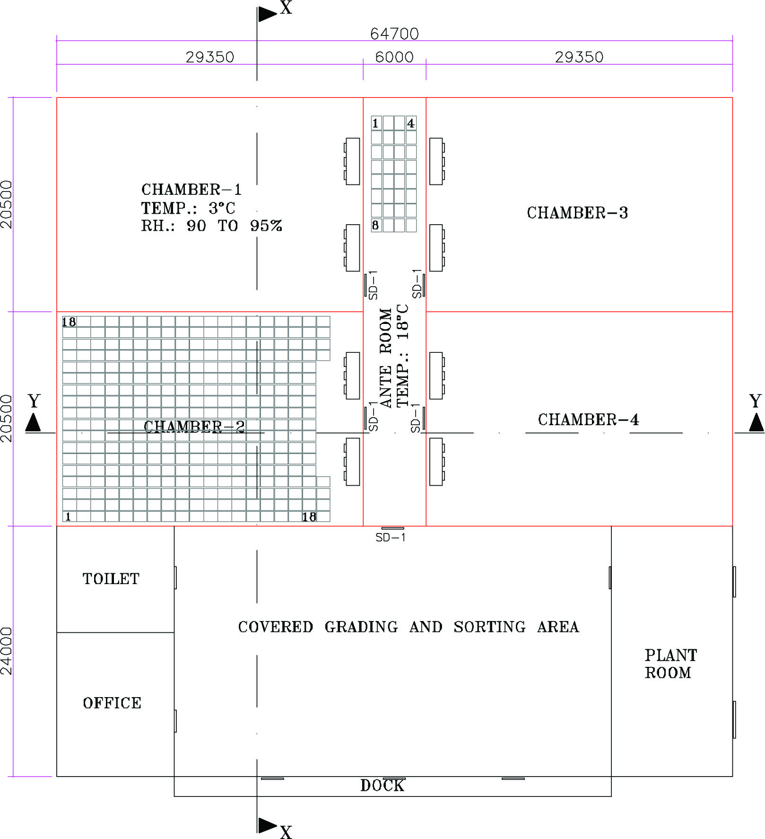

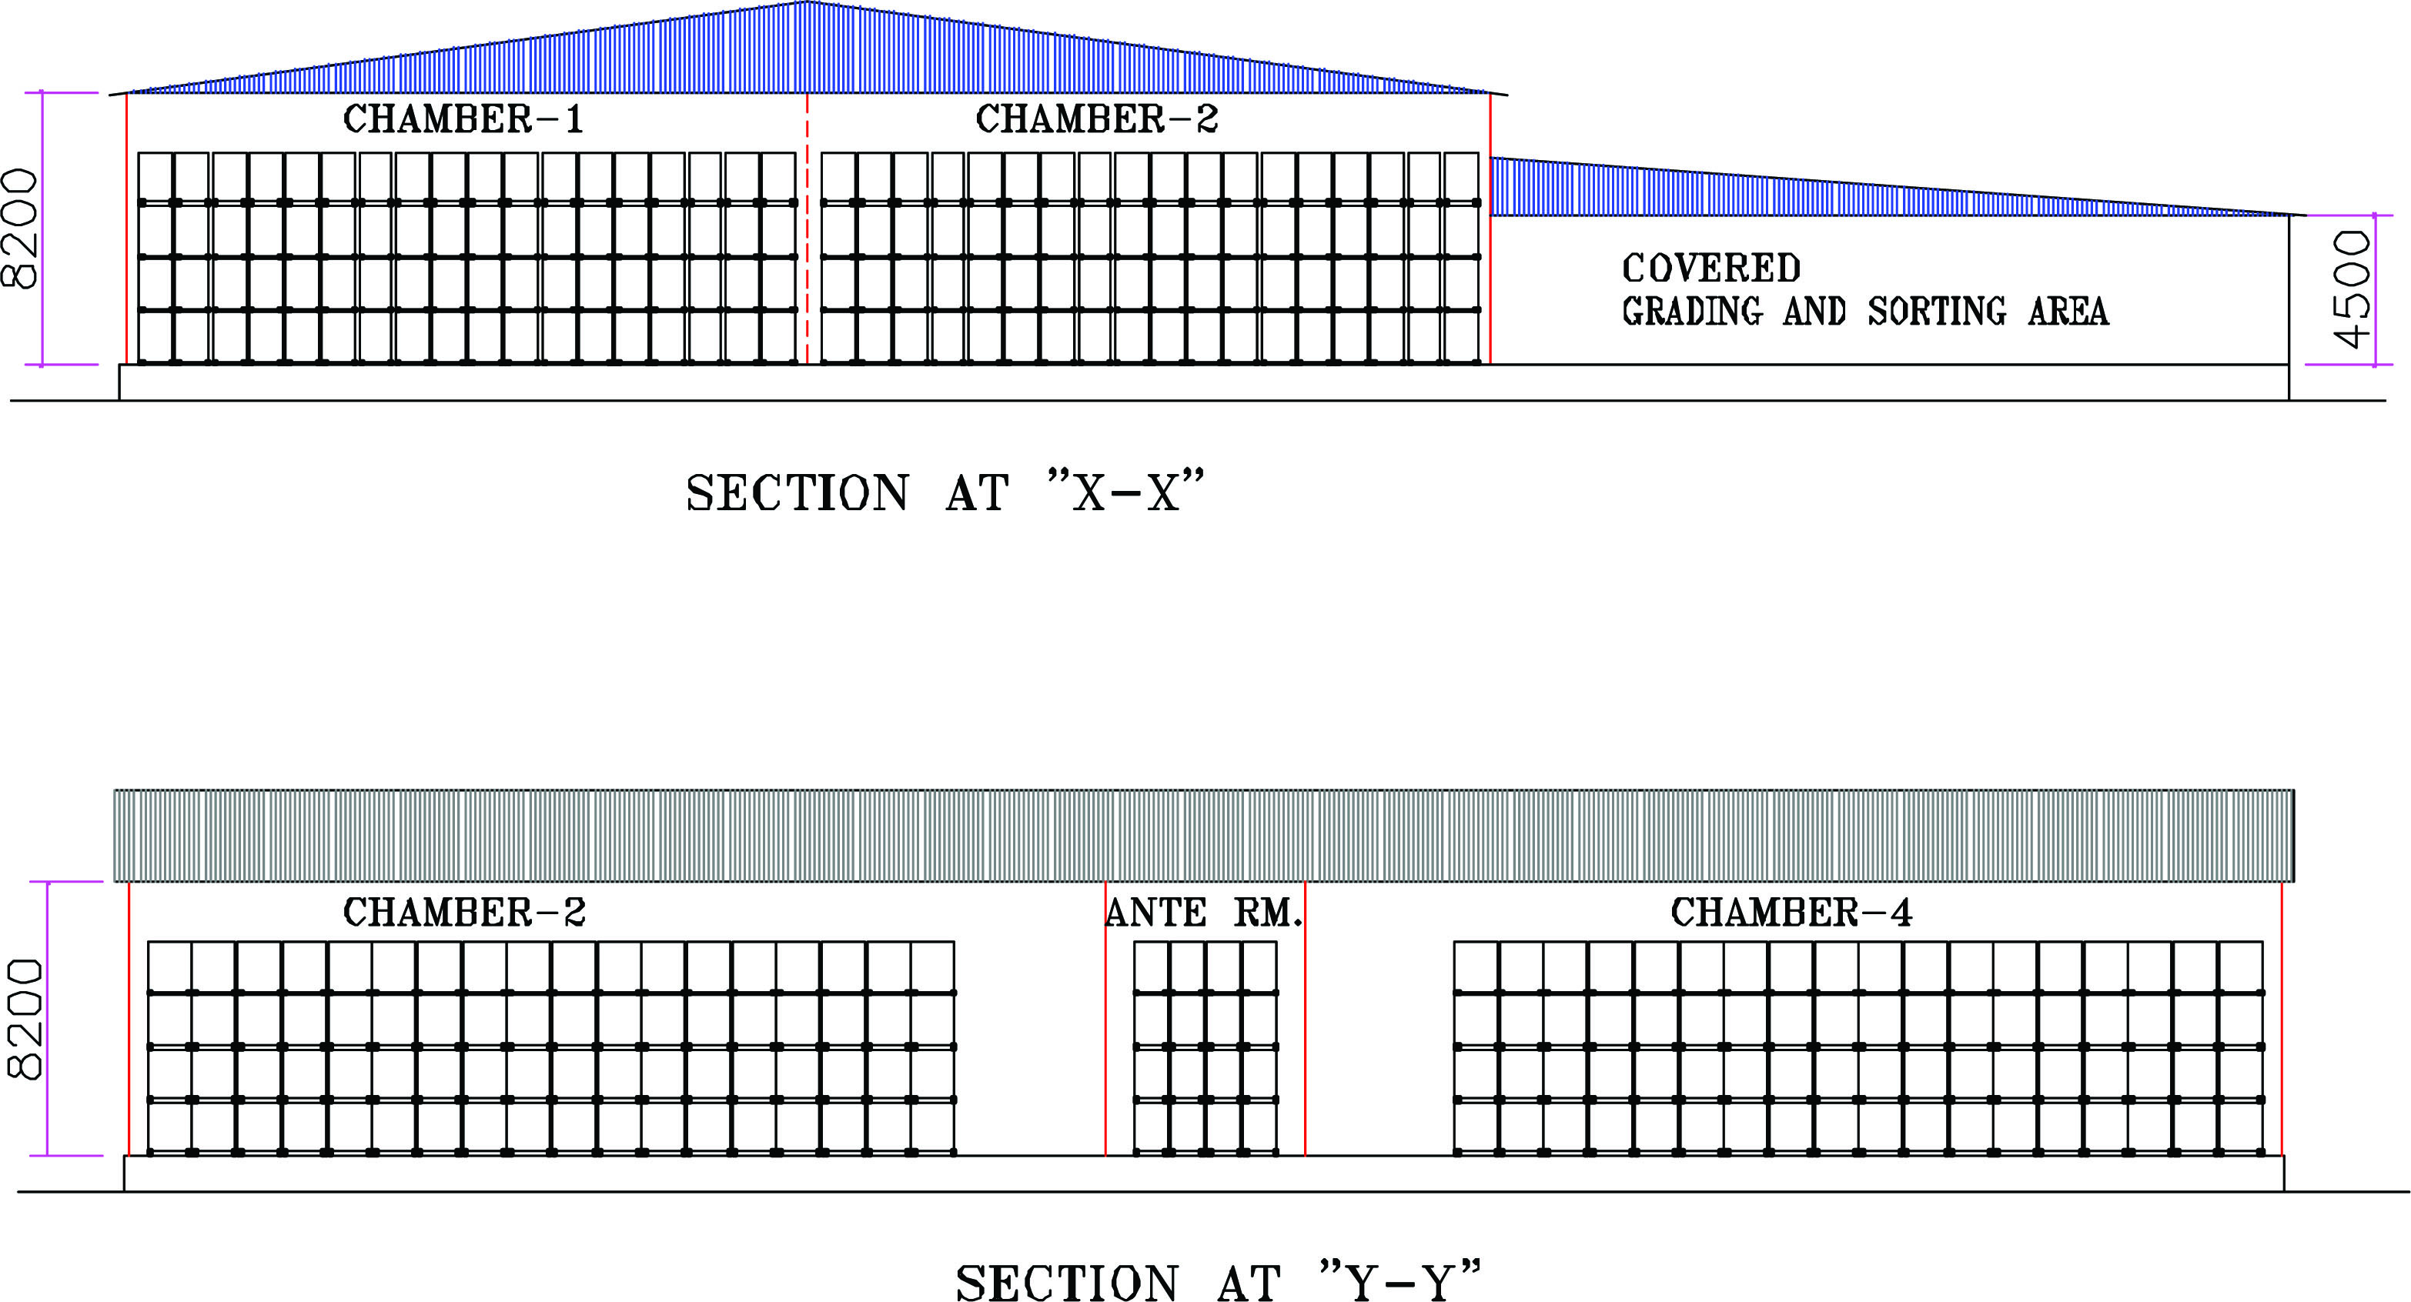
7
Note: In case of cold stores which are sized to store pallets stacked four levels high, the floor to ceiling height can vary between 7400 mm to 8200 mm depending on pallet frame height to allow sufficient space for air circulation
OPTION-2: Typical Multi Commodity Cold Store with provision of separate pre-cooling rooms and high humidity cold stores.

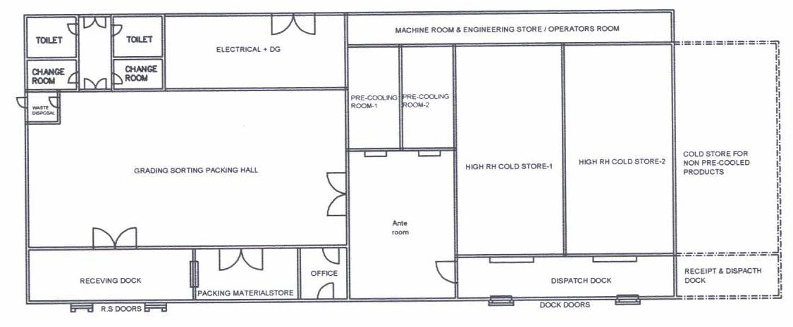

Typical Configuration: Multi Commodity cold stores will have multiple chambers each having capacity of 30 MT to 1250 MT, anti rooms, docking area, grading/sorting area, grading /sorting line, crates/ palletized storage System & material handling system packing material store, machine room, toilets and changing room, waste disposal, electrical room etc. The facility must be sized to handle peak amount of product. The floor area of each chamber can be calculated based on volume and weight of the produce in crates / pallets, its stackable height and considering floor area for aisle, fork lift manoeuvring and staging. The maximum storage height is limited by stackability of bin or / and fork lift reach.

Construction Features: The general convention of conventional construction is as follows:

Foundation: Superstructure and Foundation (which may be conventional Footing Type, Pile Foundation, Raft Foundation etc) to be designed by qualified & licensed structural / civil engineer. The design shall meet the BIS standards and relevant seismic zone norms for earthquake proof designs.

Cold Chamber: Cold stores with room cooling facility for long / medium term storage will generally have at least four chambers having capacity of 250-1250 MT. However, multi commodity cold stores facilities for short term storage / transit storage which are provided with separate pre-cooling chambers generally have storage capacities ranging from 30 MT to 150 MT depending on frequency of container loading. Total capacity of cold stores can be estimated based on Pallet Frame positions considering 1000 Kg per pallet position or on PVC crate layout and product weight per crate.

Cold Store Building: The Building should be constructed as per approved drawings and dimensions indicated. These facilities can be completely civil construction or steel construction / pre-engineered construction conforming to relevant BIS Codes for live load as per IS 875 Part-II, wind load as per IS 875 Part-III, seismic load as per IS 1893 and other codes and standards if applicable.
8

In case of conventional civil construction the general specifications are as under:

Walls: 230 mm Brick walls / solid concrete blocks with sand- cement plaster. However, in RCC structure or pre-fabricated structure insulated panel boards may also be provided in place of masonry walls.

Roof: RCC slabs or Truss Roof with G.S / Pre-coated G.S.Sheet cover. RCC slab to have proper water proofing with reflective colour paint / China mosaic finish. Slab to have proper slope for rain water drainage.

In case of truss roof, provision to be made for fixing insulated panels on the ceiling & supporting of cooling units from the trusses (alternatively cooling units can be supported on floor mounted frame structure on top floor).

Provision for FRP sheets for natural lighting to be made in roof sheeting at certain locations. For ventilation of attic, provision of ridge monitor or turbo ventilators (which require no electric power) can be made. Alternatively roof can also be designed by installing insulated roof panels with proper slope & sealing of longitudinal & lateral joints. The work to be handled by experienced agencies to ensure a trouble free roof structure. The roof may be kept walkable for maintenance.

However, in case of Steel / Pre-engineered construction the steel structure components / construction sections are fabricated conforming to relevant codes and standards of ASTM/BIS as applicable. The walls ceiling and partition are generally constructed of Insulated metal skin composite structural panels with core insulation of polyurethane. The insulation requirements or equivalent “U” values are mentioned in the subsequent para. The insulated panels are generally 1 to 1.2 Mtr. wide and in single piece and are extended from floor to the ceiling and held together by fasteners and fixing system. All the joints are properly sealed with silicon sealants for leak proof joint.

Floor: The floor comprises of base concrete, in cold stores with suitably lower levels in cold chambers. The level difference between cold chambers and ante room to be equal to the thickness of floor insulation plus the layer of PCC or tremix finish,

Ante Room: The cold rooms should be provided with at least one common ante room area to avoid direct infiltration of warm ambient air into the cold rooms. The ante room also serves as warm-up chambers for produce stored so they do not get wet due to condensation on unloading for dispatch.

Process Grading and Sorting Area: The process area will be maintained at comfortable conditions by using evaporative cooling particularly in dry areas. In high humidity areas, air-conditioning with humidifiers control to maintain temperature range of 20°C to 24°C can be provided which would be suitable for handling of fresh fruit and vegetable produce. Dock shelters will be provided in the dispatch areas of pre-cooled / chilled product.
9
Grading & Sorting Line: Suitable mechanized sorting; grading, washing and packing line should be provided.

Palletization & Strapping Facility: Pallets / Racks for bulk storage in bags or in bins are to be provided. Moreover, sufficient space for Drive in / Drive through Racks need to be provided, if such storage systems are provided.

Pallet Jack & Fork Lift: Fork lift need to be provided for movement of palletized crates. High reach Stackers / pallet Jack are needed depending on height of palletization.

Bins, Crates, Pallets and Racks: These are required in sufficient numbers for storing and vertical stacking of produce. Bins and Crates may be replaced by ventilated CFB boxes provided they meet the commodity storage requirements and in view of the period of storage.

Strip curtains for cold rooms and Air Curtains for external outlets/ inlets: Strip curtains are quite common for reducing infiltration of air during loading/ unloading. Air curtains need power for operation but are more effective if properly installed.

Rodent proof civil structure and proper drainage of water to be ensured.

Rooms for machines, Electricals etc.

Dock: Loading & unloading dock shall be designed with RCC slab roof or sheet roofing. However the machine roof can have RCC slab-roof to accommodate the evaporative condensers, pump sets, water tank, water softener etc. The dock area to accommodate suitably sized office & toilet for staff & labour.
Ancillaries: Underground fresh water storage, storage for fire fighting, water supply & sanitary arrangements, compound wall / fencing, main gate, security, small canteen / electrical sub-station & D.G. set platform, roads & parking place for vehicles etc. Green landscaping with benches for labourers is desirable.

- Thermal Insulation:
It is recommended that appropriate BIS standards are adopted for selection of design parameters (IS 661:2000) and method of application of thermal insulation (IS 661 & 13205). For fresh F & V stored at + 0º C , it is recommended to design thermal insulation for (- 4º C to + 2º C) temperature condition to have lower heat load.

Materials of thermal insulation and its application:

Cold chambers have to be insulated on walls, ceilings / roofs & floors with proper insulating material of adequate thickness, with provision for vapour barrier on outer side & proper cladding/ cover on inner side. The commonly used insulation materials are:

- Expanded polystyrene
- Rigid Polyurethane foam
- Rigid phenolic foam
- Mineral wool / glass wool
- Extruded polystyrene
10

The ancillary materials to be used include:

- Vapour barrier e.g. aluminium foil, polyurethane sheet, with bitumen / cold mastic adhesives
- Teakwood batten pegs, Tees etc.
- G.S. sheet runners (avoid wooden batten runners)
- Cladding of profiled / pre-coated G.S. Sheets 0.5 / 0.6 mm thick / Fibre-glass sheets of suitable thickness
For Conventional Insulation

Walls & Ceiling

  - Primer Coat followed by two layers of bitumen
  - Fixing aluminium foil min. 50 microns
  - Fixing wooden pegs at suitable intervals
  - Fixing two layers of insulation with staggered joints
  - Fixing G.S sheet runners over the pegs in longitudinal & lateral directions
  - Fixing profiled & pre-coated g.s. sheets, 0.5 / 0.6 mm thick over the runners with proper finishing of joints. Alternatively FRP sheets can be used.

Floor

- Laying of polythene sheet, min. 250 microns, as vapour barrier
- Fixing insulation slabs in two layers with bitumen as adhesive for the first layer
- Covering with tar felt
- Laying PCC / tremix of 75 mm / 100 mm thickness

For Insulated Panel Structure

Walls & Ceiling

- Perimeter of the plinth to be in level for panel installation
- Panels to have cam lock or tongue / grove joints
- Sheet metal flashing to be provided on all concrete / wall ceiling joints internally & externally. PVC coving or concrete curbing to be provided on wall - floor joints.
- Horizontal Tie bracings to be provided between vertical wall panels & external columns, to take care of wind loads
- Adequate numbers of Pressure relief ports to be provided on all chambers with electrical connection
- Insulated doors shall be suitable for panel mounting

11
11
MINIMUM INSULATION THICKNESS FOR VARIOUS INSULATION MATERIALS BASED ON RECOMMENDED U VALUES FOR -4 TO +2 ° COLD STORAGE

Type of insulation | Material |  | Wall |  | Ceiling/ roof  U value = 0.24 W/m²K | Floor  U value = 0.29W/m²K
Type of insulation |  |  | External  U value = 0.27W/m²K | Partition  U value = 0.58W/m²K | Ceiling/ roof  U value = 0.24 W/m²K | Floor  U value = 0.29W/m²K
Type of insulation | ρ Density  Kg/m³ | K (at 10 ⁰C)  W/mK | Thickness  mm | Thickness  mm | Thickness  mm | Thickness  mm
EPS | 15 | 0.036 | 150 | 75 | 150 | 125
PUF | 32 | 0.023 | 100 | 50 | 100 | 100
XPS## | 30-35 | 0.025 | 100 | 50 | 100 | 100
Phenolic foam *** | 50 | 0.026 | 100 | 50 | 125 | 100
Mineral wool *** | 48 | 0.033 | 125 | 50 | 125 | 100
Bonded fibre glass/ glass wool*** | 32 | 0.033 | 125 | 50 | 125 | 100
*** Recommended only with vapour barrier and metal or FRP cladding min 0.5 mm TCT
## Recommended in conformance to ISO/FDIS 4898:2008(E) for properties of XPS used for thermal insulation of buildings, Categories II, III & IV only.

Notes-
- K values from IS661:2000.
- U values are the recommended heat transmission coefficients for cold storage temperature range -4 to 2°C by IS661:2000
- All values rounded off in multiples of inch (25 mm)

- Total Refrigeration Load - Heat Load Calculation

- Procedure for load calculation

Procedures laid out by ASHRAE Fundamentals and Refrigeration handbooks may be followed. The current method prescribed by ASHRAE Fundamentals is RTS (radiant time series) method in which room by room analysis for each hour is carried out. However, the assumptions used for the building envelope and the loads are very crucial. ASHRAE refrigeration handbook elaborates a more traditional approach. Thus, based on the overall impact/ sensitivity of important parameters, some estimates can be made. Designers also tend to take a safety factor of 5-10% on the estimated loads.
12

  - Ambient conditions

0.4% annual design conditions of that location as per ASHRAE/ ISHRAE data may be used for holding period. For the loading and pull down periods, 0.4% design conditions for those months may be taken.

  - Product incoming temperature

It varies with location and harvesting time. The initial product temperature and the final product temperature along-with the temperature pull down period has to be considered for estimating the refrigeration requirement.

- Capacity during loading, pull down, holding and lean periods

Refrigeration capacities should be calculated at various operating conditions and necessary arrangements for capacity control are included in the equipments to be provided.

- Refrigeration System & Equipment Selection

Vapour Compression systems are commonly used. However, absorption systems can also be used for cold storages, where heat is readily available instead of electricity e.g. solar, geothermal, waste heat etc. A 7.5TR ammonia-water absorption system was installed at Manikaran by IIT Delhi in 1980’s. It worked on Geo-thermal energy.

Refrigerant issues – eco-friendly, safety, energy efficiency.

Ammonia seems to be the best refrigerant in terms of environment (being natural) and energy efficiency for this application. However, it is toxic and precautions should be taken in its handling. In case there is a restriction of using ammonia at certain locations, the refrigeration system can be designed to work on R134a, R404A etc.

- Type of system – direct expansion (in case of HFC and others) , liquid overfeed and gravity with a surge drum in case of ammonia

Liquid overfeed systems force excess liquid through the evaporator to improve the system efficiency and reduce the operating costs. It becomes more favourable as the number of evaporators goes up. Details of a gravity feed system are included in details on subsequent pages with list of additional equipment for a liquid overfeed system.

- Compressor – reciprocating/ screw with capacity control

In case separate pre-cooling chambers are provided for pre-cooling produce before transferring it to the CA cold store chambers, independent compressors shall be provided for each pre-cooling chamber or the refrigeration system suitably designed to accommodate such batch cooling process.. For cold stores, a common compressor system can be provided. Multiple multi-cylinder reciprocating compressors or screw compressors with appropriate capacity control may be used. Typically the holding capacity may just be 50% of the peak capacity during loading. So, it may be suitable to go for two same sized compressors each suitable for holding capacity at peak loads. A third compressor as standby compressor is recommended. Compressors should be able to deliver the desired capacity at worst conditions not at rated conditions. VFD’s can also be used for closer control in some cases. Capacity of compressor shall be confirmed by data- sheet of manufacturer.
13

- Condenser – atmospheric, evaporative, water cooled

Condensers can be air cooled with water spray or with provision of pre-cooling of condenser air in case of HFC / HCFC or water cooled with S&T condenser or Plate Heat Exchangers (PHE) with cooling tower arrangement in case of HFC / HCFC/Ammonia plant or of evaporative / atmospheric type or shell and tube water cooled type with cooling tower arrangement in case of ammonia plant. Capacity of condenser shall be confirmed by data- sheet of manufacturer. Coils with Aluminium tubes and Aluminium fins can also be used.

- Cooling coils – ceiling / wall mounted

Delta T (difference between evaporating and air inlet temperatures) should be kept low for higher humidity in the chamber. Typical values shall be 4.4 or less during holding period and can go up to 6 during peak loading period. This shall be confirmed by data sheet of manufacturer. This increases the coil surface substantially. The coils selected are kept on the higher side to keep higher humidity levels even during loading/ pull down periods. Ammonia coils are typically MS hot dip galvanised or SS/ aluminium tubes with Aluminium fins. The cooling units for other refrigerants have coils with copper tubes and aluminium fins.

- Air handlers for ultra high humidity forced air pre-cooling

Forced air pre-cooler is a separate room from the cold store chamber and is a much faster method of cooling fresh produce than room cooling because it causes cold air to move through the produce rather than around the containers. This is accomplished by producing a difference of pressure of opposite faces of stacks of ventilated containers. This pressure difference forces air through the stacks and carries the field heat away. Various air flow designs can be used depending on need and design of the facility such as Tunnel-Type, Cold Wall and Serpentine forced air cooling. The air handling units for pre-cooling shall be specially designed units for faster rate of cooling with high RH in the range of 96 ~ 98 %. The generally used design incorporates a DX cooling coil in case of HCFC/HFC refrigerants or a flooded ammonia cooling coil with adequate water circulation and spray system over the cooling coil and heat exchange surface deck and is provided with a high airflow & high static fan mounted on the unit.

- Humidification system

Although higher humidity levels of 85-90% can be achieved by keeping low delta T in the cooling coil. But during loading periods and for RH>90%, humidification system is a must. Several techniques are available, but it should preferably be done using water mist with 2- 10 micron and uniformly distributed all over the chamber ensuring that the product does not get wet.

- De-Humidification system – In case of compatibility with Group-3 commodity namely Onion and Garlic

For achieving low humilities in case of dried roots / bulbs / dry fruits / nuts, the cooling coils are selected at a higher delta T of 11°C and are specially design in which the first section of the cooling coil cools the air much below the desired room temperature to remove extra moisture and then the air passes through a reheat section to increase its temperature in accordance to the cold room storage temperature
14
requirements. This heat is supplied by the hot refrigerant gas from the compressor discharge pipeline and controlled through special controls.

- Commodity Generated Modified Atmosphere
For some commodities, better storage results may be obtained by storing them in a modified atmosphere conditions combining the effects of temperature, relative humidity and gas compositions of CO2 and O2. In Multi Commodity Cold store chambers can be used for modified atmosphere storage, where the CO2 content in the atmosphere is increased during the natural respiration of the products. The CO2 level can be increased or decreased by natural controlled ventilation with outside air. Accurate monitoring of CO2 and O2 concentration is essential for such MA Storage. Such Modified Atmosphere cold rooms are beneficial for mid term storage of apples and short term storage of fruits like bananas.

- Capacity control of fans
Fans' operation can be cycled to save power during part load operation. VFD’s may also be used on the fans to get good savings.

- Testing and Charging the system
Installation, Testing & Commissioning should be carried out as per BIS (for standards available). ASHRAE standards may be referred to as guidelines but not mandatory.

- Air Purger (manual or automatic)
It is desirable to remove air and other non condensable gases from the refrigeration circuit to keep the compressor head pressures lower and also improve heat transfer coefficients.

- Defrosting method – water/ hot gas etc.
Water defrosting is a simple method and can be done manually or through a timer.

- Equipment de-rating at higher ambient
A designer should match the loads with the de-rated equipment capacity at higher ambient conditions.

- GENERAL SPECIFICATIONS FOR REFRIGERATION SYSTEM

Brief Specifications for Equipment / Materials / Services

    - Refrigeration Compressors & Motors
Quantity | For pre-cooling, one compressor shall be provided for each chamber to facilitate independent operation of the batch. For Cold stores, 3 No. each of 50% capacity (one preferred as standby) can be provided in case of ammonia. In case of HFC / HCFC, individual condensing units or rack system can be provided.
Type | For ammonia as refrigerant, reciprocating, multi cylinder complete with water-cooled head / jackets, with accessories like oil separators, capacity control & unloaded start. Alternatively screw compressor, open type with accessories can be provided. For HCFC / HFC, reciprocating. / scroll / screw can be provided.  15
Capacity at critical operating conditions | To be configured in kW
Estimated Motor rating | To be configured in kW, RPM, type of insulation, Input AC power supply

ii. Evaporative Condenser for Ammonia

Coil section | Hot dip galvanised M.S. pipes CDW Boiler quality tubes / ASTM A 214 or S.S.304 tubes,
Fan section | With 2 / 3 Axial Flow Fans with Cast Aluminium OR S.S impellers, complete with TEFC Sq. cage motors, Class F insulation & IP-55 protection
Water sump tank | S.S.304 or M.S. Epoxy coated with necessary connections
Other provisions | Water spray arrangement, air inlet grilles, eliminators of suitable design
Unit casing | with removable G.S sheet panels & inspection windows etc.
Estimated Heat rejection capacity  at 38 deg C condensing & and applicable WB temp | To be configured in KW
Suggested Standard | ARI Std 490

Air cooled / water cooled condenser for HFC / HCFC.
Capacity | To be configured in KW
Size | To be furnished

iii. H.P. Receiver
Horizontal Ammonia receiver complete | With necessary connections, reflex type level gauge etc.
Capacity | To be configured
Material of Construction | Boiler quality steel plates
Quantity | 2 Nos. (Two no’s are suggested in case some States’ regulations call for Pressure testing of high pressure vessels on a periodic basis)
Suggested Standard | ANSI / ARI 495 / BIS Code IS 2825  16

iv. Air Cooling Units

a) Finned cooling coil | Coil design to be suitable for gravity feed / pump circulation for ammonia & DX operation for HCFC / HFC as per design
M.O.C | Hot dip galvanised coil with M.S. pipes CDW Boiler quality tubes – ASTM A 214 with MS fins  or S.S.304 tubes & Aluminium fins OR Aluminium tubes & Aluminium fins with proper bonding system with bullet drawn expansion / equivalent expansion for Ammonia  For HFC / HCFC coils with copper tubes & aluminium fins or aluminium tubes with aluminium fins.
Fin spacing | (4-6) FPI for rooms with coil temperature above 0°C and for all other conditions fin pitch should be (3-4) FPI
b) Axial Flow fans | With cast aluminium / S.S. / FRP impellers, with variable pitch, TEFC Squirrel cage motors with class F insulation, IP-55 protection
c) Accumulator | Vertical / horizontal with necessary connections (in case of gravity feed units) for Ammonia
d) Unit casing | G.S. sheet duly painted, drain pan of G.S / M.S with epoxy paint
d) Defrosting arrangement | Water
Unit capacities
Number per chamber | To be configured
Estimated capacity each at critical operating conditions | To be configured
Estimated coil surface area | To be configured
Estimated air flow capacity each | To be configured

17

v. Refrigerant Piping, Fittings & Valves
Piping  Interconnecting piping between compressor, condenser, receiver and cooling units | M.S. black piping conforming to IS-1239 / ASTM A Gr.106B for 40 NB & smaller sizes / ASTM A Gr.53B for 50 NB & larger sizes. For HFC / HCFC, hard Copper piping type L  Piping as per. ANSI guidelines and pressure vessels as per BIS Code IS 2825). Reference to ASHRAE B-31.5 recommended.
vi. Water Piping, Fittings & Valves
Piping shall be used for  a. Condenser water circulation  b. Compressor cooling  c. Defrosting  d. Drain lines | Piping to be G.I class B or sizes up to 65 NB & M.S. black pipe conforming to IS-1239.  Valves up to 40 NB to be Gate / Globe type.  Valves 50 NB / larger to be butterfly type.

vii. Water Pump sets
Water flow capacity to take care of condenser water flow & compressor head / jacket cooling | 2 nos. (one standby)
Capacity | To be configured

viii. Thermal insulation for refrigerant piping etc.
Material for insulation for refrigerant suction line, accumulators etc. | - EPS pipe section  - PUF pipe section  With 0.6 mm Aluminium or 0.5 mm G.S. pre-coated sheet cladding  - Nitrile Rubber / EPDM / chemically cross linked polyethylene pipe section / other acceptable materials with woven glass cloth with UV treated pigmented epoxy Coating

ix. Duct Mouth pieces
To be provided on each fan outlet for uniform distribution of air at the topmost level | G.S. sheet ducting as per IS 655

18

x. Ventilation for cold chambers

System to be designed for providing adequate air changes / day | Axial flow / Inline duct fans with cleanable inlet filters, G.S sheets / Aluminium / PVC ducting up to cold chambers and ducting for exhaust from cold chambers to outside  Heat exchanger with energy recovery wheel or heat pipe can be used for cooling the incoming air from the exhaust air. Typical efficiencies of heat exchangers are 70% or higher and recommended for achieving higher CoP.

xi. Humidification

External humidification for 90 to 95 % RH | Fogger type external humidification system with 2 to 10 micron particles with automatic regulation

xii. Controls- One sensor per 100 ton of storage is suggested as good (Univ. of Idaho study).

Temperature control | Temp Indicators cum controllers for individual chambers. Temperature scanners and a centralized temperature indication in machine room
RH control | RH indicator & controller
CO₂ control | CO₂ sensors for regulation of ventilation system
Refrigerant flow controls | Liquid level controls, solenoid valves etc.
PLC control systems | For overall control of various parameters

xiii. Installation, Testing & Commissioning

Installation | The plant shall be installed, tested & commissioned as per IS 660 / ASHRAE. Std 15.

19

General Notes:
- The above design recommendations are based on Ammonia as refrigerant & the system designed for gravity feed for air cooling units. It is also possible to use pump circulation system (overfeed system) requiring following components :
- Centralised ammonia L.P receiver
- Ammonia pumps – 2 nos.
- Refrigerant flow & safety controls
- Interconnecting piping – both supply & return lines shall be insulated. In this case the individual accumulators for AC units & level controls etc. are not required.

- ELECTRICAL INSTALLATIONS

- Power Factor – not less than 0.95
- Transformer of minimum required capacity

20
ELECTRICAL INSTALLATION
    - Substation
Substation with a rating of about 200kW | a. Step down transformer suitable for incoming H.T. voltage / 433 V as per IS-2026 / other applicable standards  b. Two pole / four pole structure as per local requirements  c. Outdoor type metering cubicle with approved meter, CTs / PTs etc.  d. Earthling station as per requirement  e. Switchyard fencing with gates as per Electrical Board requirements

    - D.G. Set for standby power
D.G. set complete with accessories and with weather-proof and noise-proof canopy as per local pollution control norms | Estimated Rating: as per design. One big for pull down period and one small for holding period may be used.

    - Main power distribution panel
Main power distribution panel with changeover facility for normal electric supply & D.G. set supply. With ongoing feeders for various electrical panels.

    - Electric panels
Electric panels for | a. Refrigeration  b. Lighting, Electric hoist, Fans  c. APFC (automatic power factor correction) panel  d. Water supply, fire fighting etc.

    - Power & Control cabling etc
Power and Control cabling, earthing etc  for various electrical circuits | Aluminium armoured conductors for main power lines & equipment lines & copper conductors for lighting, control wiring etc.

    - Lighting
Lighting in  a. cold stores, ante room  b. other areas  c. outside areas | The light fittings (with non glass covering) should be energy efficient eg. CFL (with vapour proof casing) fittings for cold chambers. A central switch should be provided outside each chamber. Typical installations for lights may be 2 to 3 W / m² of floor area. (IS 15111 )
21
- Safety:

SAFEETY MEASURES
Provision for handling accidental leakage of ammonia | Ammonia sensors in cold chambers near ACU’s & machine room  Emergency ventilation for machine room  Safety release of refrigerant to water sump  Ammonia masks  First aid kit  Instructions for handling emergencies
Fire protection | Fire sensors in cold chambers & machine room.  Dry & water based fire fighting systems as per specs below.  Sprinklers for high pressure receivers
Emergency lighting system | May be solar PV cells with batteries & controller
Emergency alarm system | To be provided with switches near all cold store doors and alarms located in common public areas
Lightning arrestors for the building as per local regulations

- Fire Fighting
- Dry Type
Fire fighting equipment necessary for  extinguishing liquid, solid and electrical fire : | i) Dry chemical powder type 5.0 Kg Cap with ISI Mark Fire Extinguisher complete with wall mounting bracket.  ii) Carbon Di-Oxide (CO₂) type 4.5 Kg. capacity Fire Extinguisher complete with wall mounting bracket.  iii') G.I. Fire Buckets  iv) M.S. Stand for Fire Buckets

- Water based (mandatory if local code so prescribes)
System shall comprise of | i) 2 sets of Water supply pumps.  ii) 2 sets Fire fighting pumps  iii) G.I. piping, class C with necessary fittings & valves  iv) Rubber Hose reel  v) Canvas Hose pipe  vi) M.S. Fabricated hose box with key
22

- Coefficient of Performance (CoP) - Optimum energy efficiency should be determining criteria for CoP.

- Operation & Maintenance- Cold storage design must be accompanied by Operation & Maintenance Manual for cold storage operator which should cover following points in English as well as Hindi languages-
- No. of operating hours
- Training of operators
- Monitoring & control – temperature, humidity, CO₂
- Door seals – checking methods
- Maintenance of equipment / cold store
- Hygiene issues

- Variation / amendment Clause-

The standards prescribed above are not intended to prevent or discourage variations arising out of new concepts, innovations and R & D in building design & construction, thermal insulation and cooling & refrigeration technology etc. However, any variations or deviations from the above prescribed standards must be supported by scientific / technical details for prior approval of the competent authority, on the basis of merit who may decide the proposal in view of relevant technical details including critical storage requirements, energy efficiency (coefficient of performance), availability of Standards, environmental concerns, safety etc. Similarly, periodic amendment of standards for general application may also be undertaken by the National Horticulture Board; in consultation with a committee of subject matter experts duly constituted for this purpose.

23

SECTION 2

Basic Data Sheet

Section-2
Basic Data Sheet
NHB/TSC/Multi Commodity/Draft

Data Sheet for Multi Commodity Cold Stores for Long Term & Short Term
Storage of Horticulture Produce that requires Pre Cooling (Rapid cooling)

A. Identification

Name of Cold Storage
Location of Cold Storage | Area / Village |  | Town
Location of Cold Storage | District |  | State
Name of Promoter Company / Owner
Type of company
(Proprietorship / Partnership / Pvt. Ltd / Ltd)
Postal address of Promoter
Postal address of Promoter | Tel / Fax | Mob. No |  |  | E-mail
Present activity in brief

Name of CEO / MD
Name of Manager / Contact Person |  |  |  | Phone / Mobile No

B. Multi Commodity Cold Store Design Considerations

- Commodity Storage Requirements
  - Multi Commodity Horticulture Produce) Reference to Annexure 1
  - More than two Commodity Groups are storable at any given time
24
  - Use separate sheets for additional commodities

Type of Commodities/Produce
Ideal / Recommended Storage Conditions
– Temperature (DB in ^{O}C)
- Humidity RH (%) Range
- CO₂ Percentage

- O₂ Percentage
(Optional in case of MA storage)

- Rapid Cooling Rate (Product Temp Pull Down duration in hrs)

- Air Circulation (CMH/MT of Produce)

- Produce Freezing Point ^{O}C

- Others

Chamber Dry bulb (DB in ^{O}C)
Chamber RH (%)
Max Storage period (months)
Max product temp (^{O}C)
– at the time of loading
Daily loading rate (MT/day)
– in each cold chamber
Loading Period (months)
Temperature Pull down rate (^{O}C / day)
Unloading Period (months)
Daily unloading rate (MT/day)
– from each cold chamber
Ante Room Conditions (T ^{O}C & RH %)
Sorting & Grading Area (T ^{O}C & RH %)

ii) Storage System (Racks, Bins, Crates with/without Pallet Racking)
Brief Description of Storage System
Bins/ Crates/Palletization in Racks  - Size of Bin/Crates  - Material of Construction  - Type of Packing of Produce  - Storage Capacity (Kg/Bin/Pallet)  - Stack ability (Bins/Pallet High) | Wood/Plastic  Boxes/Bags  25

iii) Fresh Air / Ventilation System (if Applicable)
Brief Description of CO₂ Extraction / Ventilation System
CO₂ Concentration Control Range (PPM)
Monitoring & Control Instrument
– Type
– Accuracy
Ventilation Capacity (Max Air Changes/Day)
Design Considerations for Energy Recovery and Preventing Wetting of Produce

iv) Cold Store Chamber Sizing and Capacity
  - No. of chambers: ( based on Commodity Groups- Annexure 1)
  - Type : Bins/Crates/ Palletized
  - Max Height of Building

Details | CSC 1 | CSC 2 | Precooling - 1 | Precooling - 2
Total Capacity of Each Cold Store Chamber ( MT)
Internal Chamber Dimensions
L x B x H (m)
No. of mezzanine floors for non pre-cooled storage
X Height (m) per floor
Size &Weight of Bins/Pallets being stored
Total number of Bins/Pallets stored in each Cold Store Chamber

Note. Use extra sheet for additional chambers

v) Ante Room & Process Areas

Details | Length (m) | Width (m) | Height (m)
Ante Room |  |  | 26
Sorting & Grading Area
Loading / Unloading dock

vi) Machine Room & Utility Areas

Details | Length (m) | Width (m) | Height (m)
Machine Room
Office Area
Toilets & Changing rooms
Any other

vii) Building & Construction Details

- Type of construction : Pre-engineered Building /Civil

Type of External walls of cold chambers
Type of Internal / Partition walls
Type of Roof / Ceiling
Type of Flooring for forklift/stacker movement
Types of Lighting fixtures in cold Chambers
Types of Lighting fixtures in Process & Other Areas
27
viii) Insulation and Vapor Barrier

- Type of Insulation : Insulating Sheets / Metal Skin Composite panels
- Ref IS 661:2000

Type of Insulation | Wall |  | Ceiling / Roof | Floor
Type of Insulation | External | Internal | Ceiling / Roof | Floor
Type of material
EPS / Metal Skin PUF Composite Panels / XPS/ PUR, Others
Relevant IS Code

Density (kg/m³)
Thermal Conductivity at +10°C
k value ( W/m.K)
Thermal diffusivity m2/h
Water vapour transmission rate, ng/Pa.sm, Max.
Water absorption after 24h immersion, percentage by mass.
Relevant IS Code of Practice for Thermal Insulation of Cold Store
Total Insulation Thickness (mm)
No. of layers &
Thickness / layer (mm)
Type of vapor barrier & thickness (microns)
Type of Bituminous/Sticking Compound
Type of Cladding / Covering/External Finish
Locking/Fixing & Sealing System in case of Metal Skin Composite Panels
Any other info

ix) Cold Store Doors & Air Curtains

Type of Insulation | Details
No. of Insulated doors
Type hinged / sliding | 28
Insulation Material
EPS / PUF / Others
Thickness of Insulation (mm)
Type of cladding
Size of door opening
Provision of Inspection Windows & Size
Air curtains, if any
Others type of doors for ante room and process area

x) Material Handling
- Proposed Practice : Manual / Electric Fork Lift /Stacker

Procedure | Brief Description
Material Handling Procedures
& Equipments
Any other device

xi) Grading, Sorting, Washing, Waxing & Packing Line
- Proposed Practice : Manual / Semi Automated /Automated

Procedure | Brief Description
Process Line

Total Connected Load (kW)
Please attach a Plan & Layout of the proposed Cold Store unit in accordance to the Statutory Building By-Laws and BIS Building Codes & Standards duly approved by a Registered Architect and Structural Engineer. The drawings should detail out insulation type, thickness, and fixing methodology in sectional details.
29

C. Heat Load Calculation of Cooling System – Summary

Ambient Conditions | Summer | Monsoon | Winter
Dry Bulb Temperature (°C)
Wet Bulb Temperature (°C)

Refrigeration Load |  | During Loading (kW) | During Pull Down (kW) | During Holding (kW)
Transmission Load
Product Load
Internal Load | Lighting load
Internal Load | Occupancy load
Infiltration Load
Ventilation/ Fresh Air Load
Equipment Load - Fan motors etc.
Total Load (kW/24 hrs)

Compressor Operation  Hours/Day | Pull Down Period
Compressor Operation  Hours/Day | Holding period

Multipliers | Safety Factor
Multipliers | Defrost Period

Total Refrigeration Load | Pre-cooling load | Holding Period
Total Load (KW)

Please attach detailed heat load calculation sheets of the proposed cold store unit in accordance to the prescribed Technical Standards and Guidelines duly approved by a Qualified Engineer.
30
E. Cooling System Design & Equipment Selection

  - Cooling System Configuration

Type of Refrigerant | Ammonia /Freon /Others
Type of System | Direct Exp / Gravity Feed / Overfeed
Type of compressor | Reciprocating / Screw / Scroll / Others
Type of capacity control | Automatic In steps / Step less
Type of condenser | Atmospheric / Evaporative / Shell & Tube / Plate Heat Exchanger / Other
Cooling Towers ( if applicable) | FRP Induced Draft / Others
Type of cooling coil | Ceiling suspended / Floor Mounted / Others
Type of defrosting | Air / Water / Electric / Hot gas
Humidification System & Control
( Brief Description)

  - Compressor Detail – for ammonia

Compressor Make & Model | Nos. | Comp. RPM | Operating Parameters Evap. SST. / Cond. Temp (^{O}C) | Refrigeration Capacity  (KW) | Motor Rating.  (KW) | Total Electric Power.  (BkW) | Remarks Working /Standby

  - Condenser Details – for ammonia

Condenser Make & Model | Nos. | Operating Parameters Cond.Temp.(SDT)/ in/out water temp(^{O}C) &flow (lps) | Condenser Capacity  (kW) | Electric Fan /Pump Motor Rating  (kW) | Total Electric Power (BkW) | Remarks Working /Standby

31
  - Condensing Unit Details – for HFC / HCFC

Make & Model – condensing unit | Make & Model – compressor | Qty – condensing unit (nos) | Qty – compressor per cond unit (nos) | Operating Parameters Cond.Temp.(SDT)/ in/out water temp(^{O}C) &flow (lps) | Refrigeration capacity  (kW) | Condenser Capacity  (kW)

Electric Fan /Pump Motor Rating  (kW) | Compressor power consumption (kW) | Total Electric Power consumption (ikW)

  - Cooling Tower Details ( if applicable)

Cooling Tower Make & Model | Nos. | Operating Parameters DB & WB Temp, in/out water temp(^{O}C) | Cooling Tower Capacity(KW) | Fan & Pump Capacity (CMH/LPS) & Motor (kW) | Total Electric Power (BkW) | Remarks Working /Standby

  - Air Cooling Units (ACU)

ACU Make & Model | Nos. | Operating Parameters Evap. (SST)/ inlet-outlet  & TD* (^{O}C) | Cooling Capacity  (kW) | Air Flow  (CMH) &  Face Velocity (M/S) | Material of Coil Tubes  & Fins | Fin pitch  (mm) | Total Fan  Electric Power (BKW)
(*) TD – Temperature difference between Evap. (SST) ^{O}C & Return Air (at coil inlet).
32
Please attach Detailed Technical Data Sheets of each equipment namely Compressors, Condensers, Cooling Towers, Air Cooling Units giving General Layout, Dimensions, Material of Construction, Rated Capacity, Operating Parameters and COP (please note that the Air Cooling Unit data sheet should include heat transfer area, fin spacing, no. of rows, air flow, face velocity, fan static, air throw, Fan Motor BKW/KW, fin spacing, etc ) duly Certified by the respective equipment manufacturers with reference to the Relevant Codes & Standards.

- Electrical Installation
Total Connected load (kW)
Estimated power requirement at Peak Load Period (BkW)

Estimated power requirement at Holding Load Period (BkW)

Estimated power requirement at Lean Load Period (BkW)

Capacity of Transformer (KVA)
(proposed)
Size of Capacitor for power factor
correction & their operation

Make & Capacity of standby
D.G.Set (KVA)

- Safety Provisions
Details of Fire Fighting equipment | Dry
Details of Fire Fighting equipment | Water based
Handling Refrigerants & Leaks | Leak Detection
Handling Refrigerants & Leaks | Handling measures
Safety devices – LP/HP cutouts, safety valves, shut off valves etc.
Details of Emergency alarm system
& push button system in cold chambers
Emergency lighting in Cold chambers & other areas
Lightening arrestors
Any other safety provisions |  | 33

- Codes & Standards Followed
Building Design & Structure
Construction Materials
Thermal Insulation & Application
Refrigeration Equipment & Systems
Electrical & Mechanical Systems
Food Safety

- Energy Saving Equipment & Measures

Details of Energy Saving devices | Brief Description and Savings
Light Fixtures CFL/LED
Natural Lighting for general areas
VFD for fans / compressors
Refrigerant Controls and Automation
Air Purger
Power Factor Controller
Renewable/ Solar Energy e.g.
PV lighting
PLC Control, & Data Acquisition
Any other features e.g. water recycling, rain water harvesting …

- Operation & Maintenance
Description | Nos. / Details
Proposed staff for Operation & Maintenance
Proposed Annual Maintenance Contracts (if any)
Training & Preventive Maintenance procedures
Sanitation & Hygiene practice
Pollution Control | 34

- Estimated Performance Parameters of Proposed Multi Commodity Cold Store
Parameters | Peak Period | Holding Period | Lean Period
Coefficient Of Performance (COP)
Of the Cold Store Unit

Power Consumption (KWH/Day)
Total Electricity Cost (Rs/Day)
Electricity Cost towards Storage (Rs/ MT /Day)

- Other Information

Place Signature and
Date Name of Applicant with seal

35

SECTION 3

Protocol for Implementation
of
Technical Standards

Section-3

Protocol for Implementation of Technical Standards

Subject to provisions of Variation Clause, only those cold storage projects that are in conformity with the prescribed technical standards will be eligible for Central Government Subsidy. In order to verify this, following mechanism needs to be put in place-

- System of Letter of Intent (LoI)- LoI to be obtained by the promoter prior to undertaking construction of cold storage needs to be introduced. An application for Letter of Intent must be accompanied by following documents, in addition to any other documents prescribed-

- A copy of the detailed project report
- Information in prescribed Basic Data Sheet accompanied by requisite documents

Technical scrutiny of the above documents will be undertaken to ensure that the project is in conformity with the prescribed technical standards or any variation is fully justified keeping in view the product to be stored, prescribed storage conditions, energy efficiency and environmental and safety concerns.

- Civil Structure- Following documents must be submitted by the promoter in respect of civil construction

- Certificate of approval of the building plan by local planning authority,
- Certificate issued by registered civil design engineer about conformity with relevant BIS Standards and prescribed standards and safety concerns,
- Certificate by site engineer / architect to the effect of construction of the civil structure as per approved building plan and design and completion of the civil components accordingly in all respects as per prescribed plan and standards,

C. Thermal Insulation & Refrigeration System, Control and Safety Devises

- The components of insulation and refrigeration system should be certified in form of a technical data sheet by the manufacturer confirming the rating and performance as per prescribed standards.
- Further, site inspection at appropriate stages of construction / erection and commissioning may be undertaken by an inspection team constituted by competent authority for this purpose.
- Finally, the manufacturer/refrigeration contracting agency will issue a certificate of satisfactory commissioning of the cooling system in conformance to the performance indicators as per prescribed standards.
- The manufacturer/refrigeration contracting agency will also provide “as built drawings”, including cold store layout, P&I and electrical drawing and an operation & maintenance manual along with a list of essential spare parts.
- A set of above documents along-with the refrigeration system performance certificate issued by the refrigeration company / contracting agency, duly signed by an authorized graduate engineer of the company/agency, must be submitted to competent authority for record and a copy of the same must be issued to the promoter / owner of the project.

36

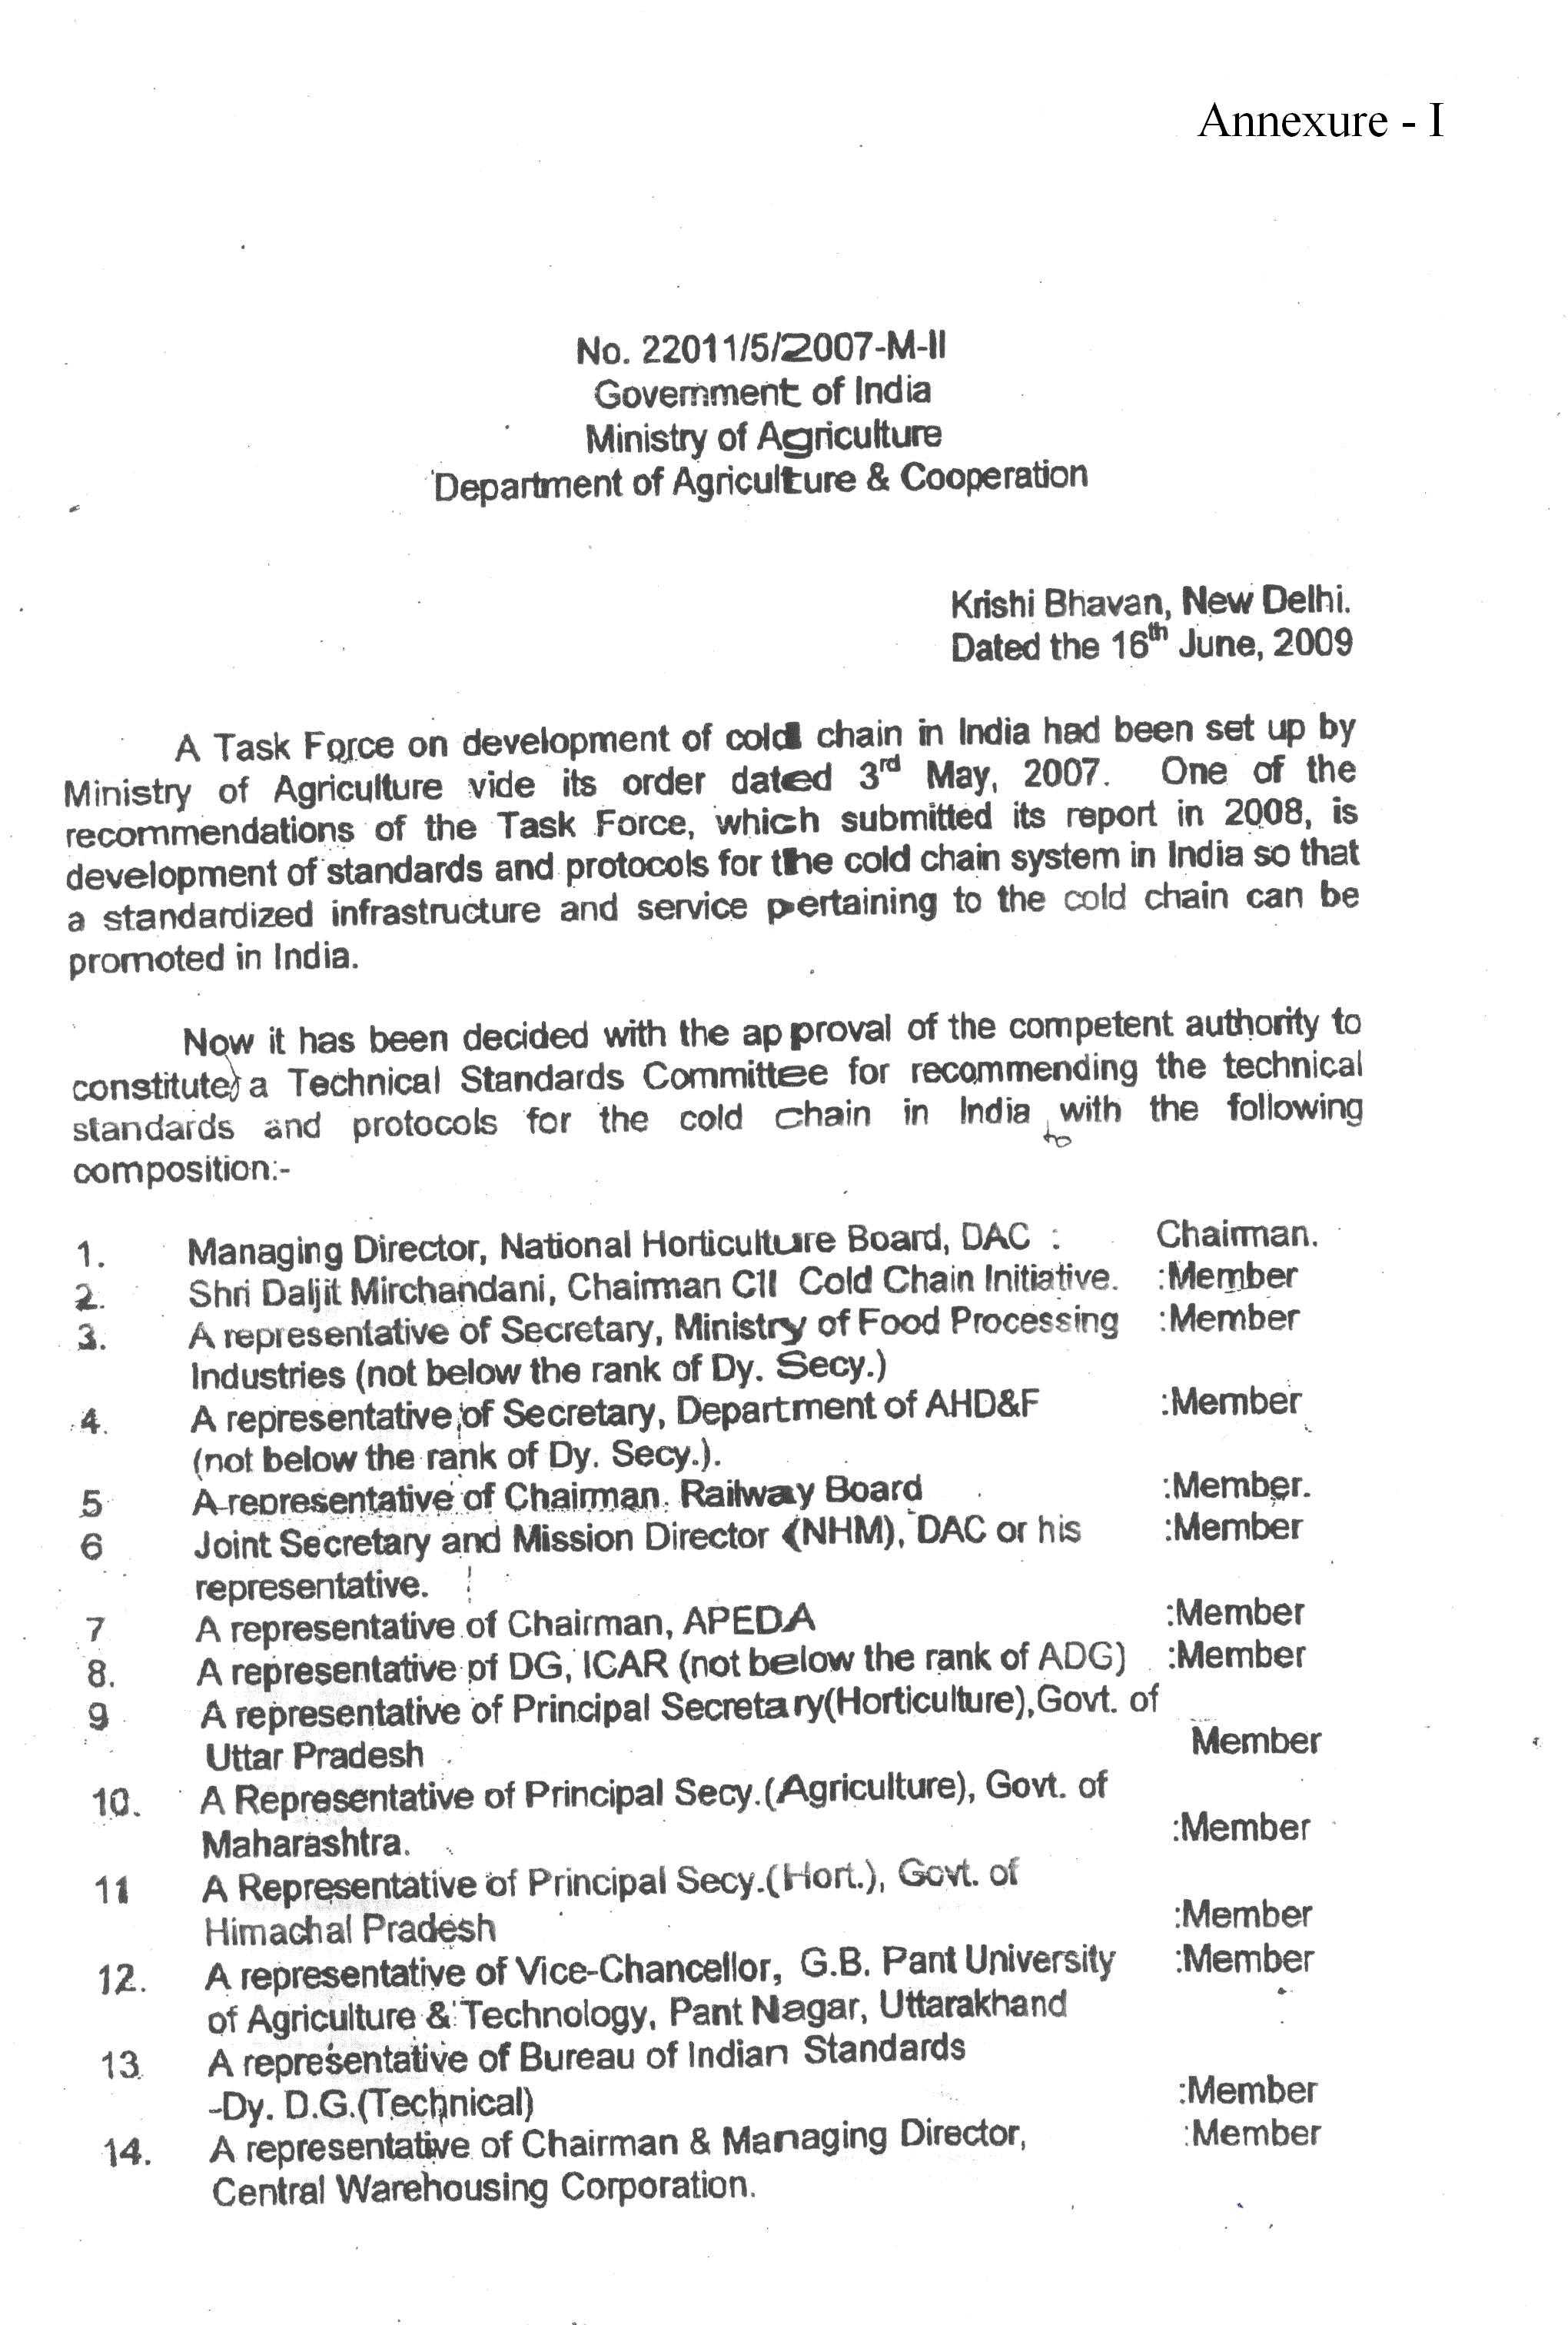
37
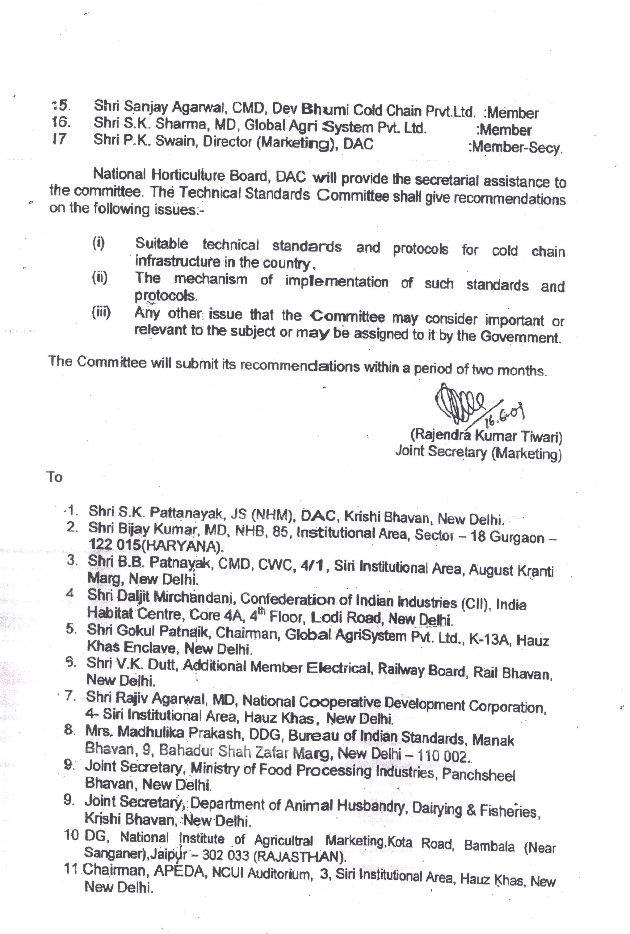
38

39
Annexure - II
Technical Standards Committee Experts

- Sh. Bijay Kumar, Managing Director, National Horticulture Board, Ministry of Agriculture, Govt. of India, Plot No. 85, Institutional Area, Sector-18, Gurgaon-122 015 (Haryana)
- Dr. R. Ezekiel, Head, PHT, Central Potato Research Institute, Shimla.
- Sh. Awadhesh Kumar, Director, Ministry of Food Processing Industries, Panchsheel Bhawan, New Delhi
- Sh. P. Saxena, Executive Director, National Cooperative Development Corporation (NCDC), 4, Siri Institutional Area, August Kranti Marg, Hauz Khas, New Delhi-110016
- Sh. L. Shivatania Reedy, Deputy Commissioner, National Horticulture Mission, DAC, Krishi Bhawan, New Delhi -110019
- Sh. R. K. Boyal, GM, Agricultural and Processed Food Products Export Development Authority (APEDA), 3rd Floor, NCUI Building, 3 Siri Institutional Area, August Kranti Marg, New Delhi-110016
- Sh. Vinod Pandey, Agricultural and Processed Food Products Export Development Authority (APEDA), 3rd Floor, NCUI Building, 3 Siri Institutional Area, August Kranti Marg, New Delhi-110016
- Sh. O. P. Bharti, General Manager (Commercial), Central Warehousing Corporation, 4/1, Siri Institutional Area, August Kranti Marg, New Delhi-110016
- Sh. I. S. Teotia, Sr. Assistant Manager, Central Warehousing Corporation, 4/1, Siri Institutional Area, August Kranti Marg, New Delhi-110016
- Sh. Gurmit Singh, Managing Director, M/s Walco Engineering Ltd., 7/15, Kirti Nagar, Industrial Area, New Delhi-110 015 (and Chairman of CII, Technical Standards Committee).
- Mr. Suresh Kumar, General Manager, Confederation of Indian Industry (CII),(Blue Star), India Habitat Centre, Core 4A, 4th Floor, Lodi Road, New Delhi - 110 003 (INDIA)
- Sh. N.K. Jawa, CEO, Fresh & Healthy Enterprises Ltd., HSIIDC Industrial Estate, Rai, Sonepat-131029 (HR)
- Sh. Arvind Surange, ACR-Project Consultant, H.O. Vijay Apts., 39/35 Erandavana, Pune-411 004 (Maharashtra)
- Sh. Sanjay Aggarwal, Dev Bhumi Cold Chain Pvt. Ltd., 17 & 18, Azadpur, New Subzi Mandi Delhi-110 033
- Sh. A.K. Choudhary, Dev Bhumi Cold Chain Pvt. Ltd., 17 & 18, Azadpur, New Subzi Mandi, Delhi-110 033
- Sh. Anil Dwivedi, Dev Bhumi Cold Chain Pvt. Ltd., 17 & 18, Azadpur, New Subzi Mandi, Delhi-110 033
40
- Sh. M.Verma, Vice President, International Coil Ltd., A-21/24, Naraina Industrial Area, Phase-II, New Delhi-110 028
- Sh. Amit Garg, Head (Agrifresh & New Initiative), Adani Agrifresh Ltd. Adani House, 83, Sec-32, Institutional Area, Gurgaon- 122 001
- Sh. Sanjay Gupta, INFRA Cool, AD-95 A, Pitam Pura, Delhi - 110 088
- Sh. Naresh Kohli, harshna Group of Companies, C-76, New Fruit Market, Azad Pur, New Delhi
- Sanjeev Jain, Prof., IIT, Houz Khas, New Delhi
- Sh. S.K. Sharma, Global Agri Systems Pvt. Ltd. K-13A, Hauz Khas Enclave, New Delhi-110 016
- Sh. Arvind Surange, ACR-Project Consultant, H.O. Vijay Apts., 39/35 Erandavana, Pune-411 004 (Maharashtra)
- Mr. J. M. Gupta, Managing Director, JBM engineering Pvt. Ltd., A-1/296, 3rd Floor, Janak Puri, New Delhi -110 058
- Sh. Arvind Agarwal, Chief Technical Advisor, Cold Storage Association, U.P., 40E/2-3, Lal Bahadur Shastri Marg, opp. A.H. Wheelers, Civil Lines, Allahabad
- Sh. M.K. Chourasia, Head, Deptt. Food Coprn., Bidhan Chandra Krishi Viswavidyalaya, Mohanpur, Nadia - 741 252, West Bengal
- Sh. N.S. Ranawat, Deputy Director, National Institute of Agricultural Marketing, (Ministry of Agriculture, Government of India), Kota Road, Bambala, Sanganer, Jaipur – 303906
- Sh. Gubba Nagendev Rao, Federation of Cold Storage (A.P)
- Sh. Har Pal Singh, Deputy General Manager, Agricultural and Processed Food Products Export Development Authority (APEDA), 3rd Floor, NCUI Building, 3 Siri Institutional Area, August Kranti Marg, New Delhi-110016.
- Sh. Ajay Kumar Lal, Bureau of Indian Standards, Manak Bhavan, 9 Bahadur Shah Zafar Marg, New Delhi – 110002
- Sh. K.K. Paul, Sc. E.(Chemicals), Bureau of Indian Standards, Manak Bhavan, 9 Bahadur Shah Zafar Marg, New Delhi – 110002
- Sh. V. Naranyanaswami, Director (CS), Directorate of Marketing & Inspectionm, Ministry of Agriculture, Department of Agriculture & Cooperation, A Block, CGO Complex, Faridabad, Haryana.
- Sh. Vijay Singh, RINAC India Ltd. 101, Kundan House (1st Floor), Harinagar, Ashram, New Delhi-110014
- Sh. Rajesh Goyal, National Coordinator, Federation of Cold Storage Association of India.
- Sh. Atul Khanna, Director, GCCA India Chapter, 10, Sunder Nagar, New Delhi
- Sh. Zafer Ansari, Dow Chemical International Pvt. Ltd. Corporate Park, Unit No. 1, V.N. Purav Marg, Chembur, Mumbai – 400 071
- Sh. Anil Sahu, J. M. Coating Pvt. Ltd, A-1/296, 3rd Floor, Janak Puri, New Delhi -110 058
41
- Sh. Hitin Suri, Suri Agro fresh Pvt. Ltd. C-129, N.S.M. Azadpur, Delhi – 110033
- Sh.. Amit Srivastava, Kirloskar Pneumatic Co. Ltd., 208, Meghdoot 94, Nehru Place, New Delhi.
- Sh. K.K. Mitra, Sr. General Manager Marketing & Technical, Lloyd Insulation Pvt. Ltd., Punj Star Premises, 2, Kalkaji, Industrial Area, Opposite Chandiwala Estate, New Delhi – 110 009
- Mrs. Megha Sanjeev Borse, President Flower Growers Association Maharastra , 20/4, Kulkarni Bagh. Opp. Natural Synergies Ltd., 20 (Old 156) Santheme High Road, Chennai-603004
- Shri Sopan Kanchan, President, E-15, Nisrag, Market Yards, Gultekdi, Pune-37 (Maharashtra)
- Shri K. Natrajan, President, M/s Natural Synergies Limited, 20 (Old 156) Santhome High Road, Chennai- 603 004
- Dr. R. S. Minhas, Himalayan Plant Health Clinic & Leaf Analysis Laboratory Khaneri Rampur Bushahar, Distt- Shimla (H.P)- 172001
- Sh. Shri Ram Gadhave Shivneri Krushi Gram Vikas, Pratishthan, A/P Naryanagaon, Nimbarkar Market, Tah. Junnar, Distt. Pune- 410504
- Sh. Ravinder Chauhan, President, Lal Bhwan, VPO Kiari, Teh. Kotkhai, Distt. Shimla (HP) – 171204
- Sh. D.K. Sharma, Vice President Mango Growers Association of India, 166-Acivil line 11, Bijnor - (UP)
- Dr. R.K. Sharma, Sr. Deputy Director, National Horticulture Board, Ministry of Agriculture, Govt. of India, Plot No. 85, Institutional Area, Sector-18, Gurgaon-122 015 (Haryana)
- Sh. P. K. Swain, Director (Marketing), Department of Agriculture, Ministry of Agriculture, Govt. of India, Krishi Bhawan, New Delhi
42
Annexure – III

List of Relevant BIS and Other Standards

The Codes and Standards listed in this annexure represent practices and methods published by Bureau of Indian Standards (BIS) and other International Organizations applying to design and construction of Cold Stores, Pack House, Ripening Chambers, and Food Processing Facilities etc. They are valuable guides for the practicing engineer in determining test methods, rating, performance requirement and limits applying to design construction and equipments used.

The codes and standards listed are intended to serve as minimum requirement, and are not to be construed as limiting good practice. Wherever IS-Code is not available, relevant standard codes of ASME / ASHRAE / IIAR or other International Codes are to be followed. Latest revisions will be followed in all cases.

The responsibility for deciding whether other requirements additional to the ones listed in this document are necessary to ensure system integrity, efficiency and overall safety, including operation, maintenance and servicing and/or the necessity to adopt additional requirements in the system design and construction to guarantee the overall performance, still rests with the supplier / manufacturer. The suppliers / manufacturers shall furnish to the owner copies of instruction manual which shall include operation & maintenance instruction, as built drawings, wiring diagrams, recommended spare parts and replacement part list.

The suppliers / manufacturers shall provide training for the plant and machinery installed including safety and emergency procedures. The supplier /manufacturer will follow all practices set forth by “good manufacturing practices” by various applicable Codes and Standards listed in this document and shall fully certify the equipment, plant and machinery supplied / installed in compliance to the relevant codes and standards.

Where there is a requirement for deviation, the difference(s) must be brought to the intention of the regularity body and the customer in writing.
All “exceptions/deviations” to the codes and standards for the plant and machinery including civil works and design shall be identified and detailed in the proposal / bid documents to the customers /owner and his specific approval in writing will be taken before commencement of supply/work.

The supplier / manufacturer/contractor should be fully aware of all details in his scope etc, and it is imperative that all work performed shall be done by personnel trained and skilled in the installation of plant and machinery.

43
CODES AND STANDARDS

- Electrical
Bureau of Indian Standards (BIS)

S. No. | Title | Reference
1. | PVC Insulated cables (light duty) for working voltage up to 1100 volts | IS 694-1977  Part I & II
2. | PVC Insulated cables (heavy duty) for working voltage up to 1100 volts | IS 1554-1976  Part-I
3. | PVC Insulated cables for voltage 3.3 KV to 11 KV | IS 1554-1976  Part-II
4. | Specification of Polyurethane insulated PVC sheeted heavy duty electrical cables, voltage not exceeding 1100 V | IS 5959-1970  Part-I
5. | Specification of Polyurethane insulated PVC sheeted heavy duty electrical cables, voltage 3.3 KV to 11 KV | IS 5959-1970  Part-II
6. | Guide for making of insulated conductors | IS 5578-1970
7. | Code of practice for installation and maintenance of paper insulated power cables | IS 1255-1967
8. | Code of practice for earthling | IS 3043-1966
9. | Guide of practice for installation and maintenance of induction motors | IS 5216-1969
10. | Code of practice for installation and maintenance of AC induction motor starters | IS 5214-1969
11. | Code of practice for installation and maintenance of AC induction motors | IS 900-1965
12. | Code of practice for installation and maintenance of switchgears | IS 372-1975
13. | Code of practice for installation and maintenance of transformers | IS 1886-1967
14. | Code of practice for electrical wiring installation, voltage not exceeding 650 V | IS 732-1963
15. | Code of practice for electrical wiring installation (system voltage exceeding 650 V) | IS 2274-1963
16. | Guide for testing three-phase induction Motor | IS 4029-1967
17. | Three Phase induction Motors | IS 325
18. | Electrical measuring instruments and there accessories | IS 248
19. | Current transformers | IS 2705
20 | Dimensions of slide rails of electric motors | IS 2968
21. | Flexible Steel conduits for electric wiring | IS 3480  44
22. | Air-Break Switches | IS 4064
23. | Motor Starters for voltage not exceeding 1000 Volts | IS 8544
24. | Conduits for electrical installation | IS 9537
25. | Selection, installation & maintenance of  Transformers | IS 10028
26. | Selection, installation & maintenance of switch gear and control gear | IS 10118
27. | National Electrical Codes | SP: 30

- Mechanical
Bureau of Indian Standards (BIS)

S. No. | Title | Reference
1. | Safety cods for Mechanical Refrigeration | IS 660
2. | Code of practice for thermal insulation of cold storages | IS 661
3. | Code of practice for application of polyurethane insulation by in-situ pouring method | IS 13205
4. | Rigid phenolic foams for thermal insulation | IS 13204
5. | Application for spray applied insulation code of practice – Polyurethane / Poly-isocyanurate | IS 12432  Part-III
6. | Specifications for preformed rigid polyurethane (Pur) and poly isocyanurate (Pir) foams for thermal insulation | IS 12436
7. | Expanded polystyrene for thermal insulation | IS 4671
8. | Code for practice for fire safety of industrial buildings: General Storage and warehousing including cold storage | IS 3594
9. | Anhydrous ammonia | IS 662
10. | Industrial Bitumen | IS 702
11. | Gunmetal gate, globe and check valve for general purpose | IS 778
12. | Ball Valves including floats for water supply purposes | IS 1703
13. | Mild Steel Tubes, tubular and other wrought steel pipes fittings | IS 1239
14. | Steel Plates for pressure vessels used at moderate and low temperature | IS 2041
15. | Color code for identification of pipe lines | IS 2379
16. | V-belts for industrial purposes | IS 2494
17. | Hot dip galvanizing of iron and steel | IS 2629
18. | Code for unfired pressure vessels | IS 2825
19. | Glossary of terms for safety and relief valves | IS 3233  45
20 | Steel for pressure vessels and welded structures | IS 3503
21. | Steel tubes for mechanical and general engineering purposes | IS 3601
22. | Steel for general structural purposes | IS 2062
23. | Steel tubes for structural purposes | IS 1161
24. | Specifications for steel doors, windows and ventilators | IS 1038
25. | Code of practice for design loads (other than earthquake) for building and structures | IS 875  Part I to V
26. | Criteria for earthquake resistant design of Structures | IS 1893
27. | Specifications for cold formed light gauge structural steel sections | IS 811
28. | Code of practice for use of Steel Tubes in general building construction | IS 806
29. | Code of practice for use of cold form light gauge steel structural members in general building construction | IS 801
30. | Code of practice for general construction in steel | IS 800
31. | Glossary of terms used in refrigeration and air-conditioning | IS 3615
32. | Pressure and vacuum gauges | IS 3624
33. | Safety Codes for scaffolds and ladders | IS 3696
34. | Formed ends for tanks and pressure vessels | IS 4049
35. | Shell an tube type heat exchangers | IS 4503
36. | Code of safety for ammonia | IS 4544
37. | Expanded polystyrene for thermal insulation purposes | IS 4671
38. | Hot-dip Zinc coating on steel tubes | IS 4736
39. | Units and symbol for refrigeration | IS 4831
40. | HDPE pipes for potable water supplies, sewage and industrial effluents | IS 4984
41. | Gauge glasses | IS 5428
42. | Specification for sprayed aluminum and zinc coating on iron and steel surfaces | IS 5905
43. | Steel Pipe flanges | IS 6392
44. | Injection molded HDPE fittings for portable water supplies | IS 8008
45. | Vertical steel ladders | IS 8172
46. | Treatment of water for industrial cooling systems | IS 8188
47. | Nominal sizes of valves | IS 9520
48. | Selection, use and maintenance of respiratory protective devices | IS 9623
49. | Polythene floats for ball valves | IS 9762
50. | General purpose ball valves | IS 9890  46
51. | SI units | IS 10005
52. | Recommendations for general pipeline welding | IS 10234
53. | Ammonia valves | IS 11132
54. | Finned type heat exchanger for room air conditioner | IS 11329
55. | Refrigeration oil separators | IS 11330
56. | MS tubes for vertical condenser | BS 3059
57. | Specification for metal air duct | IS 655
58. | Specification for galvanized steel sheet | IS 227
59. | Specifications for Performed Rigid Polyurethane | IS 12436 -1988
60. | Glossary of Terms used in Refrigeration& Air conditioning | IS 3615: 2007
61. | Code of Practice for Fire Safety of Ware housing including cold storages | As per Relevant IS specification
62. | Food Hygiene – General Principle – Code of Practice | IS 2491-1998
63. | Self blasted lamps for general lighting service | IS 15111 Part 1 and 2

- Publication by International Societies and Associations
Pre Engineered Building
S. no. | Title | Reference
1. | Building Code | IBC 2006
2. | Design Code | AISC 2005
3. | Tolerance Code | MBMA 2002
4. | Purlin Code | AISI 2001
5. | Welding Code | ANS 2006
6. | Wind Load & Seismic Load | IS 875 & IS A893-2002& Relevant Codes

- European Organization for Technical Approvals (EOTA)

S. no. | Title | Reference
1. | External Thermal Insulation Composite Systems with Rendering | ETAG 004
2. | Cold Storage Premises Kits Part-1: Cold Storage Room Kits | ETAG 21
3. | Cold Storage Premises Kits Part-2: Cold Storage Building Envelope and building its | ETAG 021

American Society of Heating, Refrigeration and Air Condition Engineers, Inc ASHRAE
47

Refer to REFRIGERATION - Systems and Applications, Handbook

Chapter – 51 Codes and Standards,

International Standard (ISO)
Standard and/or project
ISO 873:1980
Peaches -- Guide to cold storage
ISO 874:1980
Fresh fruits and vegetables -- Sampling
ISO 931:1980
Green bananas -- Guide to storage and transport
ISO 949:1987
Cauliflowers -- Guide to cold storage and refrigerated transport
ISO 1134:1993
Pears -- Cold storage
ISO 1212:1995
Apples -- Cold storage
ISO 1673:1991
Onions -- Guide to storage
ISO 1838:1993
Fresh pineapples -- Storage and transport
ISO 1956-1:1982
Fruits and vegetables -- Morphological and structural terminology
ISO 1956-2:1989
Fruits and vegetables -- Morphological and structural terminology
ISO 1990-1:1982
Fruits -- Nomenclature -- First list
ISO 1990-2:1985
Fruits -- Nomenclature -- Second list
ISO 1991-1:1982
Vegetables -- Nomenclature -- First list
ISO 1991-2:1995
Vegetables -- Nomenclature -- Part 2: Second list
ISO 2165:1974
Ware potatoes -- Guide to storage
ISO 2166:1981
Carrots -- Guide to storage
48
ISO 2167:1991
Round-headed cabbage -- Guide to cold storage and refrigerated transport
ISO 2168:1974
Table grapes -- Guide to cold storage
ISO 2169:1981
Fruits and vegetables -- Physical conditions in cold stores -- Definitions and measurement
ISO 2295:1974
Avocados -- Guide for storage and transport
ISO 2826:1974
Apricots -- Guide to cold storage
ISO 3631:1978
Citrus fruits -- Guide to storage
ISO 3659:1977
Fruits and vegetables -- Ripening after cold storage
ISO 3959:1977
Green bananas -- Ripening conditions
ISO 4125:1991
Dry fruits and dried fruits -- Definitions and nomenclature
ISO 4186:1980
Asparagus -- Guide to storage
ISO 4187:1980
Horse-radish -- Guide to storage
ISO 5524:1991
Tomatoes -- Guide to cold storage and refrigerated transport
ISO 5525:1986
Potatoes -- Storage in the open (in clamps)
ISO 6000:1981
Round-headed cabbage -- Storage in the open
ISO 6477:1988
Cashew kernels -- Specification
ISO 6478:1990
Peanuts -- Specification
ISO 6479:1984
Shelled sweet kernels of apricots -- Specification
ISO 6479:1984/Cor 1:1999
ISO 6659:1981
Sweet pepper -- Guide to refrigerated storage and transport
ISO 6660:1993
Mangoes -- Cold storage
49
ISO 6661:1983
Fresh fruits and vegetables -- Arrangement of parallelepipedic packages in land transport vehicles
ISO 6662:1983
Plums -- Guide to cold storage
ISO 6663:1995
Garlic -- Cold storage
ISO 6664:1983
Bilberries and blueberries -- Guide to cold storage
ISO 6665:1983
Strawberries -- Guide to cold storage
ISO 6755:2001
Dried sour cherries -- Specification
ISO 6756:1984
Decorticated stone pine nuts -- Specification
ISO 6757:1984
Decorticated kernels of mahaleb cherries -- Specification
ISO 6822:1984
Potatoes, root vegetables and round-headed cabbages -- Guide to storage in silos using forced ventilation
ISO 6882:1981
Asparagus -- Guide to refrigerated transport
ISO 6949:1988
Fruits and vegetables -- Principles and techniques of the controlled atmosphere method of storage
ISO 7558:1988
Guide to the pre packing of fruits and vegetables
ISO 7560:1995
Cucumbers -- Storage and refrigerated transport
ISO 7561:1984
Cultivated mushrooms -- Guide to cold storage and refrigerated transport
ISO 7562:1990
Potatoes -- Guidelines for storage in artificially ventilated stores
ISO 7563:1998
Fresh fruits and vegetables -- Vocabulary
ISO 7701:1994
Dried apples -- Specification and test methods
ISO 7702:1995
Dried pears -- Specification and test methods
50
ISO 7702:1995/Cor 1:2001
ISO 7703:1995
Dried peaches -- Specification and test methods
ISO 7703:1995/Cor 1:2001
ISO 7907:1987
Carob -- Specification
ISO 7908:1991
Dried sweet cherries -- Specification
ISO 7910:1991
Dried mulberries -- Specification
ISO 7911:1991
Unshelled pine nuts -- Specification
ISO 7920:1984
Sweet cherries and sour cherries -- Guide to cold storage and refrigerated transport
ISO 7922:1985
Leeks -- Guide to cold storage and refrigerated transport
ISO 8682:1987
Apples -- Storage in controlled atmospheres
ISO 8683:1988
Lettuce -- Guide to pre-cooling and refrigerated transport
ISO 9376:1988
Early potatoes -- Guide to cooling and refrigerated transport
ISO 9719:1995
Root vegetables -- Cold storage and refrigerated transport
ISO 9833:1993
Melons -- Cold storage and refrigerated transport
ISO 9930:1993
Green beans -- Storage and refrigerated transport
ISO 23391:2006
Dried rosehips -- Specification and test methods
ISO 23392:2006
Fresh and quick-frozen maize and peas -- Determination of alcohol-insoluble solids content
ISO 23393:2006
Pomegranate fruit -- Specification and test methods
51
ISO 23394:2006
Dried oleaster -- Specification and test methods

Other Standards and References

There is sufficient data available on design of energy efficient cold stores and commercial storage practices of fresh fruits and vegetables and other perishable commodities from various publications by organizations such as:
- International Association of Refrigerated Warehouses (IARW) and World Food Logistics Organizations,
- Commodity Storage Manual
- Crisis Management Manual
- Guide to Effective Ware House Operations
- Maintenance and Modernization Manual

- American Society of Heating, Refrigeration and Air Condition Engineers, Inc -ASHRAE Handbooks

- REFRIGERATION – Systems & Applications
- FUNDAMENTALS
- HVAC Systems and Equipment
- HVAC Applications

- The International Institute of Refrigeration (IIR),
- International Institute of Ammonia Refrigeration (IIAR),
- United States Department of Agriculture (USDA),
- Post-harvest Technology-Research & Information Center UC DAVIC

52

Design Essentials for Refrigerated Storage Facilities (2005). ASHRAE

